# Computing Research Project

**Topic – Digital Transformation Strategies (DX) Theme – Remote Working**

|  |  |
| --- | --- |
| Project Title | CPL-Capstone Project-Application Development |
| Qualification Name  (NICF) | Advanced Certificate in Software Applications  (Development and Process) |
| Product Name | Jumpstart Online Clothing Store |
| Module Name (NICF) | Application Development |

|  |  |  |  |
| --- | --- | --- | --- |
| Student name | | Assessor name | |
| Nethmi Nilupulie | | MS. Arvinder Kaur | |
| Date issued | Completion date | | Submitted on |
|  |  | | 11/12/2023 |
|  | | | |
| Project title | CPL-Capstone Project | | |

|  |
| --- |
| Learner declaration |
| I certify that the work submitted for this assignment is my own and research sources are fully acknowledged.  Student signature: Nethmi NilupulieDate: 11/12/2023 |

Table of Contents

Contents

Computing Research Project 1

RESEARCH PART (PART I) 4

3. Research Plan 6

b) What is its purpose? 7

c) What is its significance? 7

3.1 Research Philosophy 8

3.1.1 Saunders's Onion Theory 8

3.1.2 Stages of Saunders’s Onion Theory 8

✓ The Deductive Approach 10

✓ The Inductive Approach 10

✓ Experimental 11

✓ Survey 11

✓ Case Study 12

✓ Cross Sectional 13

✓ Longitudinal 13

3.2 Gantt chart and Work Breakdown Structures (WBS) for Research Proposal 14

3.2.2 Gantt Chart 14

3.2.3 WBS 15

4. Research Methodologies 17

4.1 Primary Research 17

4.1.1 Types of Primary Research 17

Conducting interviews is a qualitative research method that has long been used to obtain statistics. These interviews can take place in person (face-to-face) or over the phone. Interviews are an open-ended strategy that involves conversations or interactions between the interviewer (researcher) and the interviewee (respondent). 18

✓ Surveys (online or mail) 18

✓ Focus groups. 18

✓ Observation 18

4.1.2 Merits/ Demerits of Types of Primary Research 19

4.2.1 Types of Secondary Research 20

✓ Case Study 21

✓ Literature Review 21

✓ Content Analysis 21

4.2.2 Sources of data 22

4.2.3 Merits/ Demerits of Secondary Research 22

5.1 Quantitative Research 23

5.1.2 Merits/Demerits of Quantitative Research 24

5.2.1 Qualitative Research Methodology 24

5.2.2 Types of Qualitative Research Methods 25

5.3 Mixed Methods Approach 26

6. Research Design 26

6.2 Compare among research methods and research approaches 26

6.2.2 Comparison among primary methods: 27

Because this is an e commerce online purchasing site, I believe that the ideal primary method is a survey. eCommerce businesses have a lot to learn about their consumers' wants, needs, and incentive to purchase for, all of which vary. The survey results can be used to optimize the website, improve the shopping experience, change corporate practices, and so on. 28

 Helps with data collection 28

 Better Customer Experience 28

 Helps to improve market strategy 29

6.2.3 Comparison of secondary methods 29

7. Research Conduct and Analysis 30

b) Objective of survey 31

c) Identify the tool 31

7.2 Conduct Secondary research (Identify Tools and techniques): 37

Analysis of remote working before and after covid19 39

Project Part (Part II) 40

8.1 Project Aim 44

8.2 Objective 44

8.3 Responsibilities 44

8.4 Scope 45

Users should be able to perform the following functions in the portal 46

Administrators should be able to perform the following functions in the portal 46

Both Users & Administrator 46

8.5 Project out of Scope 46

8.6 Enlist Assumptions 46

✓ Resources Assumptions 47

✓ Scope Assumptions 47

✓ Environment Assumptions 47

✓ Need of Solution: 47

8.7 Project Environment 48

✓ Software Requirements 48

• Cloud Requirements 49

• Skills and Human Resources 49

8.8.1 Flow charts 50

• Login 51

• User 53

• Search Products 55

8.8.2 Story Boards 57

✓ Partner Login & Activity 58

✓ User 60

✓ Landing Page 61

✓ Registration Thank You 62

✓ About Us 64

✓ All products view page 66

✓ Profile Page 67

✓ Post Product 69

✓ Posted Product List 71

✓ Admin Product Management 72

✓ Cart – After Add Items 73

• Landing Page 74

• About Us 76

• Admin Product Management 77

• Cart After Add Items 79

• Edit Profile 81

• Partner Profile / User 83

• Post Product 85

• Registration Thank You 87

10. Project Implementation 91

• Landing Page 91

• About Us 93

• Admin Product Management 94

• Cart After Add Items 96

• Edit Profile 98

• Partner Profile / User 100

• Post Product 102

• Registration Thank You 104

11.1 Effectiveness and challenges of methods applied 105

✓ Effectiveness: 105

✓ Challenges 106

11.2 Alternative methods to overcome the challenges: 107

• Situational/behavioral interviews 107

• Work simulations 107

• Cognitive or psychometric testing 107

• Surprise/quirky questions 108

✓ Survey 108

12.1 future research considerations: 111

# RESEARCH PART (PART I)

1. Introduction
   1. Research Background

The globalization of the market brings forth a plethora of opportunities and challenges for organizations. The swift evolution, particularly accelerated by the COVID-19 epidemic, has given rise to novel digital marketing platforms and strategies. These innovations serve as valuable tools for companies aiming to broaden their market presence and achieve heightened success. The digitization process involves adapting to alterations in policies, market dynamics, organizational structure, and the overall business culture. As digital technologies become integral to vending and business operations, such as the transformation of a traditional brick-and-mortar store into a virtual counterpart, a meticulous examination and evaluation become imperative. This scrutiny is essential to discern the modifications and capabilities of the digital system, thereby facilitating a comprehensive transformation of the store from its foundational elements.

* 1. Research Purpose

Aceadora Tech has been contracted as the website developer for the expansion of Jumpstart retail chain, boasting 750 nationwide stores renowned for their exceptional and creative merchandise. The advent of a new norm, driven by remote working post-COVID-19, has necessitated a reevaluation of Jumpstart's core business strategies, prompting a shift towards customer-centric approaches. Facing these challenges, the project manager at Jumpstart sought the expertise of Aceadora Tech to devise a solution.

In my role as the project manager, I proposed the creation of an e-commerce website to address these issues. E-commerce has rapidly become a ubiquitous and widely adopted business paradigm, with an increasing number of enterprises establishing websites that facilitate online business transactions. The prevalence of online shopping is evident, making it a commonplace activity.

The primary aim of this project is to develop a versatile e-commerce platform where customers can seamlessly purchase a diverse range of products, including books, CDs, computers, mobile phones, electronic gadgets, clothing, home appliances, and more, all from the comfort of their homes via the internet.

An online store, functioning as a virtual marketplace on the internet, enables customers to explore product catalogs and select items of interest. These chosen items are then added to a virtual shopping cart. During the checkout process, the items in the cart are presented as an order, requiring additional information to complete the transaction.

1. Literature Review

A comprehensive literature review offers an in-depth exploration of previous studies concerning a specific subject matter. This survey encompasses a scrutiny of books, instructional manuals, and specialized materials relevant to the chosen topic. Within this review, the preceding research is systematically listed, elucidated, summarized, objectively assessed, and expounded upon. Its primary purpose is to establish a theoretical framework for the ongoing research, aiding the writer in defining the parameters of their observations.

By delving into earlier works, a literature review not only acknowledges the contributions of past researchers but also assures the reader of the meticulous consideration given to existing scholarship. This process signifies that the author has not only read but critically evaluated and discussed previous works pertinent to the study at hand. Consequently, the literature review constructs a comprehensive "landscape" for the reader, providing a profound understanding of the advancements in the field.

Evaluation articles, on the other hand, involve the interpretation and assessment of literary works, often presenting a viewpoint supported by evidence related to a specific subject, literary form, historical period, or political and cultural context. For instance, assessments may focus on topics such as stock management, digital transformation, and remote employment. Valuable resources for such literature reviews can be found on platforms like Pdfdrive.com and Scholar.google.com.

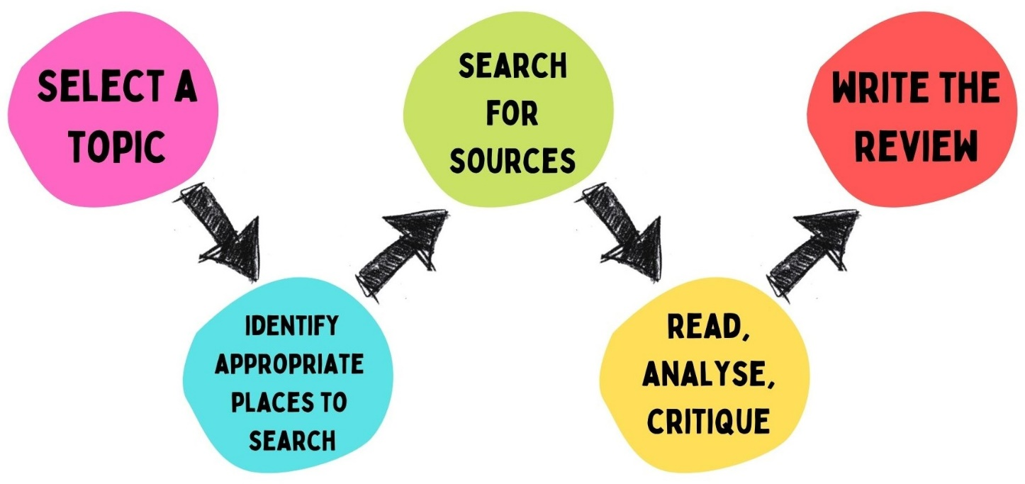

# Research Plan

1. **What is Research?**

Research is a purposeful and methodical effort aimed at expanding the body of information on a particular subject. It involves the gathering, organizing, and analysis of data with the goal of advancing understanding in a specific field. Notably, research is characterized by a meticulous emphasis on mitigating bias and errors in the process. The activities encompassed in research include acknowledging and managing biases, ensuring a thorough examination of evidence.

In the realm of academic studies, research endeavors can extend beyond mere assignments and involve a broader exploration of a subject. It may encompass a critical examination of previous projects or the entirety of a project to assess the reliability of tools, methodologies, or experiments employed. The essence of research lies in its creative and systematic approach, dedicated to enriching our knowledge base and contributing to the refinement of methodologies within a given field.

# What is its purpose?

The research proposal serves as an opportunity for you to articulate the significance of your project to potential funding organizations or supporters. Ideally, it should highlight the excellence and importance of your undertaking, showcasing your ability to effectively carry out the proposed research. Moreover, the proposal allows you to thoroughly contemplate your research project, fine-tune your focus, and anticipate any challenges that may arise. Seeking input at various stages of your research process can be beneficial, serving as a means to revisit and reinforce your project's focus and track its evolution. Ultimately, the research proposal is a vital tool for not only securing support but also for guiding and refining your research endeavor.

# What is its significance?

The section on significance aims to:

* Clarify the relevance of the problem or key impediment to progress within the specific domain addressed by the proposed project.
* Articulate how the project intends to enhance scientific knowledge, technical capabilities, and/or clinical practices within a particular or broader domain.
* Outline the potential modifications to the fundamental elements—principles, methods, technologies, treatments, services, or preventive interventions—that shape the field, should the proposed objectives be achieved.
* Clearly indicate whether there exists a robust scientific foundation supporting the project.

# Research Philosophy

# Saunders's Onion Theory

The research onion turned into developed by way Saunders et al. (2007). It illustrates the stages that need to be covered while growing a research approach. Whilst considered from the doors, each layer of the onion describes a greater specified stage of the research manner (Saunders et al., 2007).

"The research onion is an illustrative model, developed through Saunders et al, to explain the ranges thru which a researcher should progress to formulate an effective methodology"

The research onion affords a powerful development through which a study’s methodology may be designed. Its usefulness lies in its adaptability for almost any form of study technique and can be utilized in a selection of contexts (Bryman, 2012).

# Stages of Saunders’s Onion Theory

The onion is made up of 6 layers, which you’ll need to peel again one by

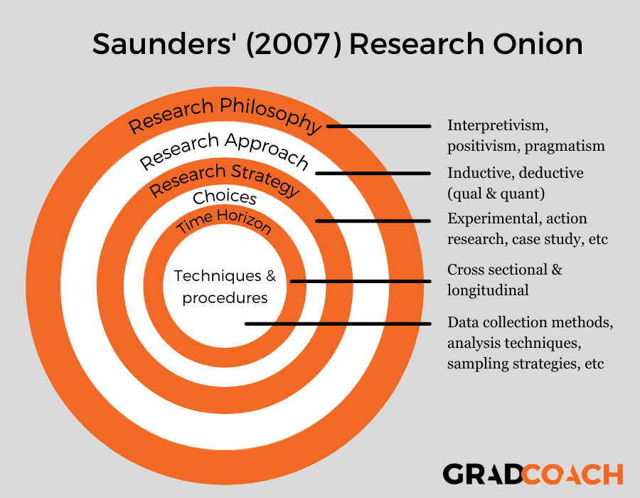One as you expand your research methodology

1. [**Research philosophy**](https://gradcoach.com/saunders-research-onion/#1)

It pertains to the set of principles governing the worldview or perspective from which research is undertaken, encompassing studies in ontology and epistemology. Ontology addresses the authenticity of data and the means by which one acknowledges its existence, while epistemology concerns the valid information required for investigation and the methods to acquire it. In the realm of educational research, two prevalent philosophical positions are positivism and interpretivism. Positivism assumes that knowledge is objective and detached from the subject under study, while interpretivism contends that individual observers bring their own beliefs and understanding of reality into the research process. Consequently, positivist research tends to be more scientific, focused on testing phenomena, whereas interpretive research often takes a qualitative approach.

1. [**Research approach**](https://gradcoach.com/saunders-research-onion/#2)

Within the second layer of the research onion, two terms, namely deductive and inductive, come into play. The dynamics of this layer are intricately linked to the preceding layer of the onion, emphasizing the importance of understanding the research's objectives and limitations in shaping these terms.

# The Deductive Approach

The deductive approach involves constructing hypotheses based on existing principles and subsequently formulating a research method to test them (Silverman, 2013). This approach aligns well with the positivist perspective, which advocates for hypotheses formulation and statistical testing of predicted outcomes at a generalized probability level (Snieder & Larner, 2009). It follows a progression from general to specific, wherein an overarching principle and knowledge base are initially established, and the specific insights obtained from the research process are then validated against them (Kothari, 2004). Notably, while the deductive approach is commonly associated with quantitative research methods, it can also be employed in qualitative research. In such cases, expectations derived from existing research are shaped differently than in hypothesis testing scenarios (Saunders et al., 2007). Utilizing questionnaires, the deductive approach seeks to generate observational insights, allowing for the examination of individuals' distinct knowledge through empirical data. The iterative nature of the process enables the confirmation or refutation of hypotheses, fostering a cycle of refinement and repetition.

# The Inductive Approach

The inductive approach stands in contrast to the deductive method by allowing the creation of a concept rather than relying on a pre-existing one. This fundamental distinction underscores the essence of these two approaches. Inductive methodology is characterized by a progression from specific observations to a general understanding (Bryman & Bell, 2011). Unlike the deductive approach, there is no pre-established framework guiding data collection, and the research perspective may take shape after the material has been gathered (Flick, 2011). While this may be viewed as the juncture where new theories emerge, it's noteworthy that as knowledge is generated, it could also align with existing concepts (Bryman & Bell, 2011).

Inductive methodology is frequently employed in qualitative research, where interviews capture unique incidents, and subsequent data analysis seeks patterns among respondents (Flick, 2011). However, it's essential to recognize that this approach can be effectively utilized within positivist methodologies as well. In such cases, data is analyzed first, and significant patterns inform the generation of results. The inductive approach, thus, offers flexibility in its application across various research paradigms.

1. [**Research strategy**](https://gradcoach.com/saunders-research-onion/#3)

The research strategy outlines the planned approach that the researcher intends to employ in conducting their work (Saunders et al., 2007). This methodology encompasses a diverse range of approaches, such as experimental research, action research, case studies, interviews, surveys, or a systematic review of scientific literature.

# Experimental

Experimental research involves crafting a research approach that contrasts the outcomes of an experiment with the anticipated results. This method is relevant across various research domains and typically entails the evaluation of a deliberately restricted set of variables (Saunders et al., 2007).

# Survey

The survey strategy, situated within the research onion, is often linked with the deductive approach and stands out as one of the simplest and cost-effective research methods. This approach facilitates the collection of abundant and reliable data. Surveys are commonly employed in quantitative research projects, involving the sampling of a representative portion of the population (Bryman & Bell, 2011). Primarily used to explore relationships among various variables, the survey method enables the gathering of substantial data aimed at addressing the central questions of the study.

# Case Study

This approach concentrates on studying one or more individuals or a specific geographical area, offering insights into the unique characteristics of a particular case and emphasizing the importance of culture and context in discerning differences between cases (Silverman, 2013). Particularly beneficial in economic research, case observation studies involve the examination of a single unit with the aim of identifying significant features and deriving generalizations (Bryman, 2012). This method proves valuable in economic research scenarios, such as evaluating the impact of investments in various contexts or comparing the experiences of two companies.

1. [**Choices**](https://gradcoach.com/saunders-research-onion/#4)

The fourth layer of the research onion, also known as research design, serves as a crucial determinant in deciding whether to integrate both quantitative and qualitative methods or to opt for a singular approach. As outlined by Saunders et al. (2007), there are three distinct choices presented in the research onion, namely the mono method, mixed method, and multi-method research options or approaches.

- Mono Method

- Mixed Method

- Multi-Method

1. [**Time horizon**](https://gradcoach.com/saunders-research-onion/#5)

The time horizon, as depicted in the research onion, delineates the timeframe necessary for completing the project work. Bryman (2012) identifies two types of time horizons in research: the cross-sectional and the longitudinal.

# Cross Sectional

The time horizon, illustrated within the research onion, outlines the duration required to finalize project work. Bryman (2012) categorizes research time horizons into two types: cross-sectional and longitudinal.

# Longitudinal

A longitudinal time horizon in data series involves the repetitive gathering of information over an extended period. This approach is employed when a crucial aspect of the research involves analyzing changes over time (Goddard & Melville, 2004).

1. [**Techniques & procedures**](https://gradcoach.com/saunders-research-onion/#6)

Ultimately, we reach the core of the onion, where the practical aspects of your research come into focus, demanding decisions on specific methods and procedures. At this juncture, you will:

- Define the type of data you intend to collect and the methods for data collection (e.g., conducting surveys or engaging in one-on-one interviews).

- Determine the approach for sampling the population, whether it be through methods like snowball sampling, random sampling, convenience sampling, etc.

- Choose the form of data analysis that aligns with answering your research questions, be it content analysis or statistical methods such as correlation.

- Establish the materials you'll employ in your study, including the formulation of survey or interview questions.

# Gantt chart and Work Breakdown Structures (WBS) for Research Proposal

* + 1. **Project Plan**

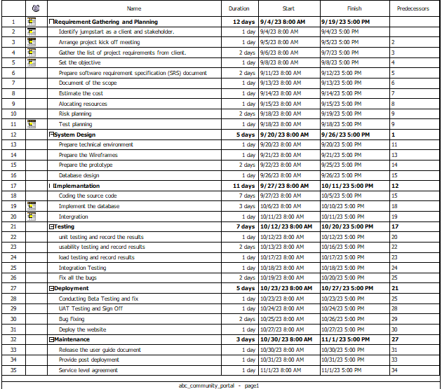

# Gantt Chart

A widely used tool in project management, the Gantt chart stands out as one of the most popular and effective means of visually representing activities (tasks or events) in relation to time. Positioned on the left side of the chart is a list of activities, while the top features a corresponding time scale. Each activity is portrayed by a bar, and the placement and length of the bar indicate the start date, duration, and end date of the activity. This visual representation provides an immediate overview, allowing you to easily observe:

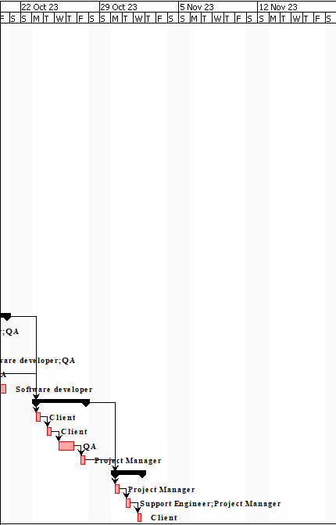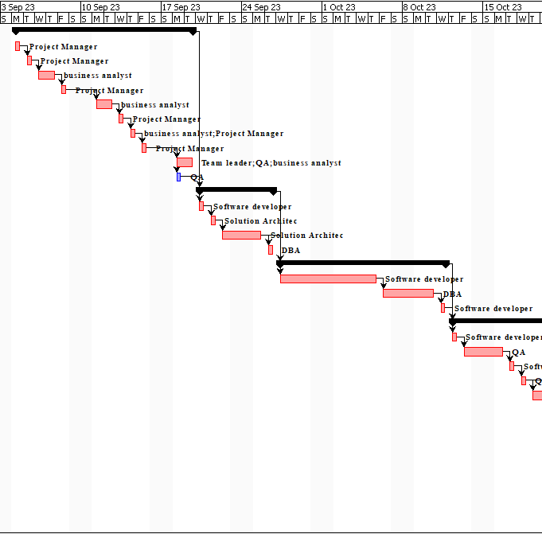

# WBS

In the realms of project management and systems engineering, a work-breakdown structure is a breakdown of a task into smaller, deliverable-focused components. Serving as a crucial project deliverable, the work breakdown structure systematically organizes the team's work into manageable sections.

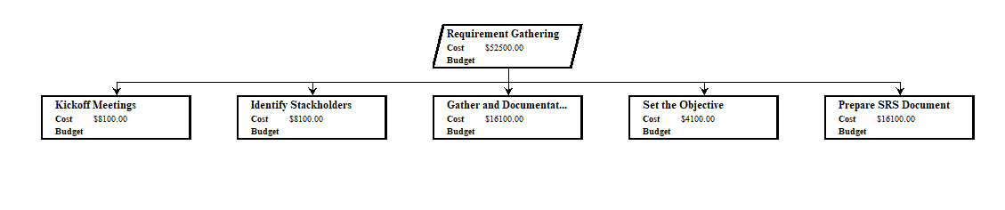

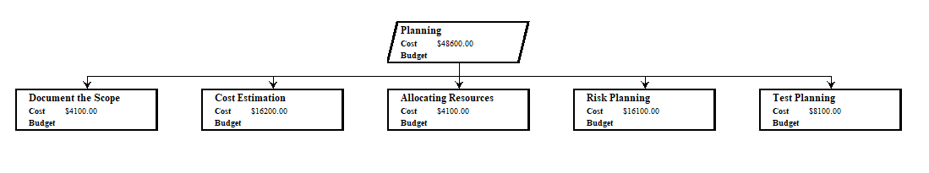

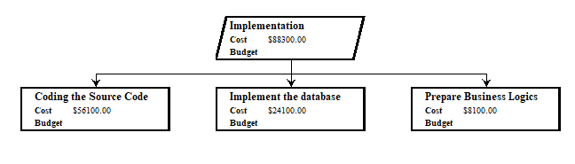

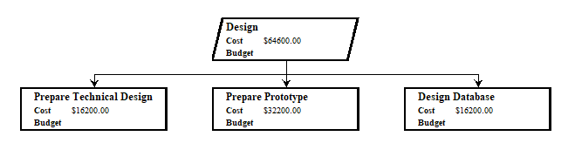

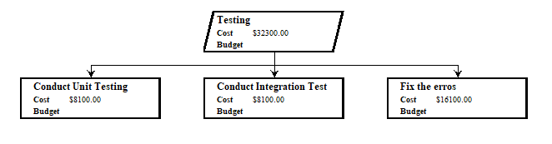

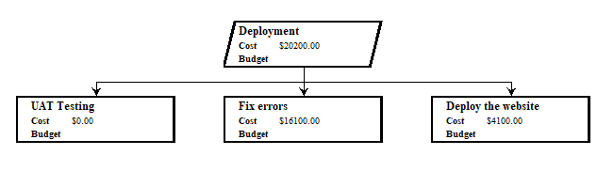

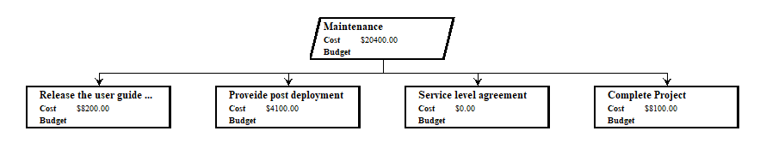

# Research Methodologies

A research methodology is a framework outlining the processes, methods, and techniques utilized in a research study to collect, analyze, and interpret data. Within research papers, there is typically a dedicated section that delves into the specifics of the research methodology employed in the study.

# Primary Research

Primary research refers to a method employed by researchers to directly gather information rather than relying on data obtained from previously conducted studies. Essentially, researchers have ownership of the data collected through primary research. This type of research is specifically undertaken to address a particular issue, necessitating a thorough and in-depth analysis.

# Types of Primary Research

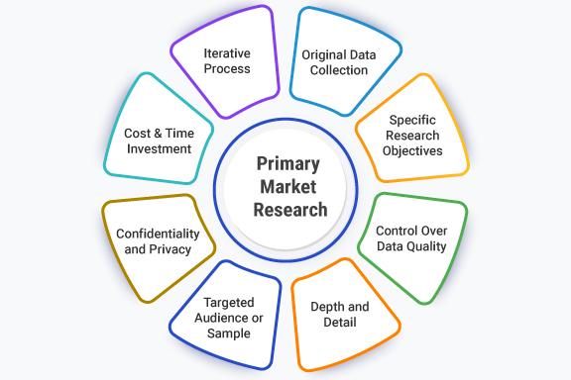

* + - * **Interviews (telephone or face-to-face)**

# Employing interviews is a qualitative research approach with a longstanding history of gathering information. These interviews can occur either in person through face-to-face interactions or remotely over the phone. Interviews follow an open-ended format, fostering conversations or interactions between the interviewer (researcher) and the interviewee (respondent).

# Surveys (online or mail)

Surveys, once conducted using pen and paper, have evolved significantly. In contemporary research practices, most researchers opt for online surveys, which are distributed to respondents electronically for data collection. Online surveys offer convenience and can be sent via email or accessed and completed online. Respondents can conveniently fill them out using handheld devices such as phones, tablets, iPads, and similar gadgets.

# Focus groups.

This prevalent research method involves gathering information from a limited number of individuals, typically ranging from six to ten. The focus group assembles participants who possess expertise in the subject matter under investigation.

Guided by a moderator, the focus group engages in discussions aimed at extracting additional insights from its members. This strategy is commonly employed by organizations and agencies seeking to identify a specific market or understand a particular group of clients.

# Observation

Observation as a primary research method occurs when an individual establishes specific criteria, characteristics, or features and then examines something to identify or assess those particular attributes.

# Merits/ Demerits of Types of Primary Research

|  |  |  |
| --- | --- | --- |
| Type | Merits | Demerits |
| Interviews | * Ability to locate the appropriate applicant * Enables exact evaluation * Excellent source of information * Identify Knowledge * Improved understanding of stakeholders | * Fairly time-consuming * Chance of personal bias * Quick to choose * Can easily shape stereotypes * Hard to affirm the truth |
| Surveys | * Relatively simple to maintain o Can evolve in considerably less time (when compared to other statistics-series methods) * Cost-effective, however costs vary depending on survey method * Can be managed remotely via the internet, mobile devices, mail, email, kiosk, or smartphone. * Remote execution can decrease or eliminate geographical dependence. | * Respondents will not feel encouraged to provide correct, truthful solutions. * Respondents will not feel comfortable proposing ideas that benefit themselves in a negative way. * Respondents may be unaware of their motivations for any particular solution due to a loss of recall about the circumstance or boredom. * Surveys with closed-ended questions may have a lower validity rate than other inquiry types. |
| Focus Groups | * Insightful data * Frame language observations * Low prices * Emotional connections | * Time-consuming evaluation * Participants are shy * Individuals are willing to present records * Difficulty in enticing a massive institution |
| Observation | * View operations of a software as they're simply occurring * Can adapt to occasions as they arise | * It can be difficult to interpret observed behaviors. * Observations can be difficult to categorize. |

* Can have an effect on behaviors of software participants
* Can be highly-priced
  1. **Secondary Research**

Secondary research involves the compilation, consolidation, and/or synthesis of existing findings. It distinguishes itself from primary research, where new knowledge is generated, as secondary research utilizes primary research sources as data for analysis. The presence of a "methods" section, where authors outline how the data were generated, serves as a strong indicator of original research.

# Types of Secondary Research

* + - * **Static Analysis**

Abundant data is accessible online from various sources, frequently in the form of datasets. These datasets are commonly open-source or available at a nominal cost, making them well-suited for conducting statistical analyses like hypothesis testing or regression analysis.

Reliable sources for up-to-date data encompass:

* + - * + The government
        + Government companies
        + Non-governmental corporations
        + Instructional institutions
        + Businesses or consultancies
        + Libraries or data
        + Newspapers, educational journals, or magazines

# Case Study

A case study involves a thorough examination of a specific problem, often delving into qualitative aspects. It serves as a method to explore and understand an individual, group, location, event, business, or phenomenon in-depth. Utilizing current research, a case study provides tangible, contextual, and comprehensive insights into a real-world situation.

This approach allows you to concentrate on a single complex case, scrutinizing a particular aspect with meticulous detail. Alternatively, you can opt to study multiple cases to compare different facets of your subject. Leveraging preexisting interviews, observational research, or other primary data sources enhances the richness of case studies.

# Literature Review

A literature review involves an examination of previously published scholarly sources related to your chosen topic. It offers a comprehensive overview of existing materials, aiding in the identification of relevant issues, controversies, and gaps within the literature you explore. These insights can be applied to your own work or serve as a starting point for initiating your primary research.

Structured similarly to a conventional academic paper, with a distinct introduction, body, and conclusion, a literature review serves as an effective means to assess the current landscape of research. It showcases your understanding of scholarly debates surrounding your chosen topic.

# Content Analysis

Content analysis is a research methodology that examines patterns in recorded communication by analyzing existing texts. It can take on either a quantitative or qualitative nature, depending on whether the analysis focuses on countable and measurable patterns or more interpretive aspects. While content analysis is commonly used in communication studies, it extends its applicability to historical analysis, anthropology, and psychology, allowing for qualitative inferences with semantic depth.

# Sources of data

Data sources serve as reliable reservoirs of information and can be categorized into two main components: internal and external sources. Primary data originates from internal sources, while secondary data is derived from external sources. The specifics of data sources are explicitly outlined in the table provided below.

* Public Library
* Online Material
* Gov/Non-gov agencies
* Commercial Sources
* Magazines
* Newspaper
* Journals
* Articles, etc.

# Merits/ Demerits of Secondary Research

|  |  |
| --- | --- |
| Merits | Demerits |
| * Secondary facts could be easily obtained and efficiently obtained. * It is also frequently free or accessible via your academic institution's library or network, making it much less expensive to practice than primary studies. * As you are relying on research that already exists, undertaking secondary research is a great   deal much less time eating than | o Ease of access does not indicate credibility. It is crucial to remember that secondary research is not always consistent and may frequently be out of date. Before you begin, it is necessary to assess any statistics you are considering employing, utilizing a process such as the CRAAP examination. |

|  |  |
| --- | --- |
| primary studies. Since your timeline is a lot shorter, your research can be ready to publish sooner.  o The usage of information from others allows you to expose reproducibility and replicability, bolstering prior research and situating your  own work within your area. | o Secondary studies are frequently based on main research that have already been completed. If the original study is prejudiced in any manner, those biases should be reflected in the secondary results. |

1. **Research Approaches**

There are three key approaches that are commonly used in research and they are:

# Quantitative Research

* + 1. **Quantitative Research Methodology**

Quantitative research methods come into play when the data being gathered is measurable and can be subjected to mathematical, statistical, or computational analyses. Commonly employed techniques for quantitative data collection include surveys, online polls, and questionnaires.

A few characteristics of quantitative research are

* Quantitative Data
* Closes-Ended Questions
* Large Sample Size
* High External Validity

# Merits/Demerits of Quantitative Research

|  |  |
| --- | --- |
| Merits | Demerits |
| * Can be tested and checked * Straightforward analysis * Prestige | * False focus on numbers * Difficulty setting up a research * Can be misleading |

* 1. **Qualitative Research**

# Qualitative Research Methodology

Qualitative research primarily deals with textual information, concentrating on words and their meanings. In the application of this methodology, data is gathered through open-ended and conversational discussions. The adoption of qualitative research is on the rise in market research as businesses seek not only to comprehend their customers' actions but also to delve into the underlying motivations. This approach provides companies with a comprehensive understanding of their target market, facilitating the implementation of impactful advertising campaigns.

A few characteristics of qualitative research are;

* Open-Ended Questions
* Complex Reasoning

# Types of Qualitative Research Methods

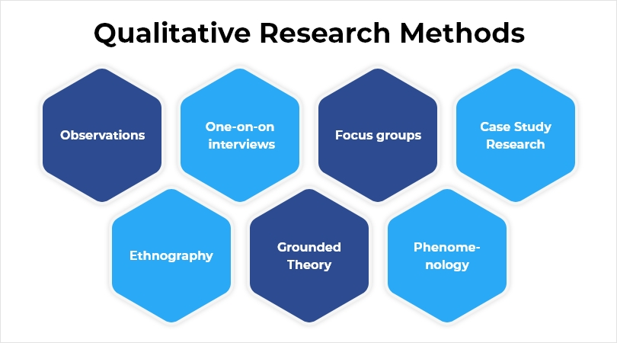

* + 1. **Merits/Demerits of Qualitative Research**

|  |  |
| --- | --- |
| Merits | Demerits |
| * Possible to understand attitudes * Content Generator * Save Money * Allows creativity to be a driving force * Open- ended * Incorporates the human experience | * Not a statistically representative form of data collection * Relies upon the experience of the researchers * Can create misleading conclusions * Can be influenced by researcher bias |

|  |  |
| --- | --- |
| * Can provide insights that are specific to an industry | * Can lose data * It may require multiple sessions * Can be difficult to replicate results |

# Mixed Methods Approach

The mixed-method approach, as the name implies, incorporates elements from both the quantitative research method and the qualitative research methodology. By integrating these two approaches, the mixed-methods approach aims to generate a more comprehensive and holistic understanding compared to conducting quantitative or qualitative research independently.

# Research Design

* 1. **Saunders Research Onion Theory**

The concept of Saunders' Research Onion, introduced in 2007, delineates the various decisions that researchers need to navigate when formulating a research methodology. This framework is applicable not only to dissertations and theses but also to any formal research project, guiding the researcher through the layers of decision-making in crafting a robust research approach.

# Compare among research methods and research approaches

* + 1. **Comparison of data Approaches**

|  |  |  |  |
| --- | --- | --- | --- |
|  | Quantitative Research | Qualitative Research | Mixed Research |
| Nature of data | Variables | Words, Images, categories, patterns | A mix of variables, words, images |
| Data Analysis | Statistical relationship | Search for patterns, themes and holistic features | Quantitative symptoms and qualitative support |
| Results | Generalizing | Particularistic finding representation of insider | Corroborated findings may generalize |
| Final Report Form | Statistical report | Narrative even with direct quotations of research participants | Eclectic and pragmatic |

Conclusion: Choose the best approach and write the reason for choice.

# Comparison among primary methods:

|  |  |  |  |
| --- | --- | --- | --- |
| Survey | Interview | Focus group | Observation |
| Surveys are a cost-powerful approach of sampling a massive institution of human beings. They involve a series of  smooth to | An interview is a qualitative research technique used to accumulate primary statistics. It includes asking one or more  humans | A focus group is a research method that brings collectively a small group of humans to answer questions in a  moderated | Primary data are original observations amassed by way of the researcher or via his agent for the first time for any  research and |

|  |  |  |  |
| --- | --- | --- | --- |
| answer questions which can be generally multiple desire. This permits quantitative statistics to be accrued and analysed with the aid of the researcher. | approximately their opinions on a organization, a product, or a topic. | putting. The institution is chosen due to predefined demographic tendencies, and the questions are designed to shed mild on a topic of hobby. It's far considered one of 4 forms of  interviews | it's miles series of records from first hand data. This type of primary data is generally pure and authentic data. |

**Conclusion:**

# Given that this is an e-commerce platform for online purchases, I am inclined to recommend a survey as the primary research method. In the realm of e-commerce, understanding consumer preferences, needs, and motivations is crucial, and a survey serves as an effective tool for gathering such insights. The data collected from the survey can be invaluable in enhancing the website, refining the shopping experience, and informing adjustments to corporate practices, among other improvements.

# Helps with data collection

Surveys conducted for online shopping provide valuable insights into customers' motivations, shopping behavior, and requirements. Through these surveys, you can gain an understanding of their challenges, experiences, and potential opportunities. The real-time data collected allows for immediate adjustments to your business, enabling you to make timely improvements based on customer feedback.

# Better Customer Experience

When a customer makes a one-time purchase and doesn't return, the reasons behind their decision remain unknown. Conducting a survey shortly after their initial purchase or a few months after utilizing your service provides an excellent opportunity to uncover any dissatisfaction they may have experienced. This proactive approach allows you to address issues promptly and take remedial actions. Addressing their concerns promptly can leave a positive impression, potentially reversing their decision to refrain from future purchases and even leading to a renewed interest in your offerings.

# Helps to improve market strategy

The insights obtained from the online shopping survey can serve as a valuable tool to assess the effectiveness of your marketing strategy. If the survey reveals that a significant portion of your target audience engages with Instagram, it signals an opportunity to adjust your approach accordingly. This enhanced understanding of your customers, derived from the survey, enables you to tailor content for each segment, ensuring that your messaging resonates effectively with the right audience.

# Comparison of secondary methods

|  |  |  |  |
| --- | --- | --- | --- |
| LR/document analysis | Grounded Theory | Case Study | Ethnography |
| Secondary literature comprises views and opinions developed from or in agreement with primary supply material. Examples include review articles (including meta-analysis and systematic views) and reference works.  Document analysis is a shape of qualitative research in which files are interpreted with the aid of the researcher/assessor to  give voice and that means round an | Grounded theory is well utilised in qualitative research for building theoretical know-how of complicated social techniques.  Grounded idea facts analysis strategies can be used with specific forms of facts, along with secondary information | The researchers describe the analysis of secondary case research as the usage of existing case studies so one can cope with a research query that is consistent with, however differs from the motive of the unique case have a look at [14]. the selected cases  offered | Ethnographic methods are a research approach wherein you have a look at humans in their cultural setting, with the purpose of producing a narrative account of that particular way of life, against a theoretical backdrop |

|  |  |  |  |
| --- | --- | --- | --- |
| assessment subject matter. Analyzing documents consists of coding content into issues, just like how attention institution or interview transcripts are  analyzed. |  | evidence based totally on actual commercial enterprise experiences. |  |

**Conclusion**

In my view, document analysis stands out as an exceptional secondary research method due to its effectiveness in examining information coverage across different time periods and geographical locations. This approach proves valuable for documenting processes, triangulating with interviews and other data sources, comprehending formal presentation of information and ideas, and gaining insights into problem framing, among various other aspects.

# Research Conduct and Analysis

* 1. **Conduct Primary Research**

**Survey:** complete process of conducting survey:

1. Consider costs, access and ethical issues

|  |  |
| --- | --- |
| Survey Considerations | Description |
| Cost | Google Form is open-source tool to create the survey form. The participants only need to use the  internet to participate in surveys. |
| Access | Can access in anywhere internet access. |
| Ethical | Make sure that the participants  agree the consent to do the surveys. All the data are kept as confidential. |

# Objective of survey

To gain an understanding of the challenges faced by Jumpstart during the COVID-19 pandemic and to identify the complete set of requirements for the desired solution.

# Identify the tool

I opted to design the survey using Google Forms, which is a survey management tool included in the free, web-based Google Docs Editors suite. This suite encompasses Google Docs, Google Sheets, Google Slides, Google Drawings, Google Websites, and Google Keep. It's worth noting that Google Docs is exclusively accessible as a web application.

1. **Frame question** for survey:

* **Pre-Survey –** [*https://forms.gle/R29BFDH216aTdmRj6*](https://forms.gle/R29BFDH216aTdmRj6)

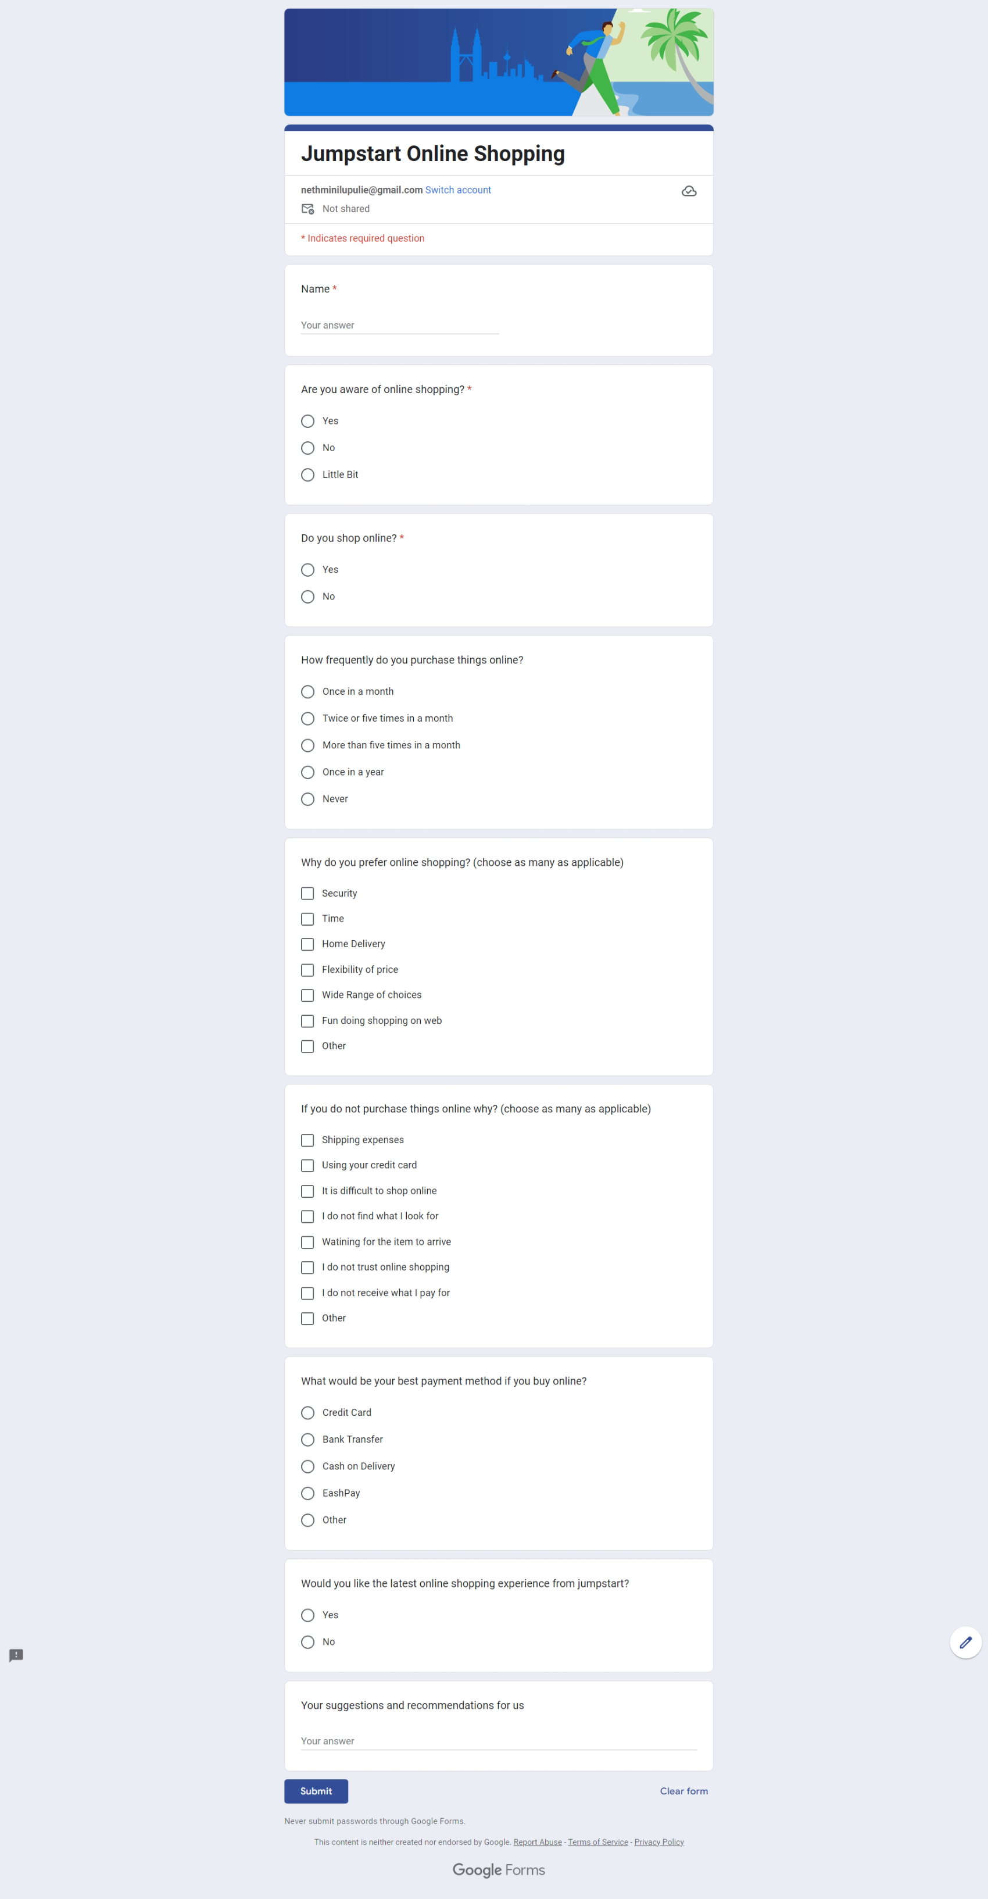

* **Collect and analyze results – Pre-Survey**

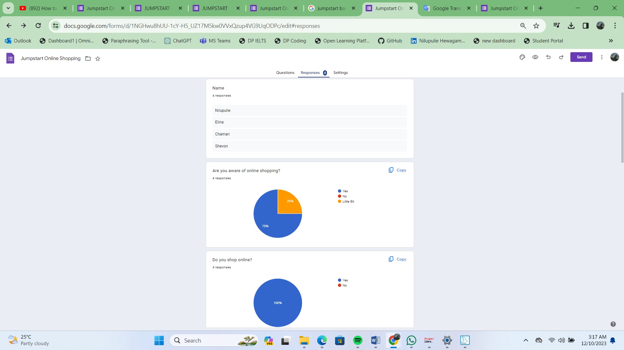

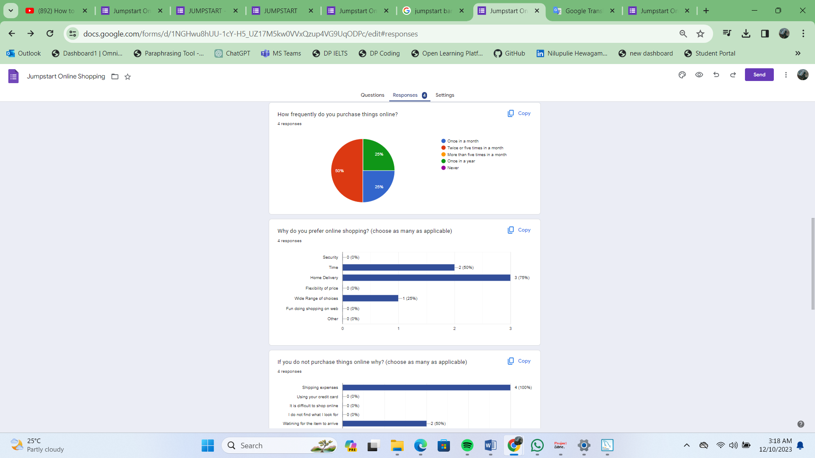

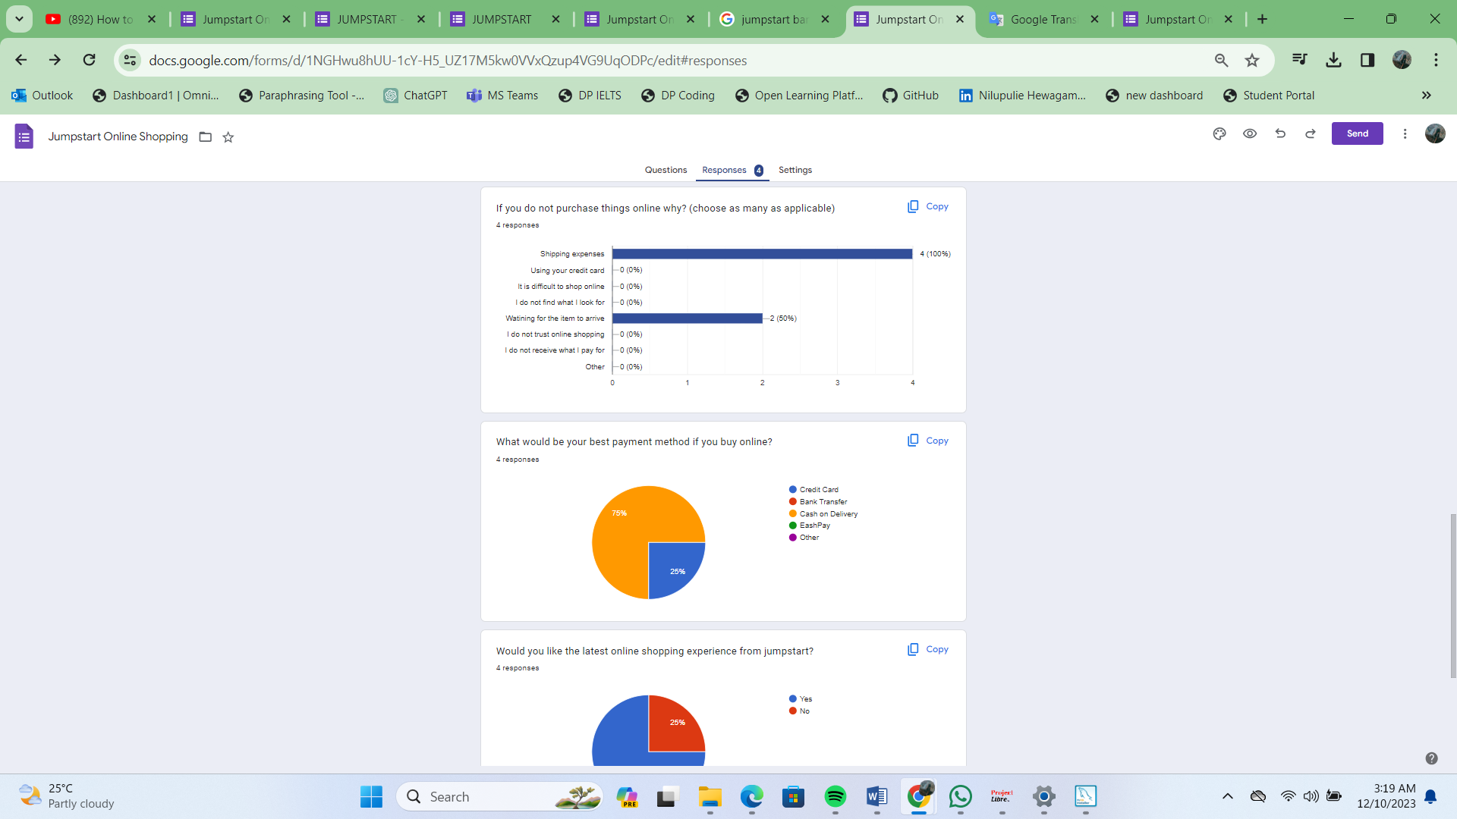

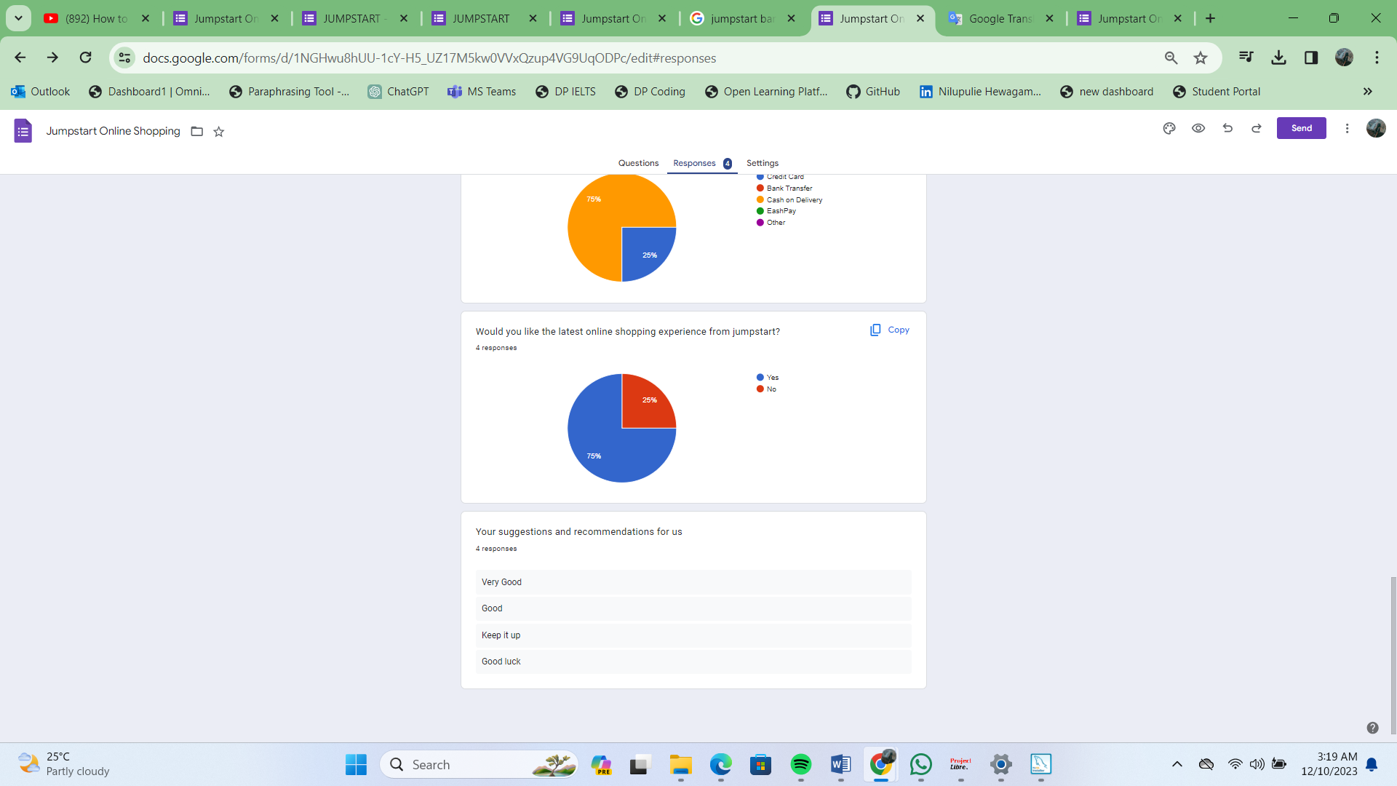

* **Post-Survey –** [*https://forms.gle/WcDUrSLFyebnePsA9*](https://forms.gle/WcDUrSLFyebnePsA9)

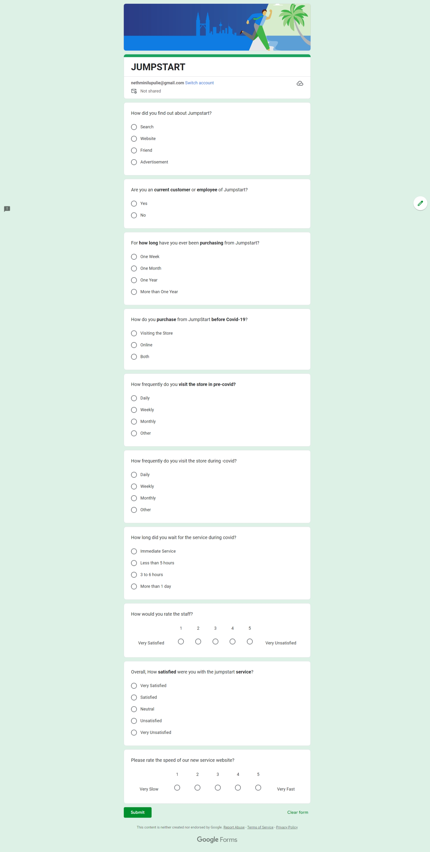

* **Collect and analyze results – Post-Survey**

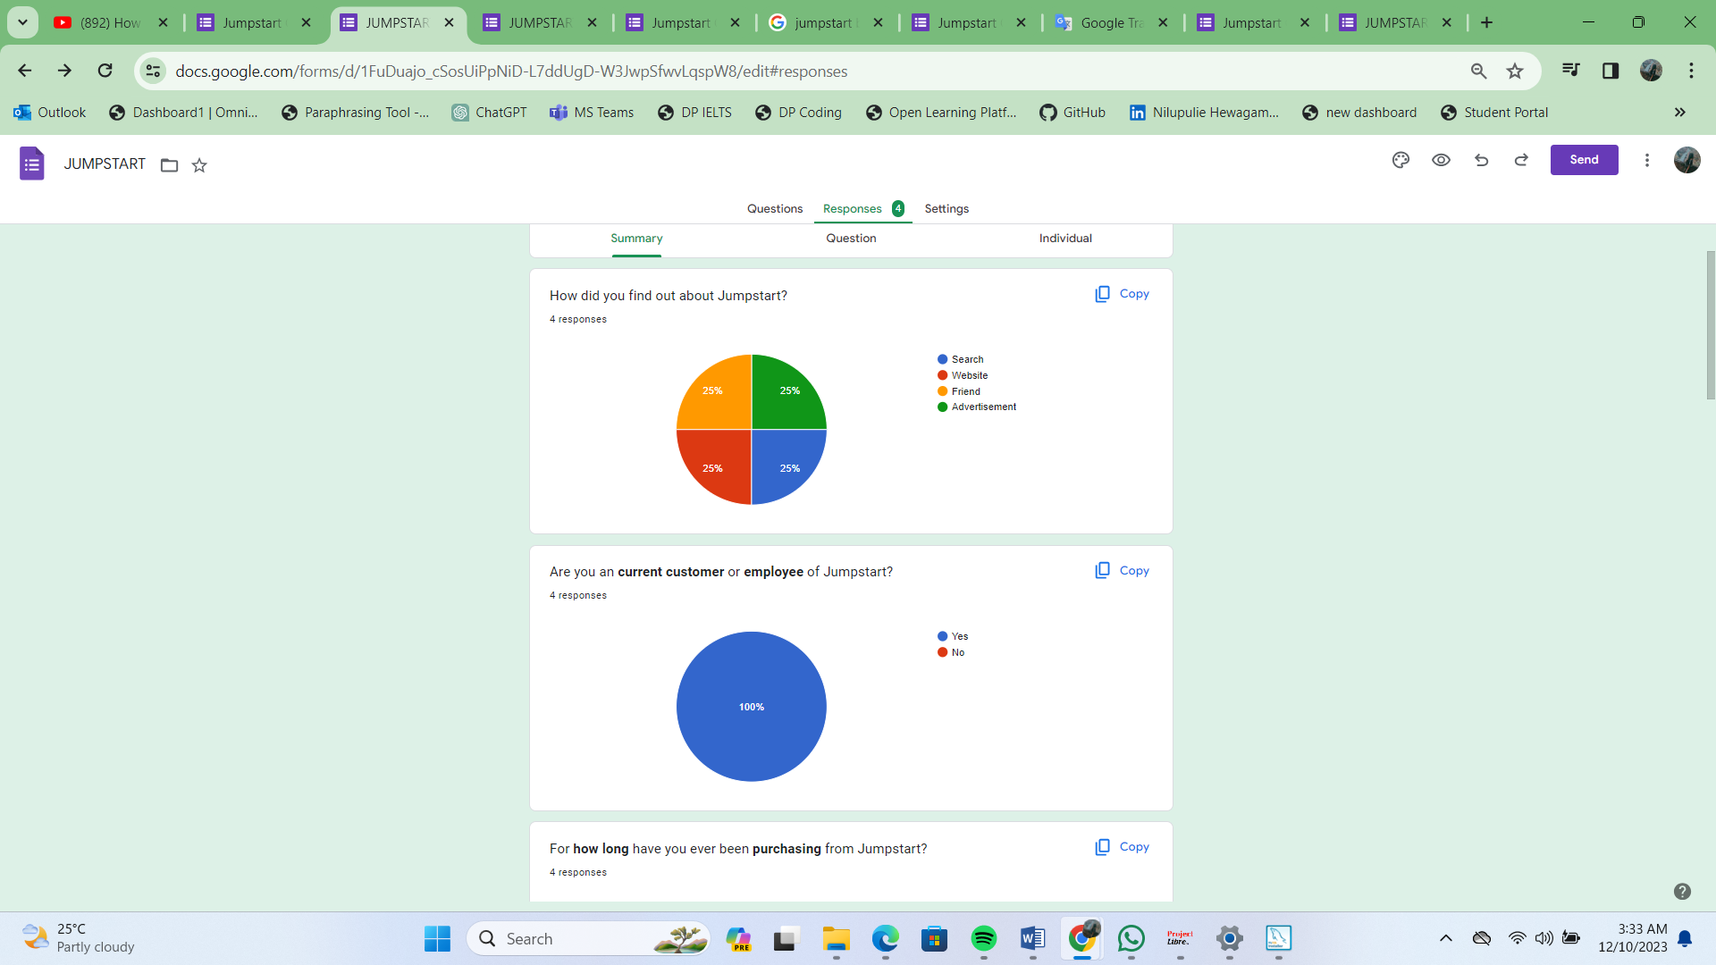

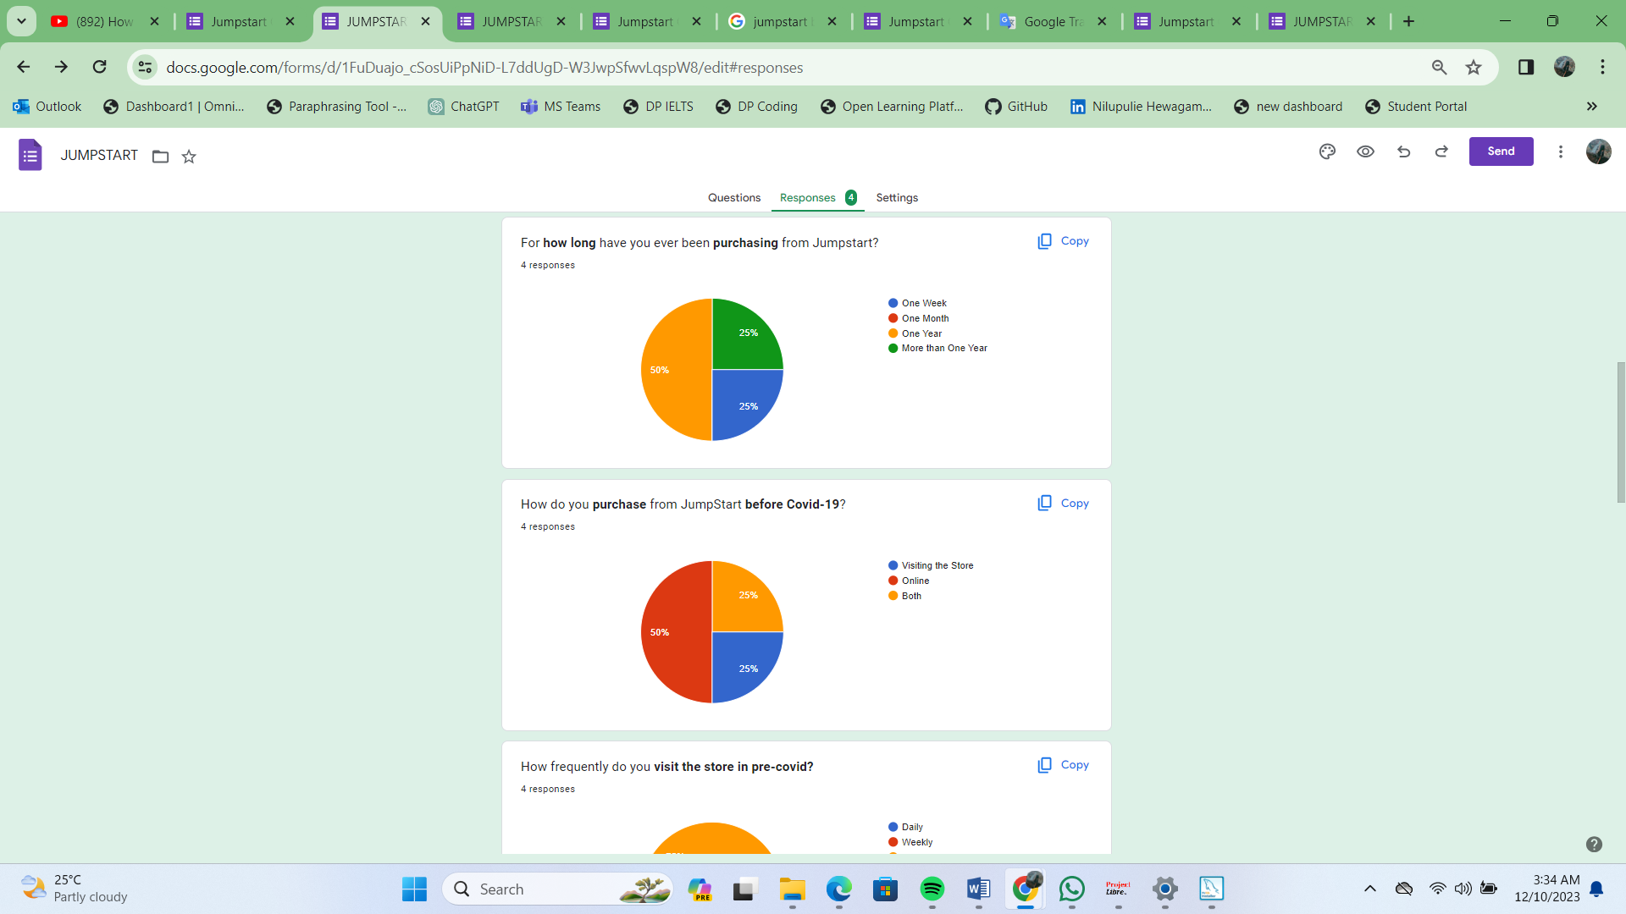

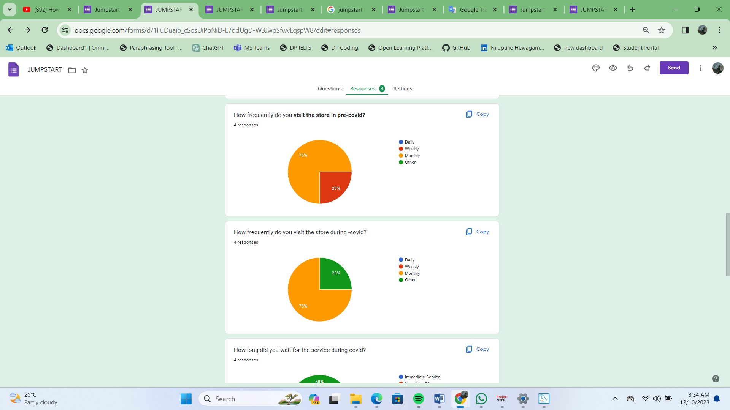

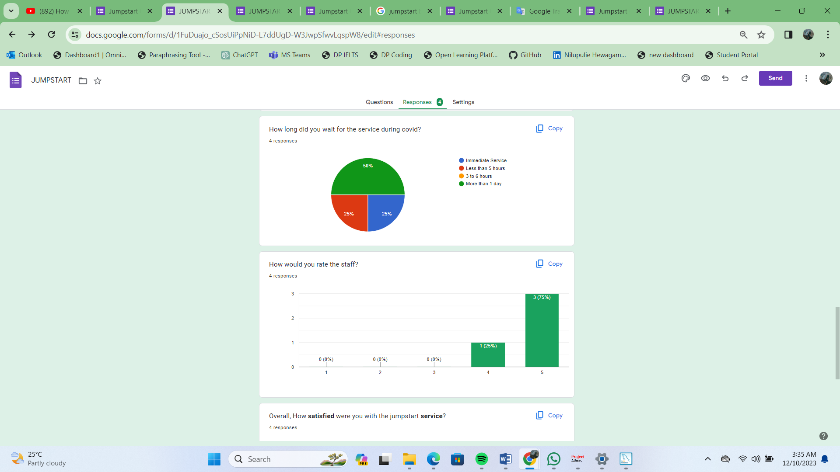

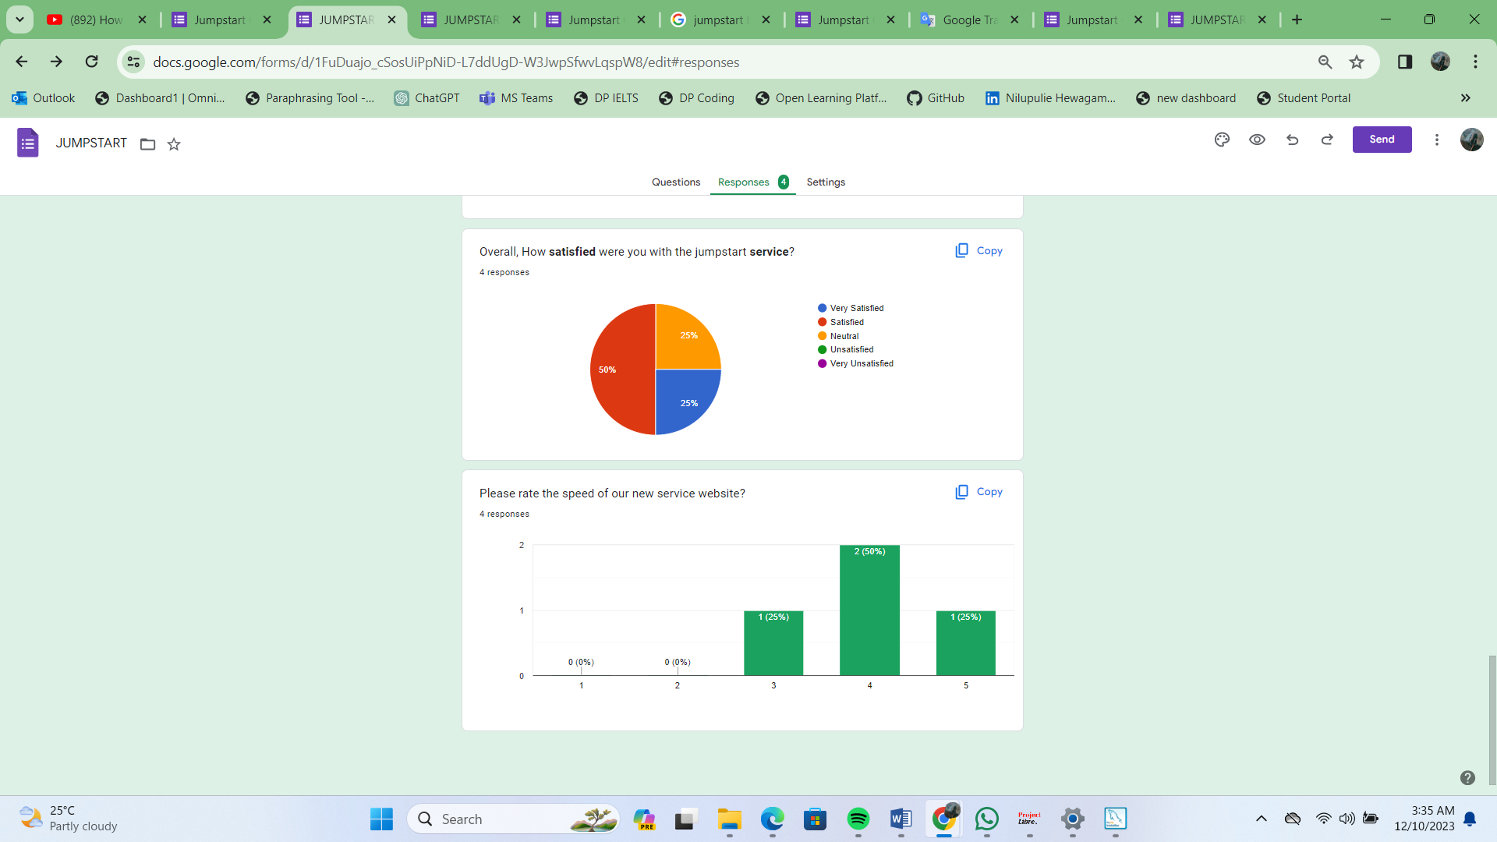

**Conclusion:**

Based on the survey findings, the majority of respondents have been utilizing the Jumpstart retail system for a duration of one or two years, with a frequency of at least once a week visiting Jumpstart stores. In the current challenging circumstances, a significant number of them opt to avoid leaving their homes and physically traveling to the market. Among the respondents, some have prior experience with an appointment system, while others do not. However, as per their feedback, concerns arise regarding the contracted e-commerce system, particularly in terms of security and compatibility issues.

# Conduct Secondary research (Identify Tools and techniques):

Addressing the challenges faced by Jumpstart involves enhancing operational efficiency, particularly in the technical aspects of the startup website. The project's objective is to provide Jumpstart with an effective solution for their remote working issues by designing a comprehensive E-commerce system. Leveraging E-commerce allows us to achieve these goals, covering aspects such as buying and selling, advertising, service delivery, and information exchange over the internet, intranets, extranets, and other networks. This includes interactions among the inter-networked company, potential customers, suppliers, and other business partners. To realize these objectives, the plan involves creating an improved E-commerce site for the Jumpstart retail system website using Axure, a collaborative web application for interface design, complemented by additional offline features through desktop applications for macOS and Windows.

|  |  |
| --- | --- |
| LR/Case study Considerations | Description |
| Cost | No cost / Open source |
| Access | Online Access |
| Ethical | Very much detailed and takes lots of time |

1. **Content analysis**

|  |  |  |  |
| --- | --- | --- | --- |
| **S. N**  **o.** | **Title** | **Reference Link** | **Outcomes** |
|  | Sunder’ s Onion Theory | https://thesismind.com/analy sis-of-saunders-research- onion/ | Understand about what are the layers of  sunder's onion theory and how to use it |
|  | Case Study | https://[www.bloomreach.com](http://www.bloomreach.com/)  /en/blog/2019/ecommerce- case-studies | General knowledge about the case study  and how is it done |
|  | Digital Transfor mation | https://egfound.org/projects/ digital-revolution-technology- power- you/?gclid=CjwKCAjwzuqgBh AcEiwAdj5dRvegY5GhoMxTou wHtEV9iHvazOVQEEODe7Blke 372V6bM7PY1QqqmhoCFV8Q  AvD_BwE | Get an idea about what is the digital transformation and hoe can use it for our project |
|  | Cart System | https://www.cs- cart.com/shopping-cart-  system.html | Good idea about what is a cart system and  how is it works |
|  | Quantita tive vs Qualitati ve | https://www.financestrategist s.com/wealth- management/fundamental- vs-technical- analysis/quantitative- analysis/?gclid=CjwKCAjwzuq gBhAcEiwAdj5dRppZQlAWtWP qjo_i8Y7ObLX_6wayaEgKa1n ELnksdjbXmKXXaF5gfBoCneM  QAvD_BwE | A good comparison of qualitative and quantitative methods and analyses of them |
|  | Researc h Methods | https://guides.lib.vt.edu/rese archmethods/design-method | Understand about the research methods and how they are  important in this project |

1. **Trend analysis**

Regarding the examination of data collected on diverse retail business trends and impacts during the periods before, during, and after the COVID-19 pandemic.

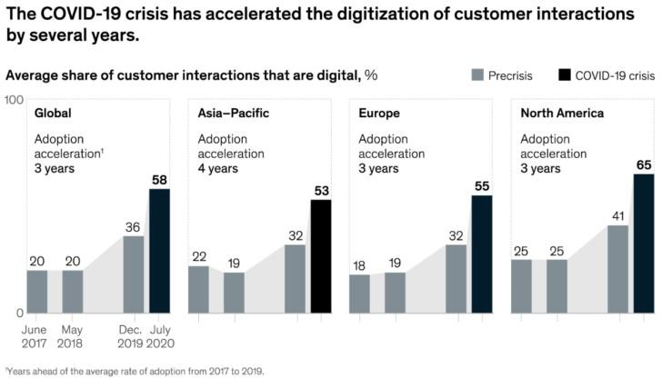

# Analysis of remote working before and after covid19

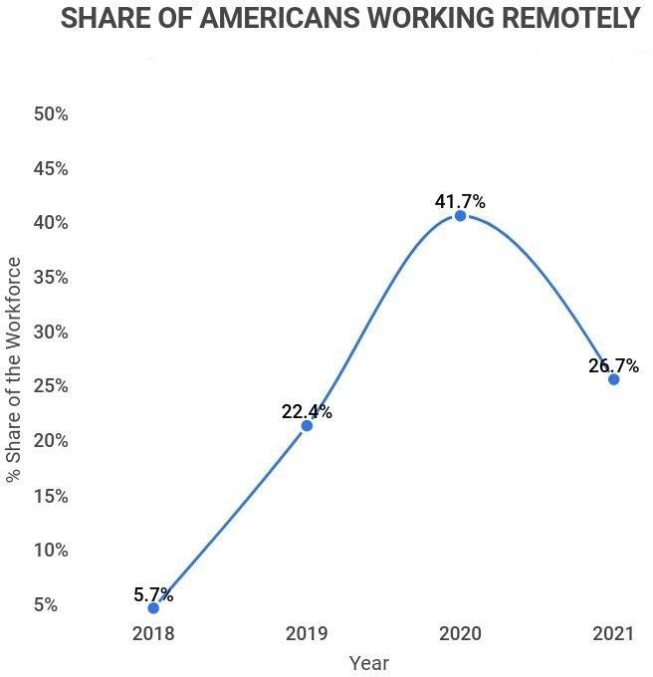

**Analysis of retail stores working during past days**

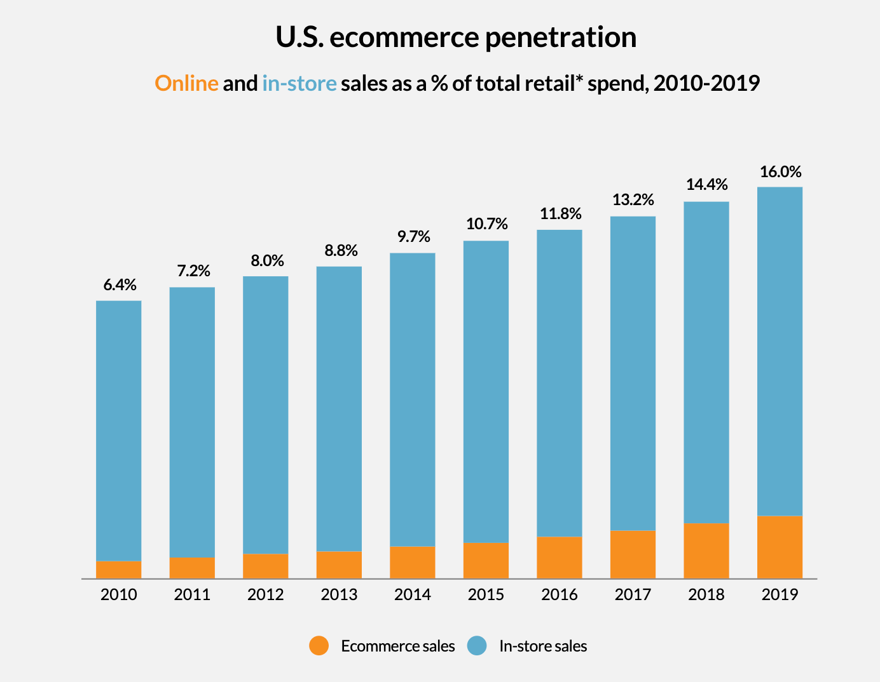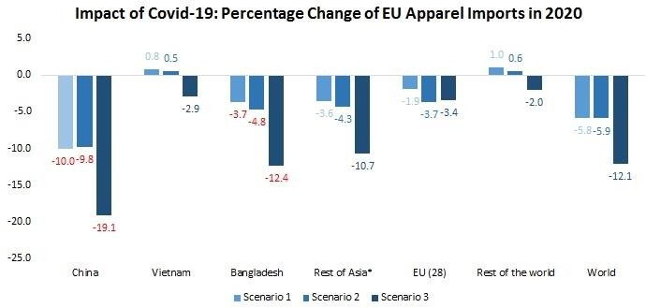

# Project Part (Part II)

1. **Project Proposal**

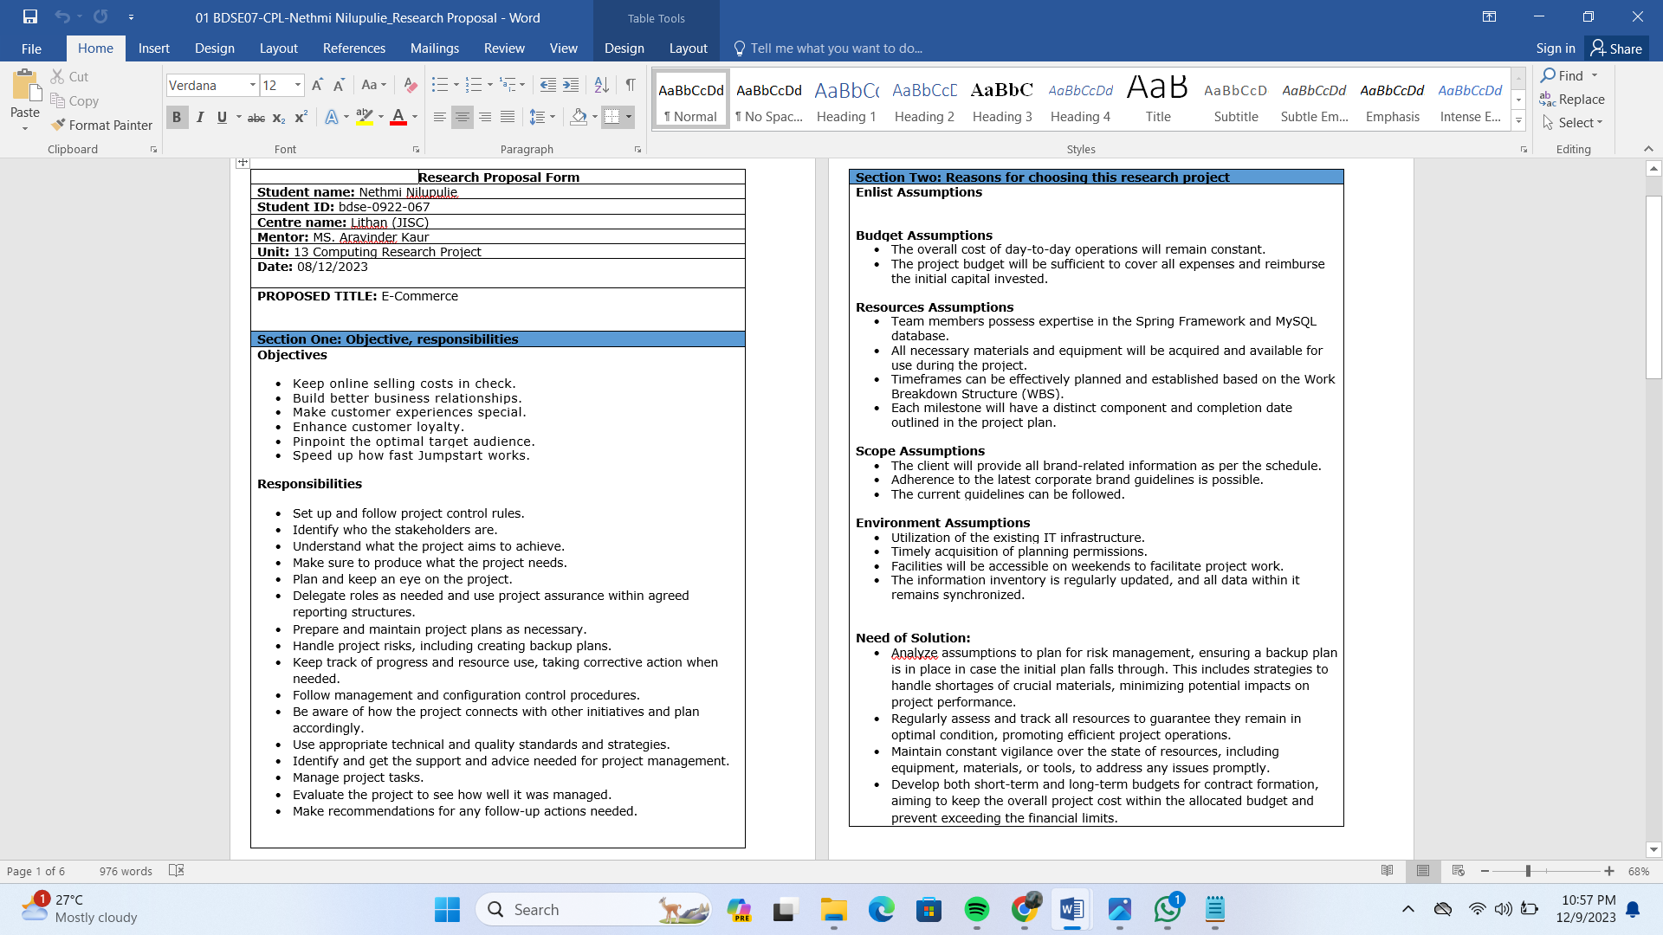

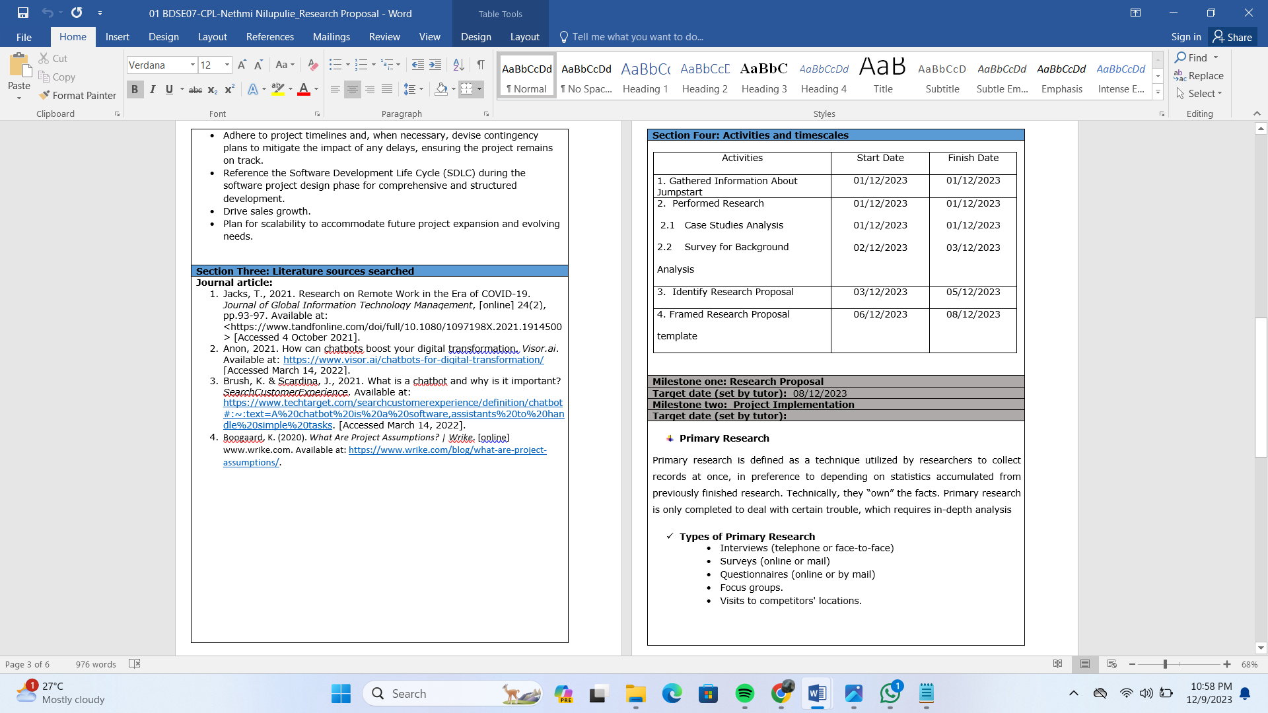



# Project Aim

The objective of the task is to streamline and digitize the garment selection process, allowing users the flexibility to shop online from any location and at any time. Utilizing the application to oversee the database ensures a straightforward and efficient approach, ultimately saving both time and resources.

# Objective

* Manage Online Selling Costs in A Strategic Way
* Establish Deeper Business Relationships
* Provide a Unique Customer Experience
* Improve Customer Loyalty
* Identify the Right Target Audience
* Increase the pace of operation of Jumpstart

# Responsibilities

* Designing and applying appropriate project control standards
* Discover the stakeholder list
* Adopting any delegation and use of project assurance roles within agreed reporting structures
* Making ready and keeping project, stage, and exception plans as required
* Handling project risks, which includes the improvement of contingency plans
* Monitoring overall progress and use of sources, initiating corrective action in which important
* Become aware of project goals and objectives
* Handling the production of the specified deliverables
* Making plans and tracking the project
* Making use of trade management and configuration control procedures
* Adopting and applying suitable technical and quality strategies and standards
* Figuring out and acquiring support and recommendation required for the control, making plans and control of the project
* Managing task management
* Conducting a project evaluation evaluate to assess how properly the project was managed
* Preparing any observe-on action recommendations
* Retaining an awareness of capability interdependencies with other initiatives and their effect

# Scope

The scope of this project includes the following:

* The implementation of a new software system
* Data migration from the old system to the new system
* Explain principles of problem management across its lifecycle.
* Use various tools, process and technologies to facilitate problem identification, investigation, analysis & resolution
* Explain various steps to investigate & diagnose problems.
* User training and support
* System maintenance and upgrades
* Document & monitor the problems
* Explain best practices in documenting problems
* Prioritize & Categorize change requests.
* Prepare a solution to address the root cause of the problem.

# Users should be able to perform the following functions in the portal

* + Register in the Portal
  + Login to the Portal
  + Add items to the cart
  + View cart items
  + Post a product for Sale along with a Picture Upload
  + Deactivate an Existing product
  + Update their Profile after logging in.

# Administrators should be able to perform the following functions in the portal

* + Register in the Portal
  + Login to the portal
  + Activate / Deactivate a product post
  + Update their profile
  + Transact the sales if the price is right
  + View the List of Registered Users/partners
  + Mark a User as Administrator

# Both Users & Administrator

* + Visit the Home Page
  + View product Listing
  + About Us Page
  + Contact Us Page
  + Terms & Conditions
  + Search for a product by Name, Brand, Serial No & Price Range

# Project out of Scope

* Upload the comments alternative and rating system to get the user’s

Thoughts.

* Develop FAQ pages to remedy the issues frequently requested by the customers.

# Enlist Assumptions

* **Budget Assumptions**
  + The overall cost of everyday operations will stay unchanged
  + The whole price range of the project will no longer exceed and may cover back the capital used.

# Resources Assumptions

* + Team members may have expertise on Spring Framework, MySQL database
  + All of the materials and equipment wished might be obtained and to be had for use when conducting the project
  + Time frame can be planned and created based totally on WBS
  + Every milestone could have its character issue and end date in the plan

# Scope Assumptions

* + The client will offer all brand records in line with the dates detailed in the schedule
  + Can use the modern business brand tips
  + Can use the modern guidelines

# Environment Assumptions

* + Will use the existing IT structure
  + Can be able to get making plans permission in a timely way
  + The facilities can be open at the weekend to permit the crew to do the project work
  + The records were routinely updated inside the data inventory, and all statistics within the information stock is synchronized.

# Need of Solution:

* + - Conduct assumption analysis for the risk administration plans to come up with a backup plan if the primary plan does not work, such as how to manipulate the lack of materials that may be deemed critical for the task, thus lowering the risk that can have an effect on the project's performance.
    - Always display all of the resources and keep track of the condition of the resources to ensure that the assets are within the acceptable cir
    - Continually monitor and take a look at the situation of the resources (gadgets, materials, or tools)
* Create short-term and long-term budgets to support the formulation of contracts, which will typically keep the whole project value within the budgeted value, preventing the Project from going above the real budget.
* Complete the project according to the schedule, and try to mitigate the impact if the timeline cannot be fulfilled by establishing a backup plan.
* When creating a software task, always consult with the software development life cycle (SDLC).
* Boost Sales
* Scalability

# Project Environment

* **Hardware Requirements**

|  |  |  |  |
| --- | --- | --- | --- |
| No | Hardware | | |
| **Type** | **Server** | Client |
| 1 | Processor | Intel(R) Core(TM) CPU@ 2.60GHz | Intel Core i5 |
| 2 | Memory | 32 GB | 8 GB |
| 3 | Hard Drive | 4 TB | 1 TB |
| 4 | Network | SLT Fibre Network | SLT Fibre Network |
| 5 | Monitor | Monitor 24” | Monitor 24” |
| 6 | Keyboard | USB Keyboard | USB Keyboard |
| 7 | Mouse | USB Optical Mouse | USB Optical Mouse |

# Software Requirements

|  |  |  |
| --- | --- | --- |
| No | Software | Functionality |
| 1 | Windows 10 | Operating System |
| 2 | Bootstrap, CSS, Spring Boot | Web Creation |
| 3 | MySQL | Database Server |
| 4 | Tomcat | Web Server |
| 5 | Axure | Design |
| 6 | Google Chrome, Microsoft Edge | Web Browser |

* **Network Requirements**

|  |  |  |
| --- | --- | --- |
| No | Network Device | Functionality |
| 1 | Switch | Cable connecting network from workstation |
| 2 | UTP Cable | Connecting Medium |
| 3 | RJ 45 Connector | Cable connecting network with LAN Card |

# Cloud Requirements

- AWS

- Azure

# Skills and Human Resources

|  |  |  |
| --- | --- | --- |
| No | Requirements | Skills |
| 1 | UI/UX Designer | Axure |
| 2 | Web Developer | HTML, CSS, JavaScript, Bootstrap, Spring Boot Java, MySQL. |

* 1. **Project Blueprint**

# Flow charts

* **Admin**

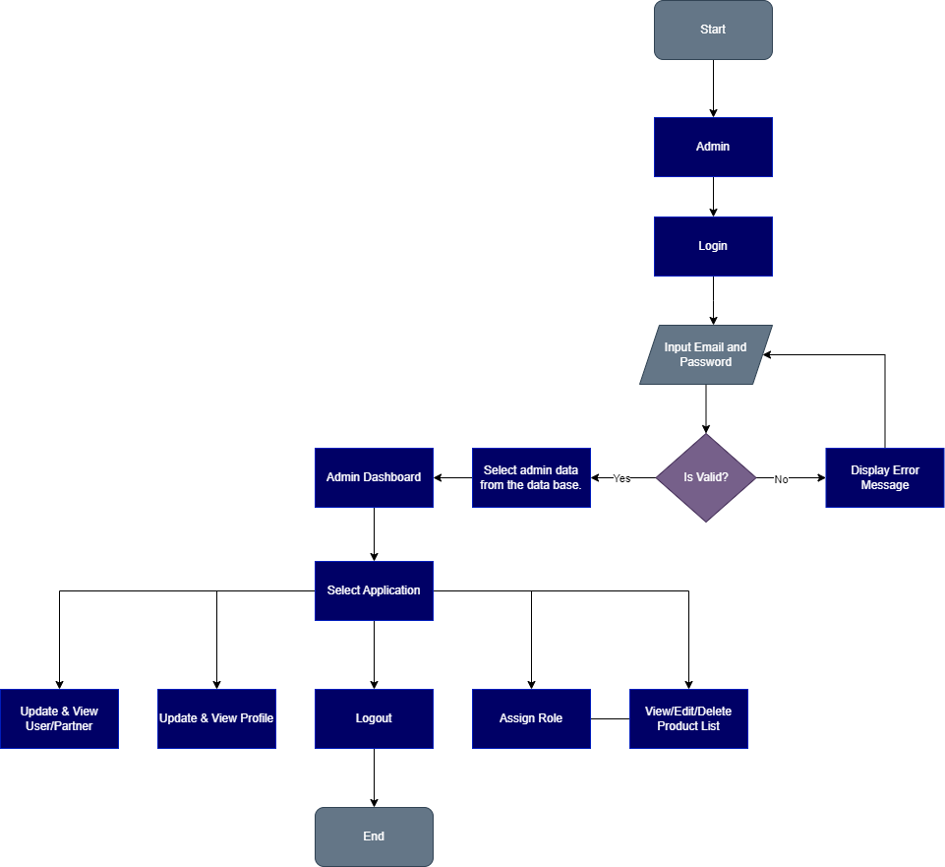

# Login

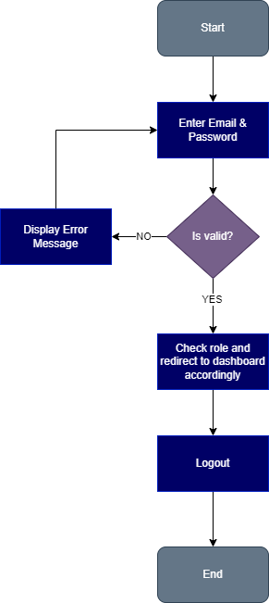

* **Registration**

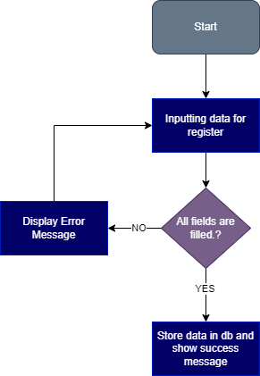

# User

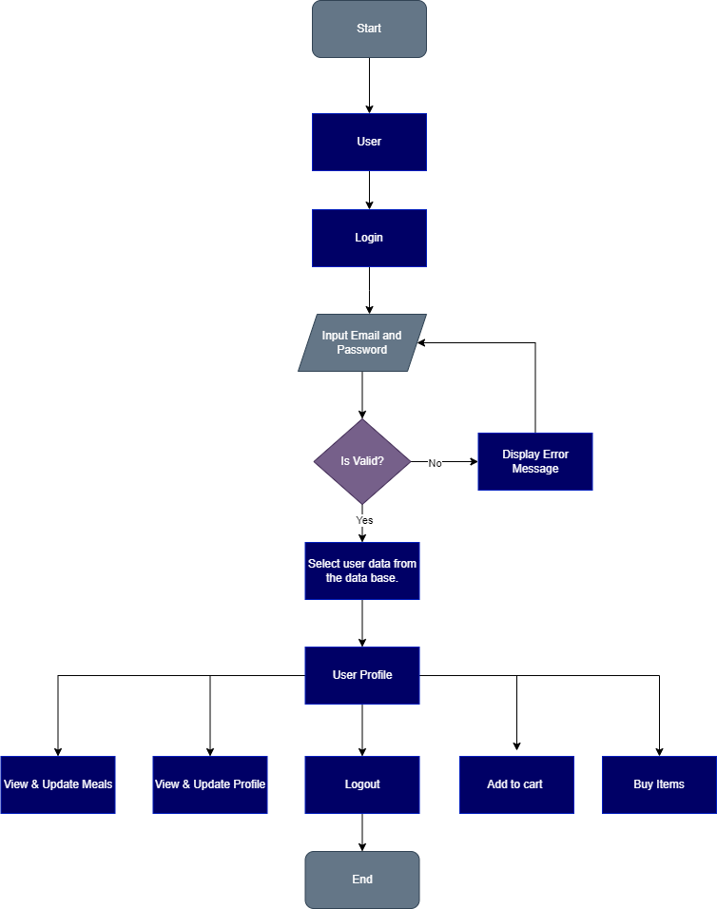

* **Partner**

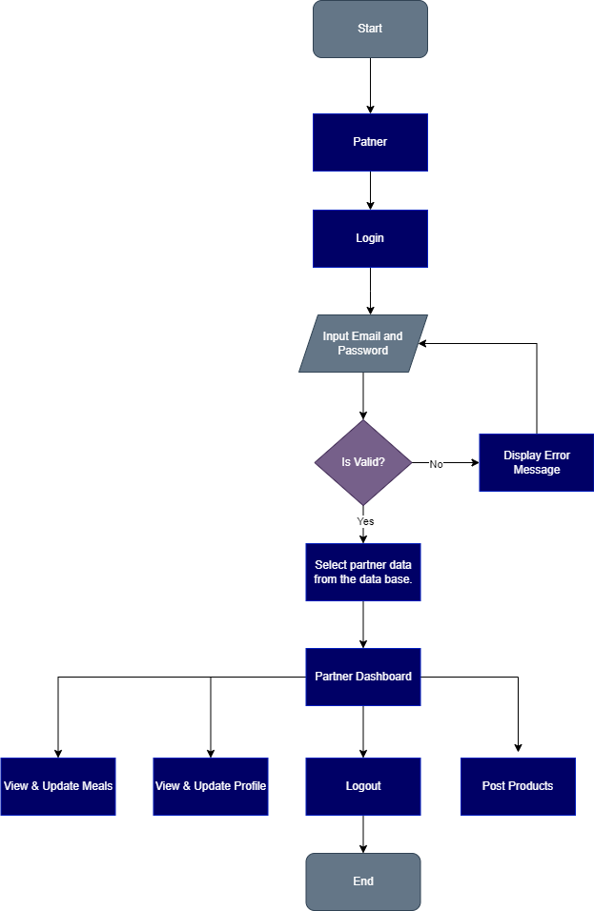

# Search Products

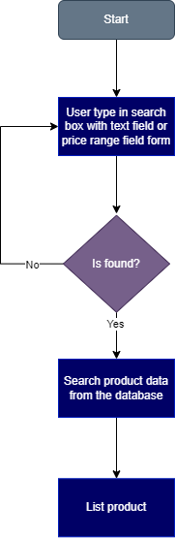

* **Post Products**

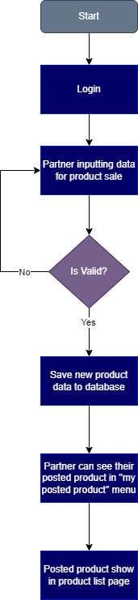

# Story Boards

**Landing**

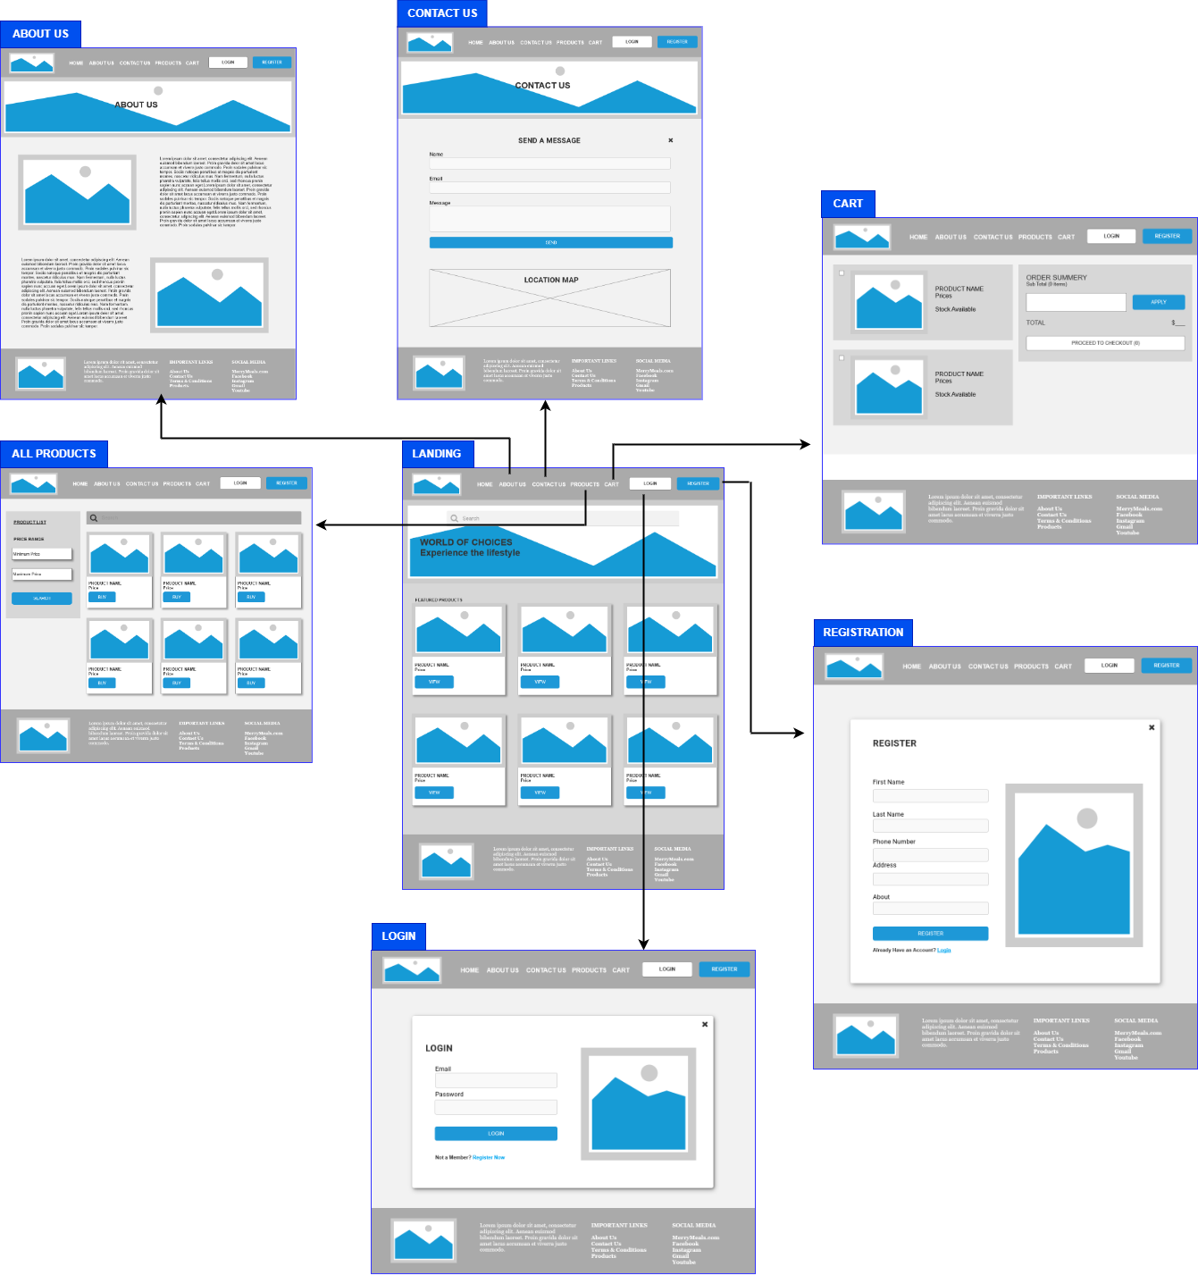

# Partner Login & Activity

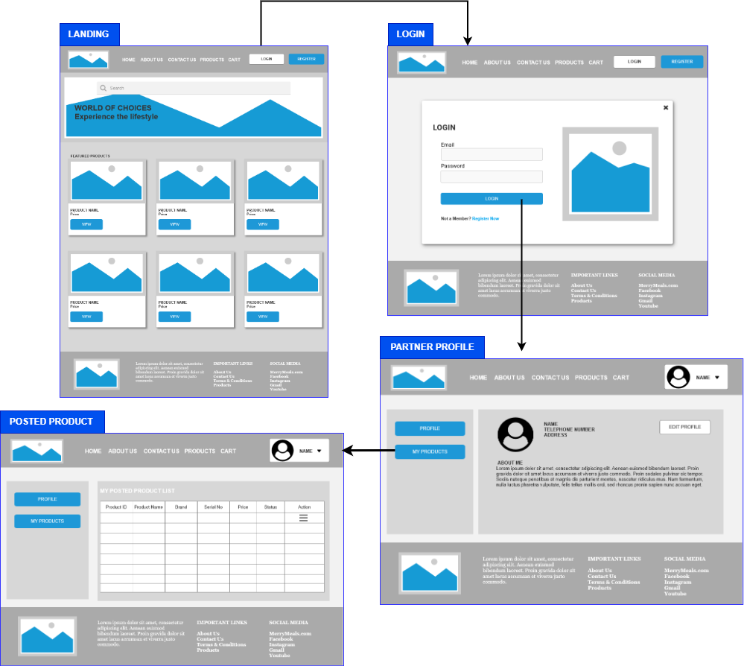

**Admin**

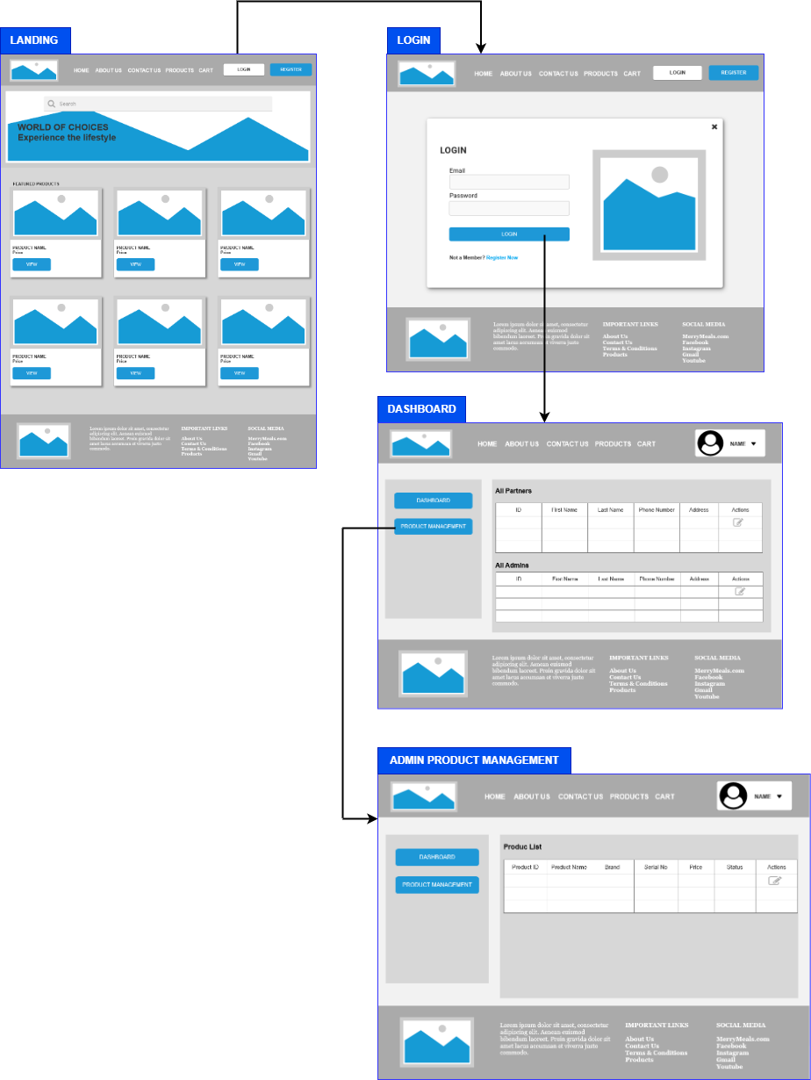

# User

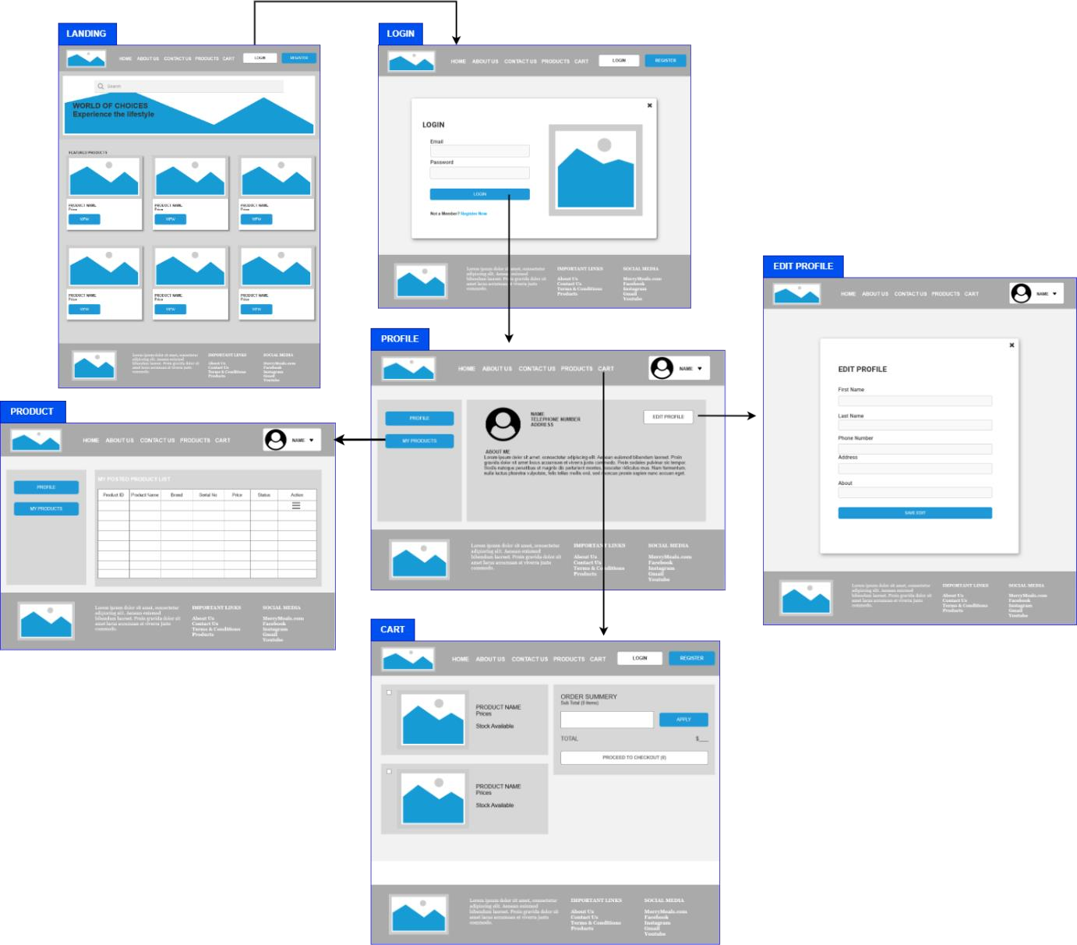

* + 1. **Wireframes**

# Landing Page

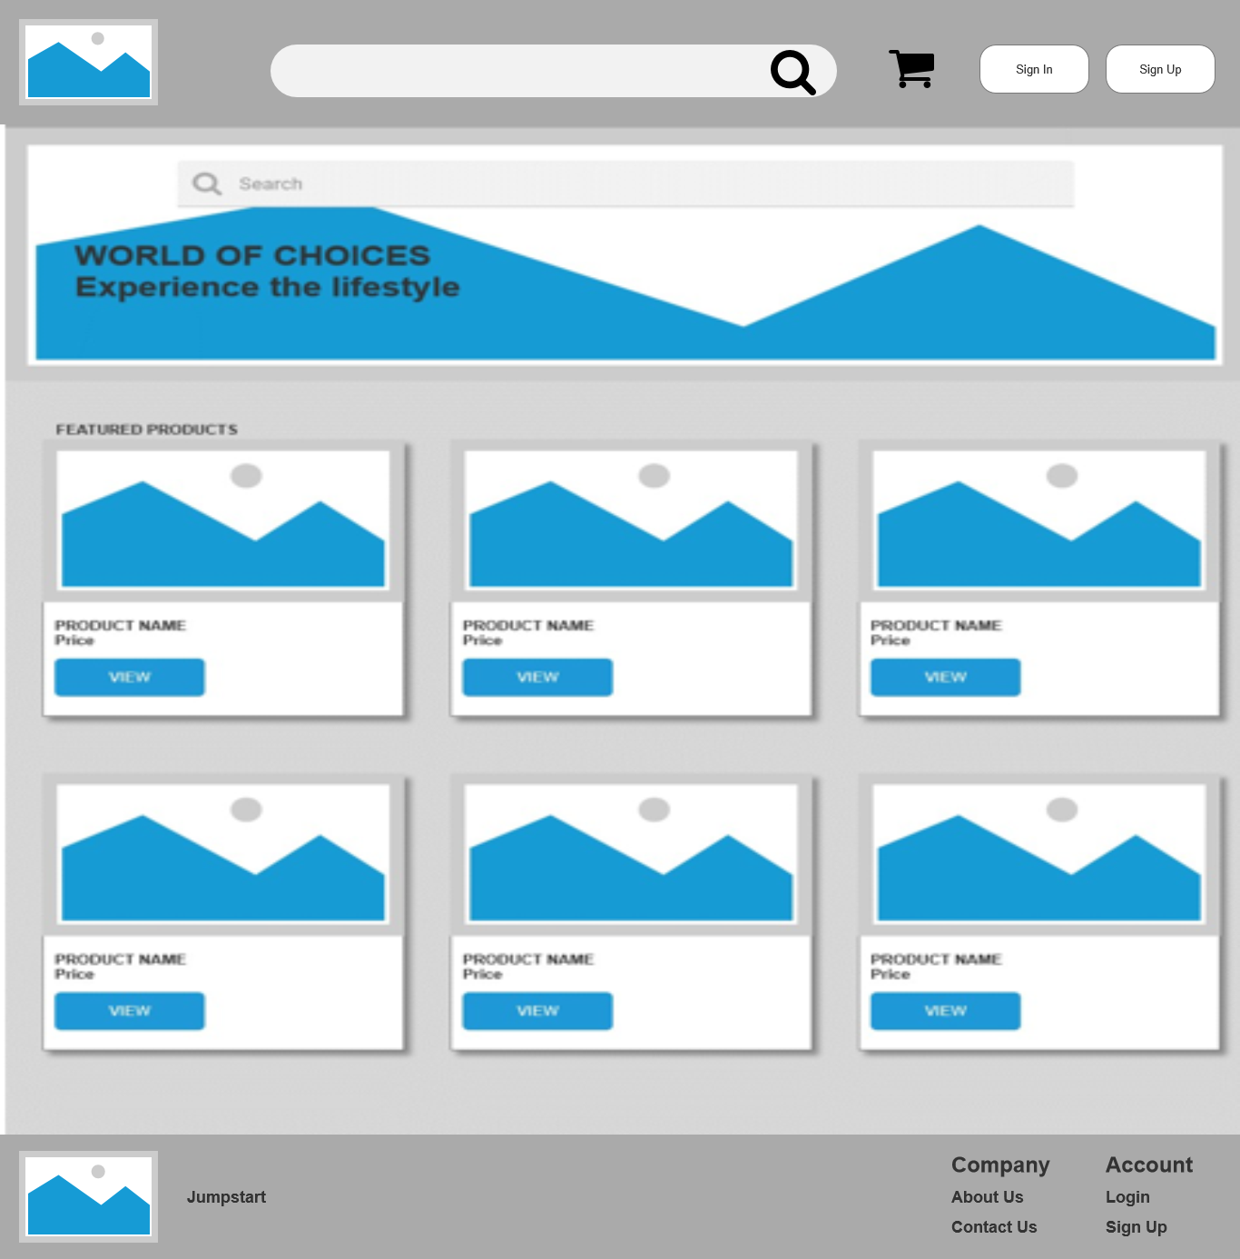

**Login**

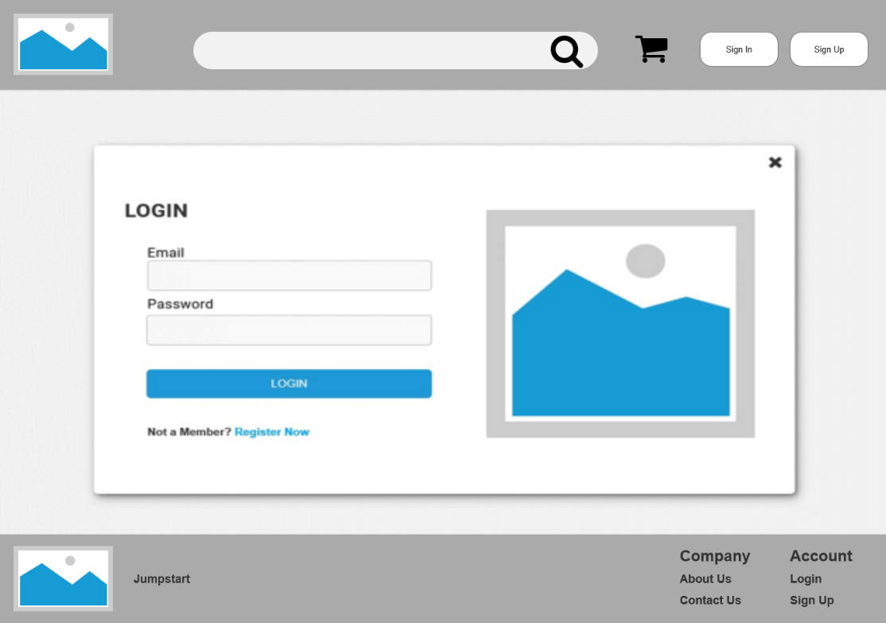

# Registration Thank You

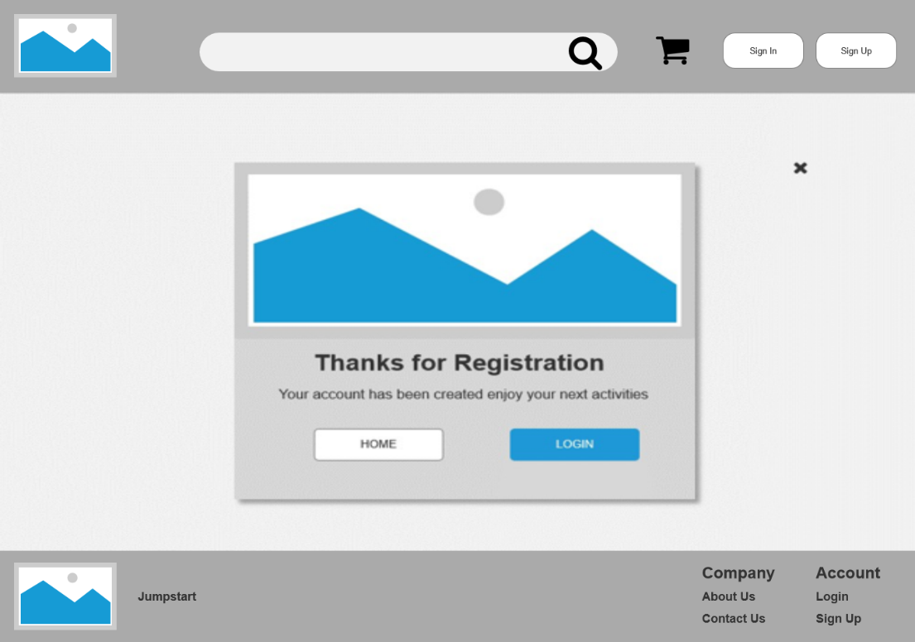

**Registration**

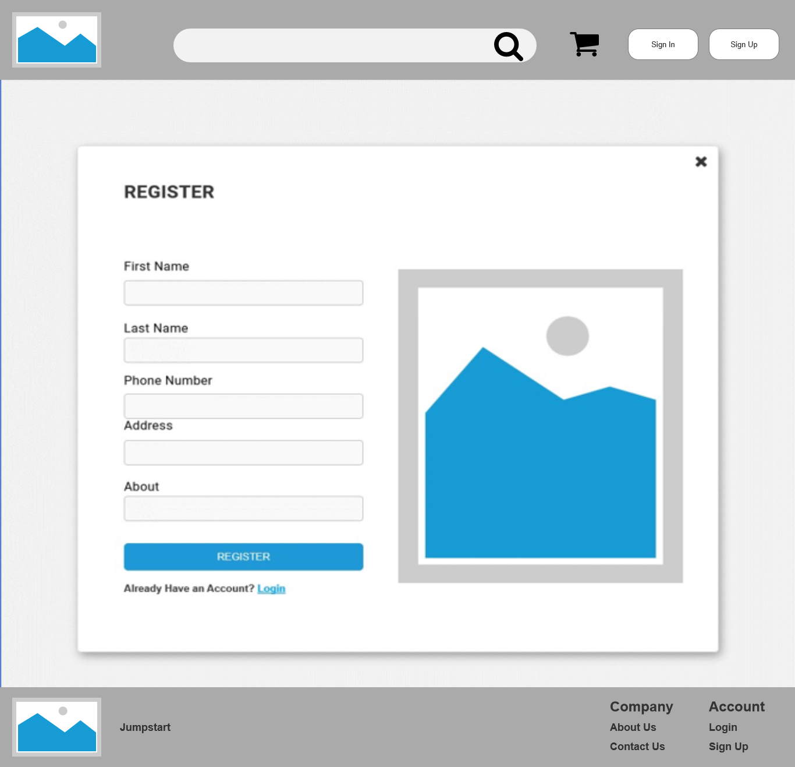

# About Us

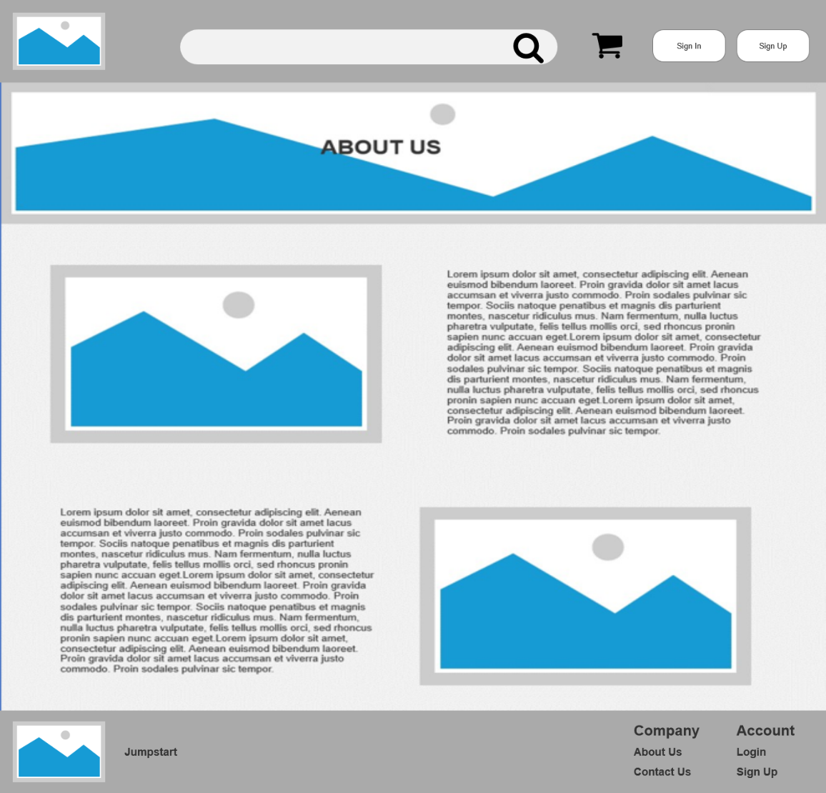

**Contact Us**

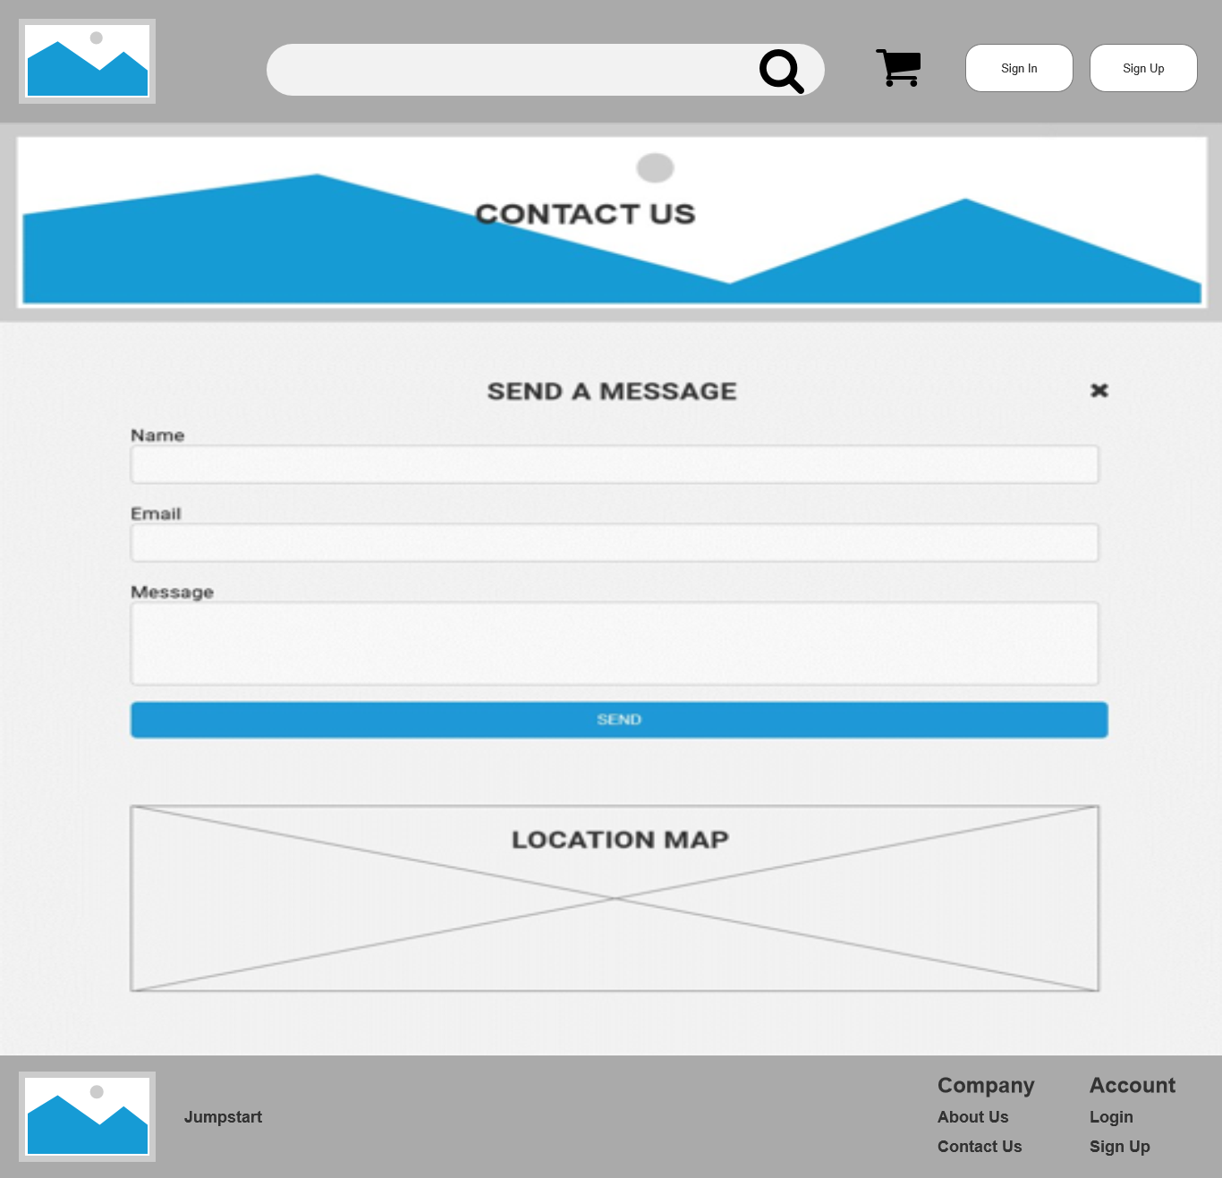

# All products view page

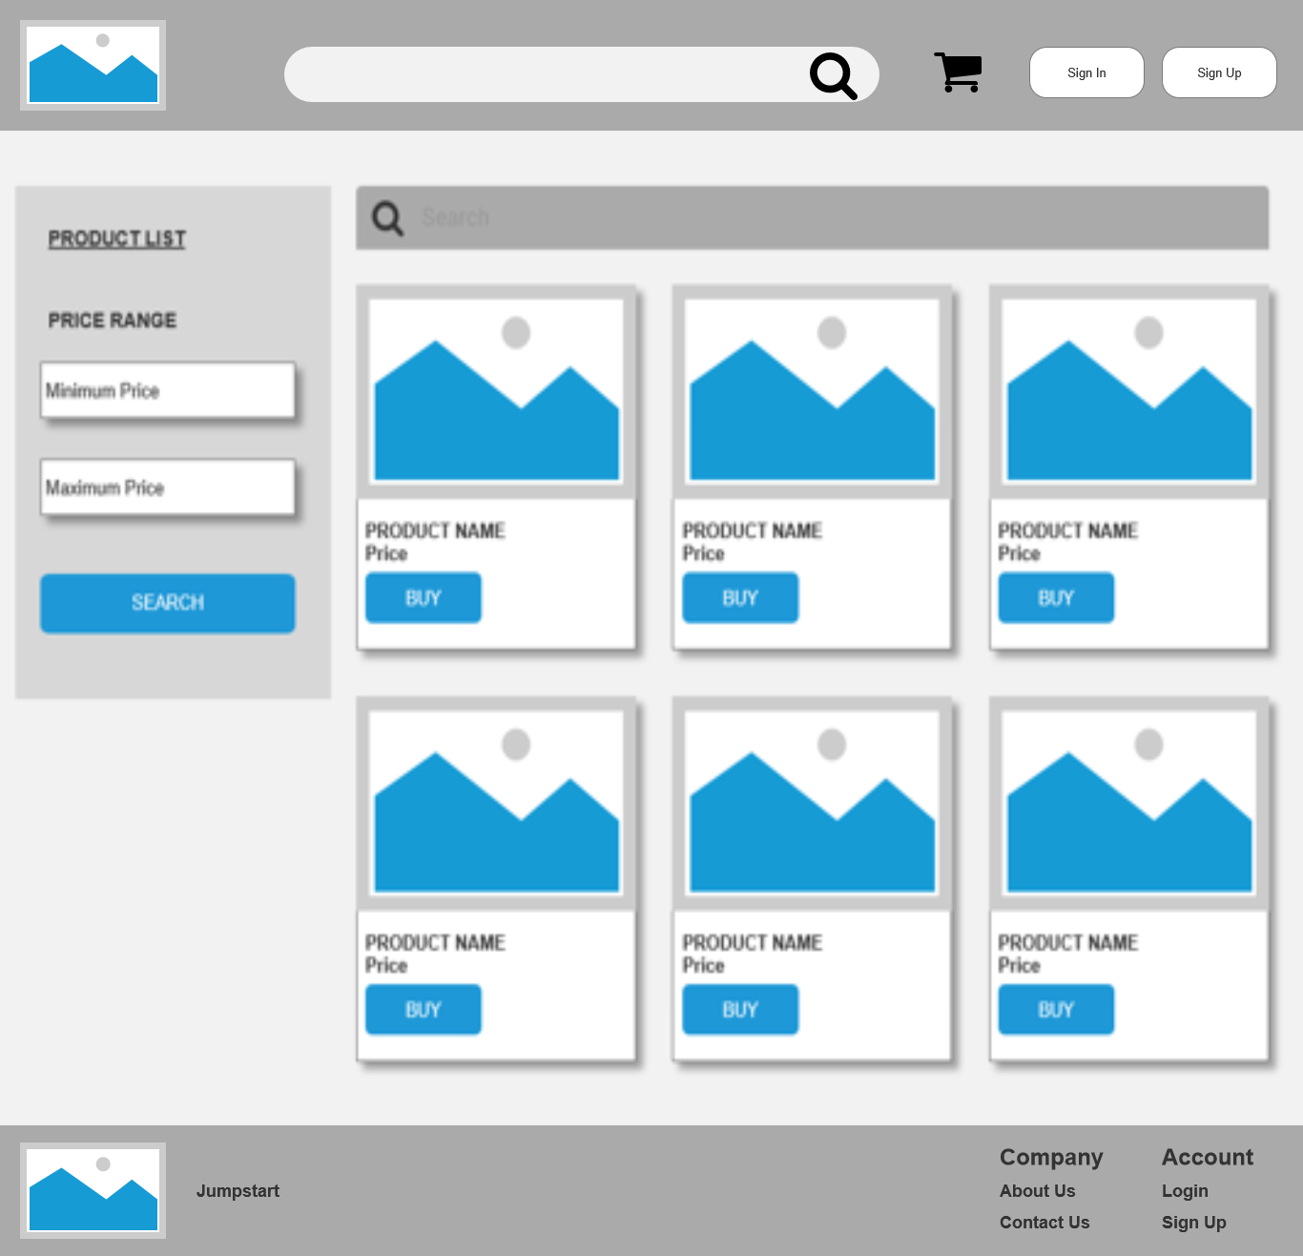

**View Product**

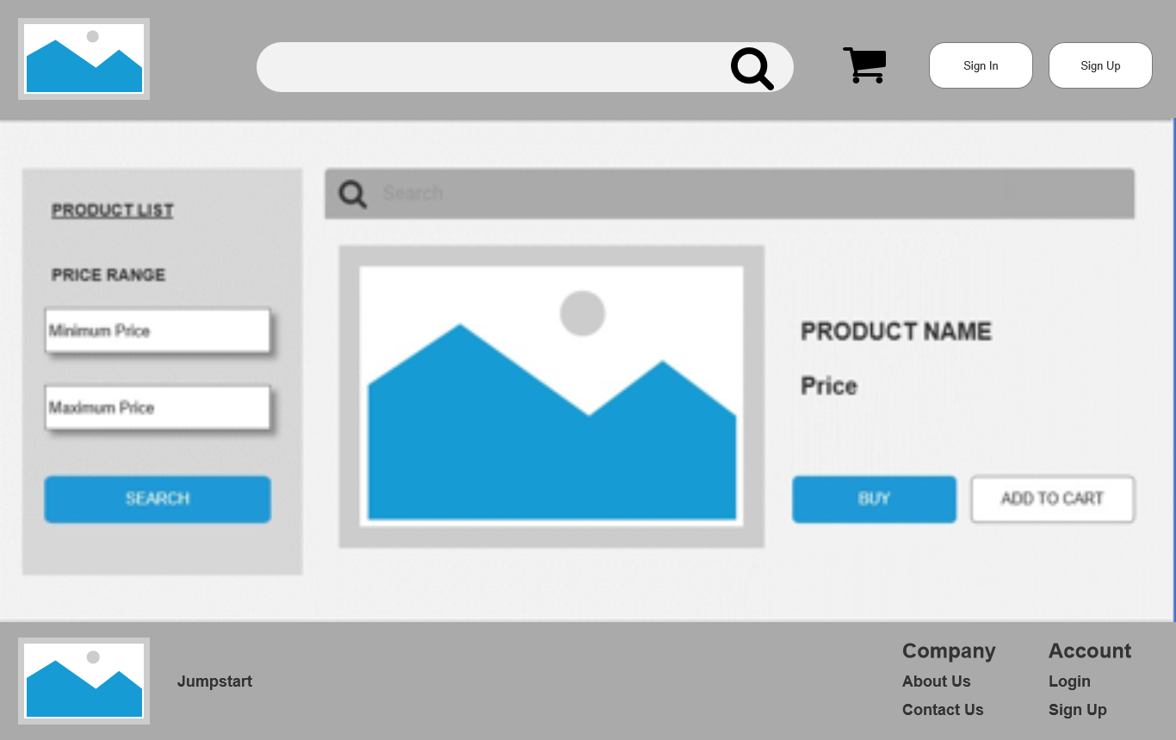

# Profile Page

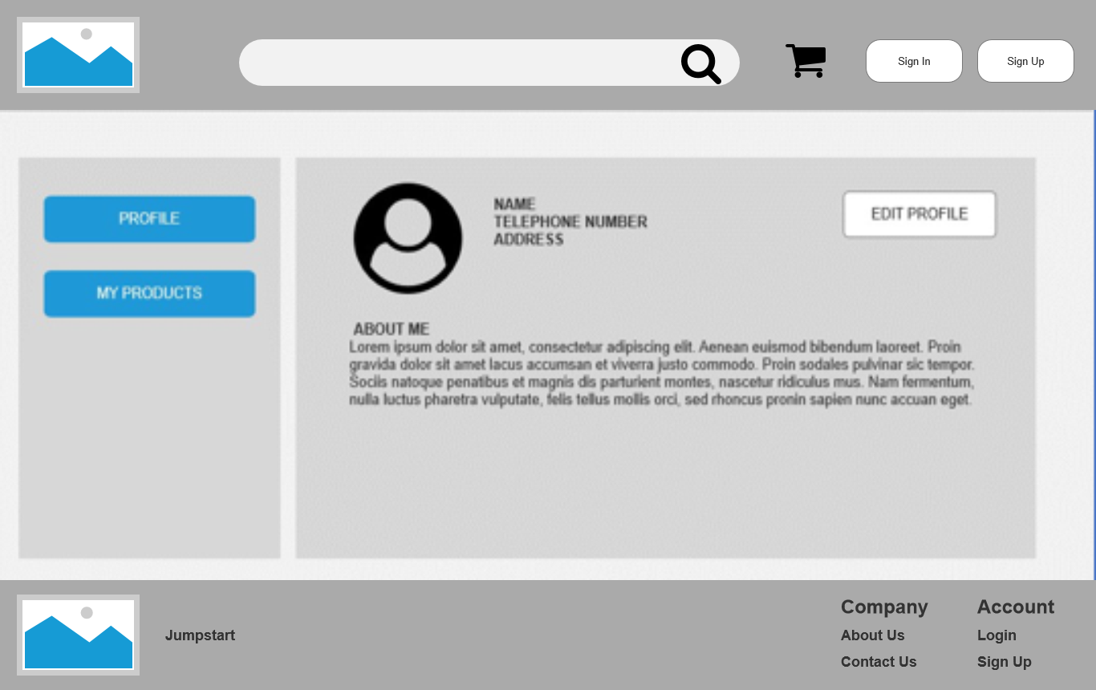

**Edit Profile**

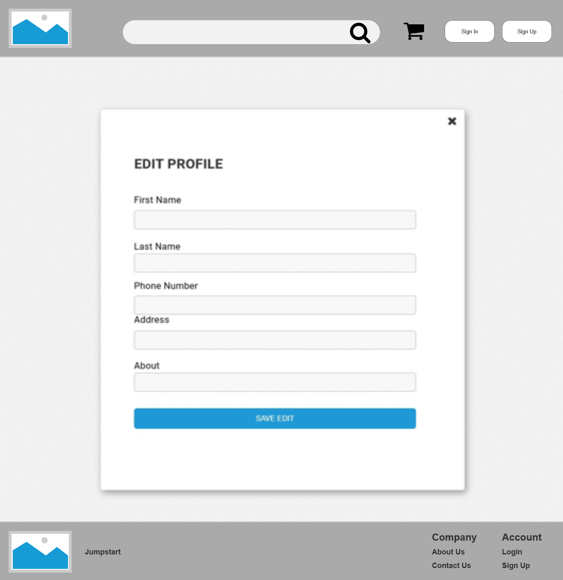

# Post Product

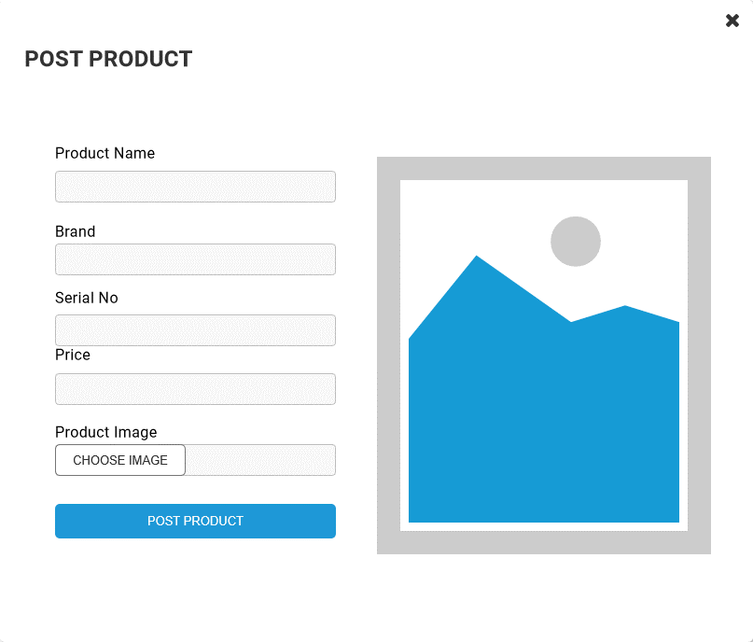

**Edit Posted Products**

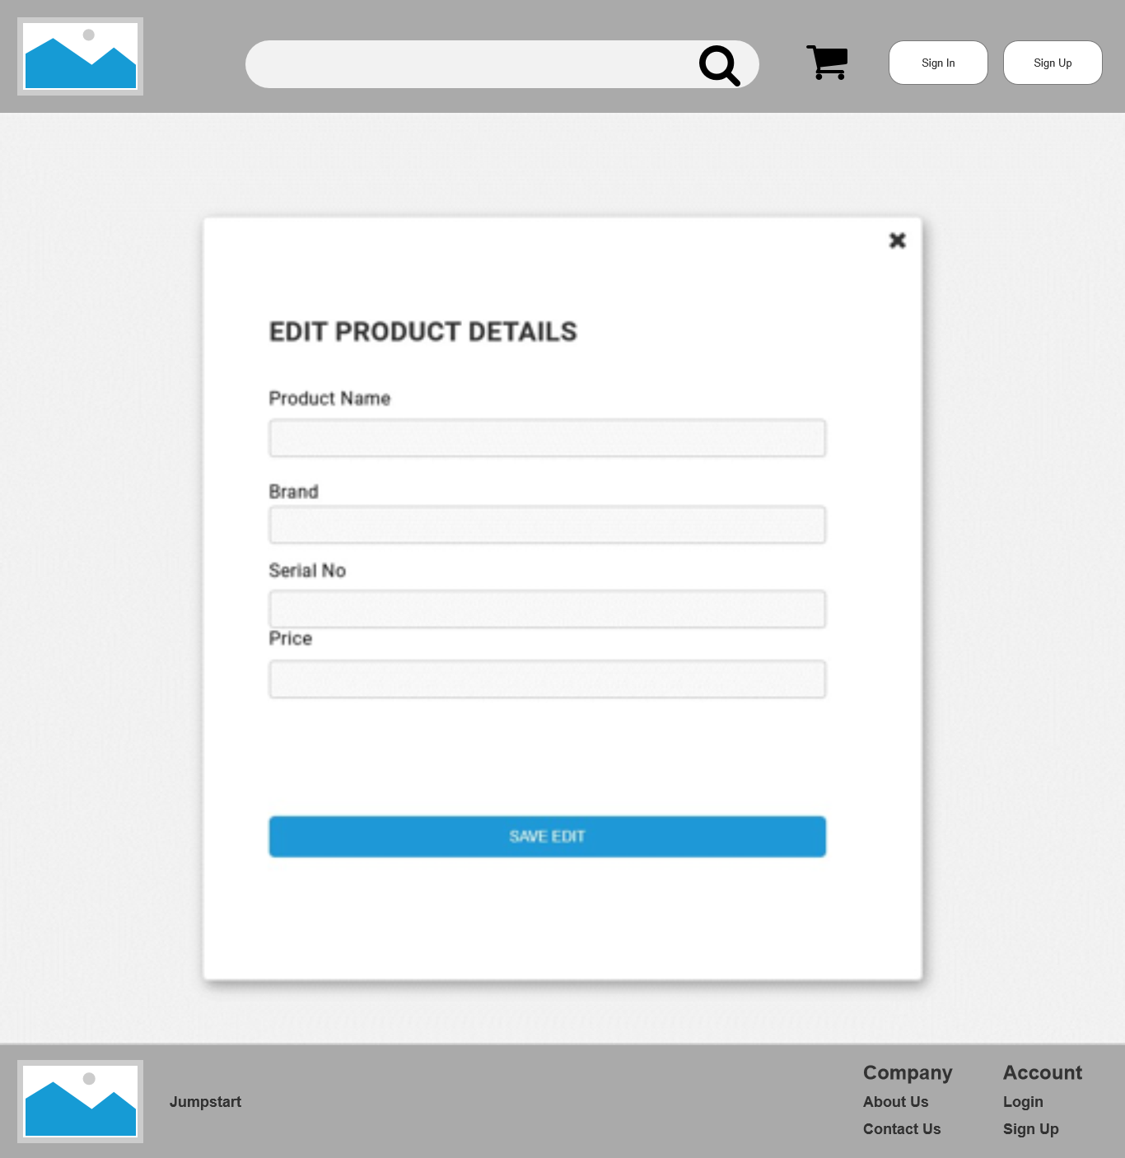

# Posted Product List

# E:\lithan\Module 12-CPL\product list.png

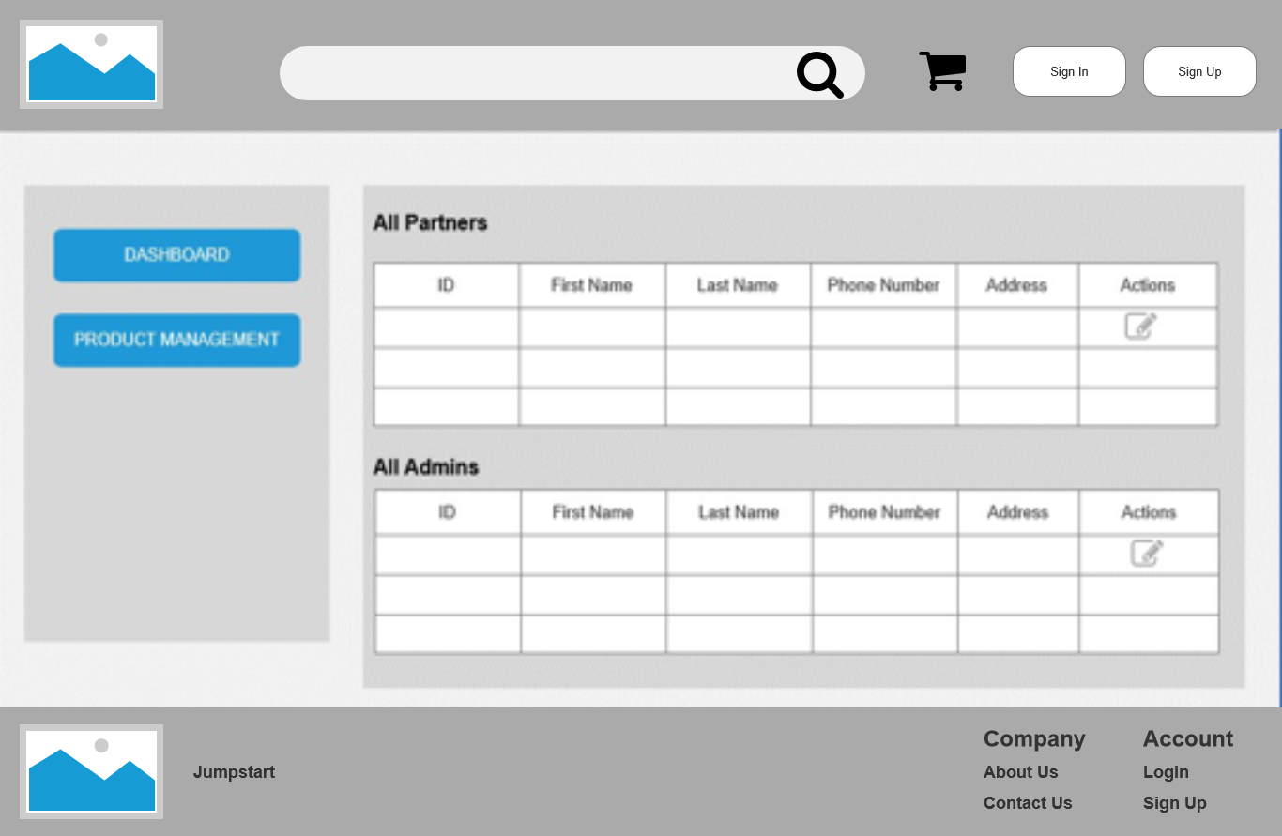**Admin Dashboard**

# E:\lithan\Module 12-CPL\admin product management.pngAdmin Product Management

**Cart – Before Add Items**

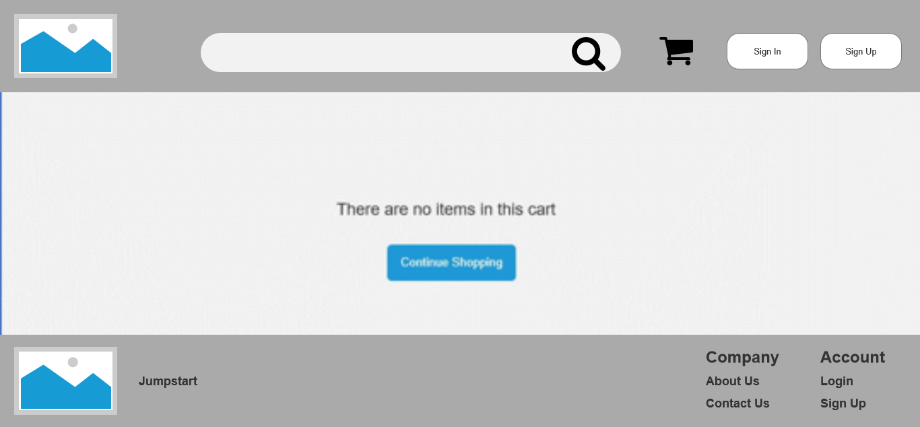

# Cart – After Add Items

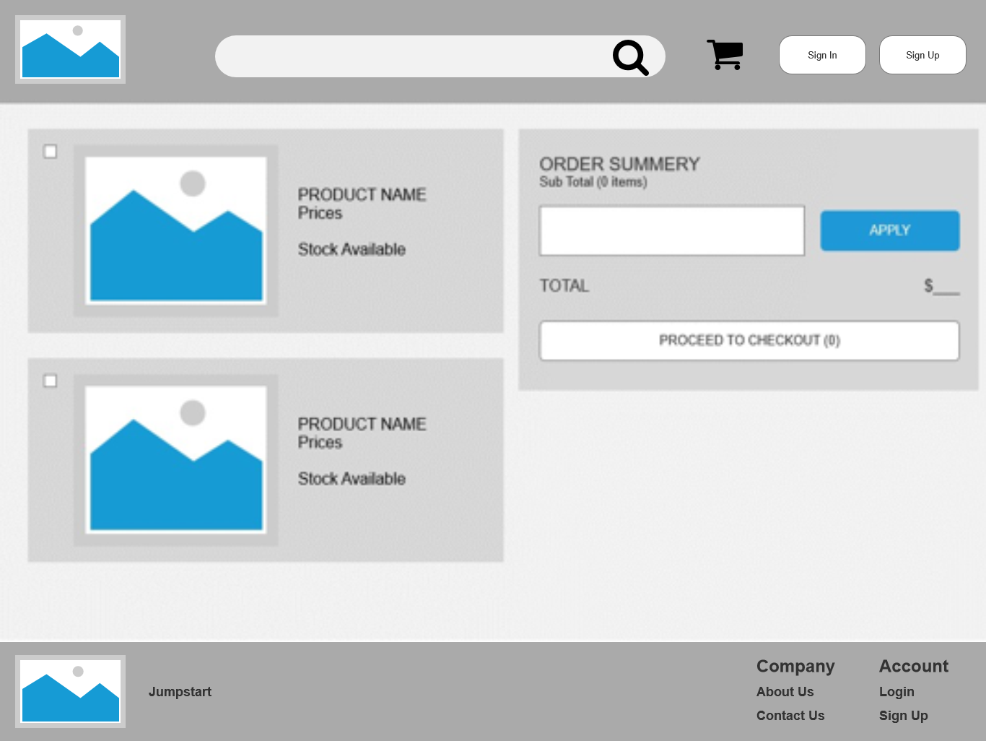

* + 1. **Prototypes**

Landing Page



Contact Us

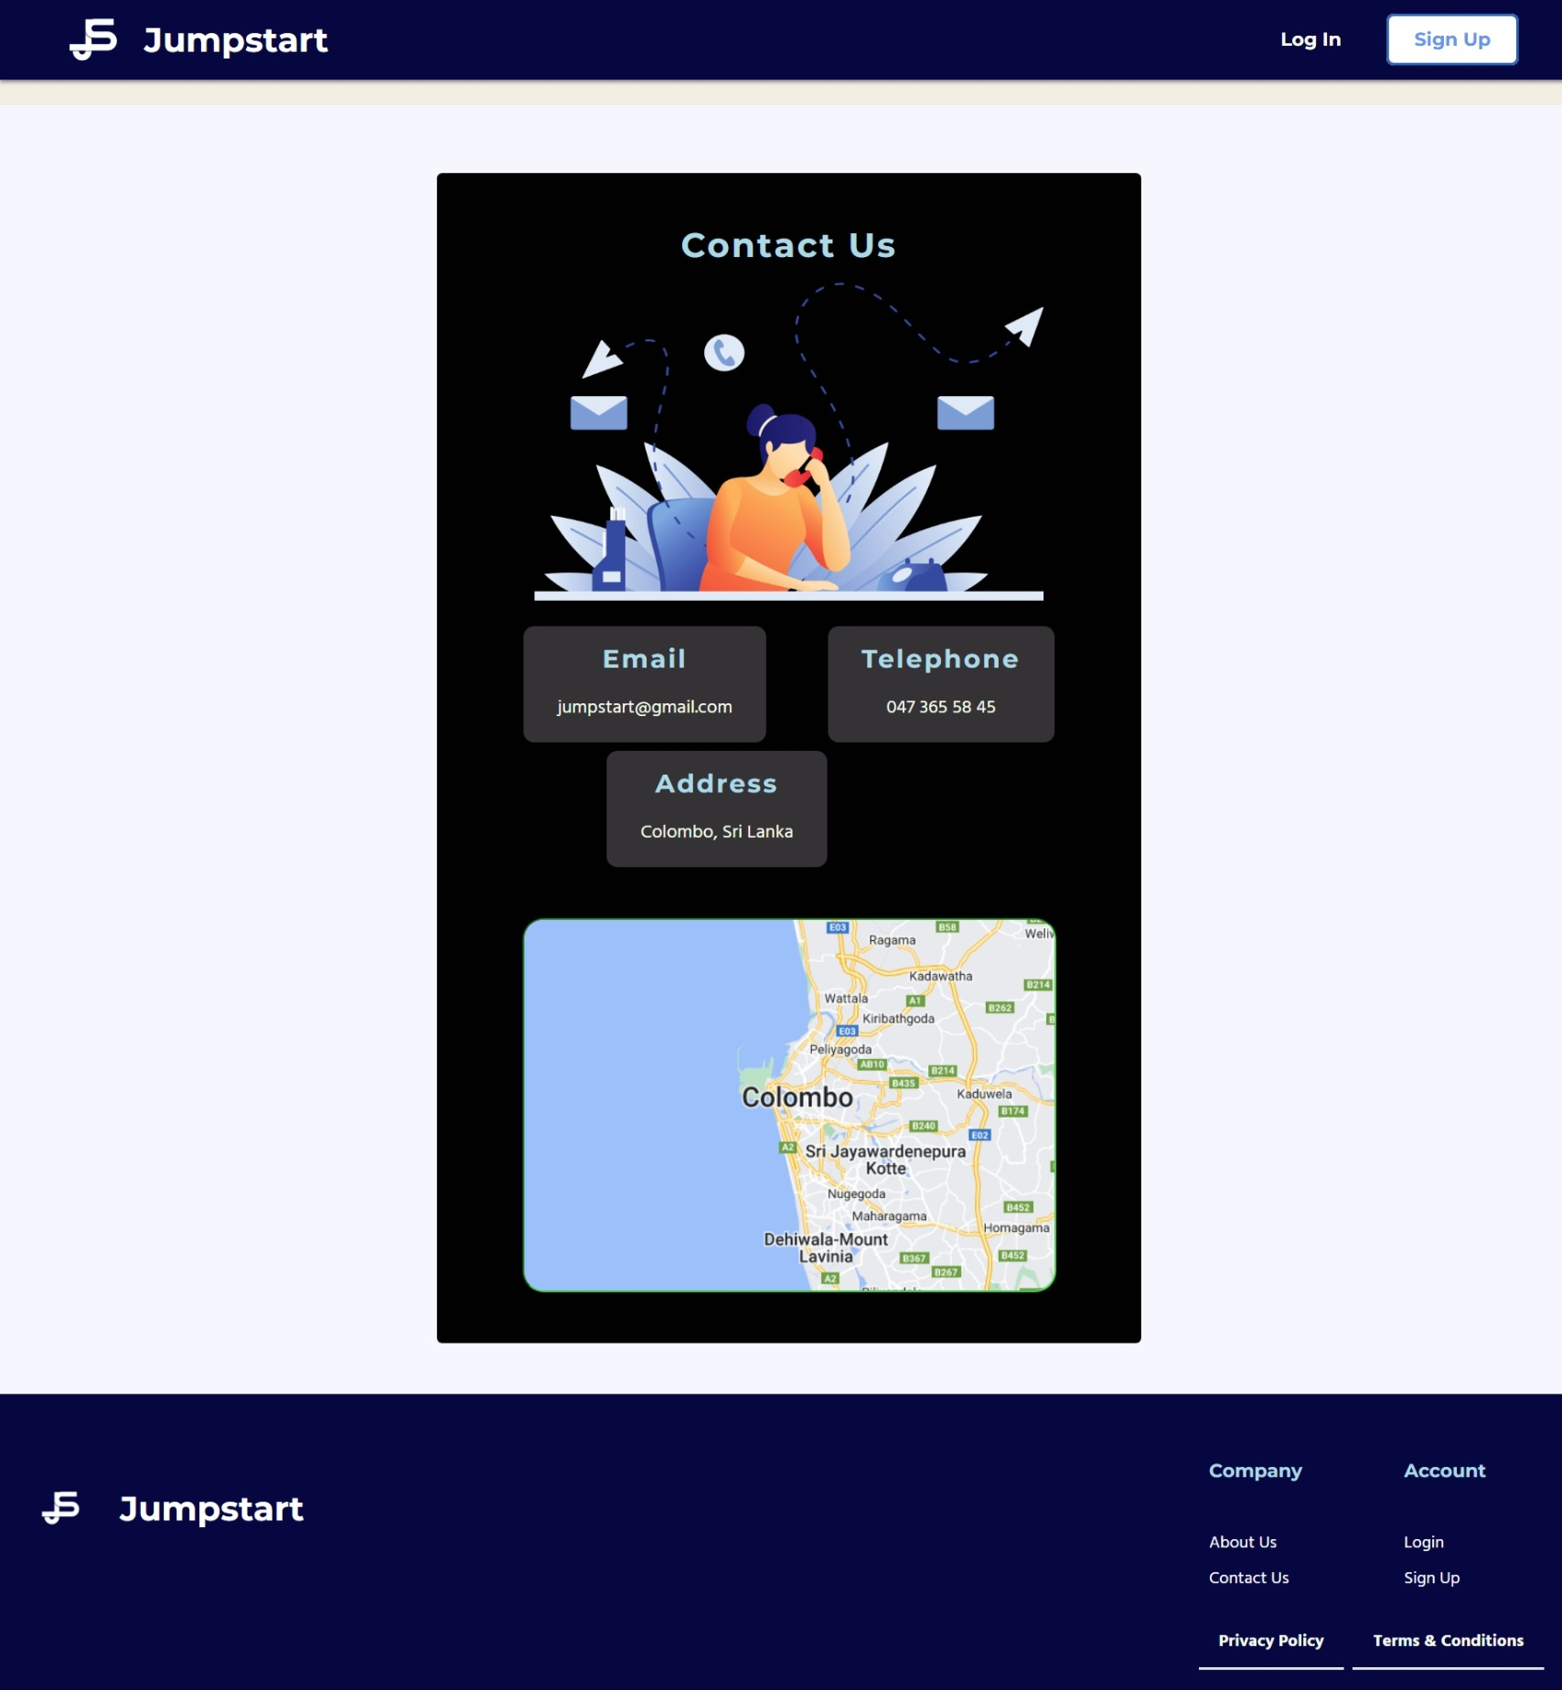

About Us

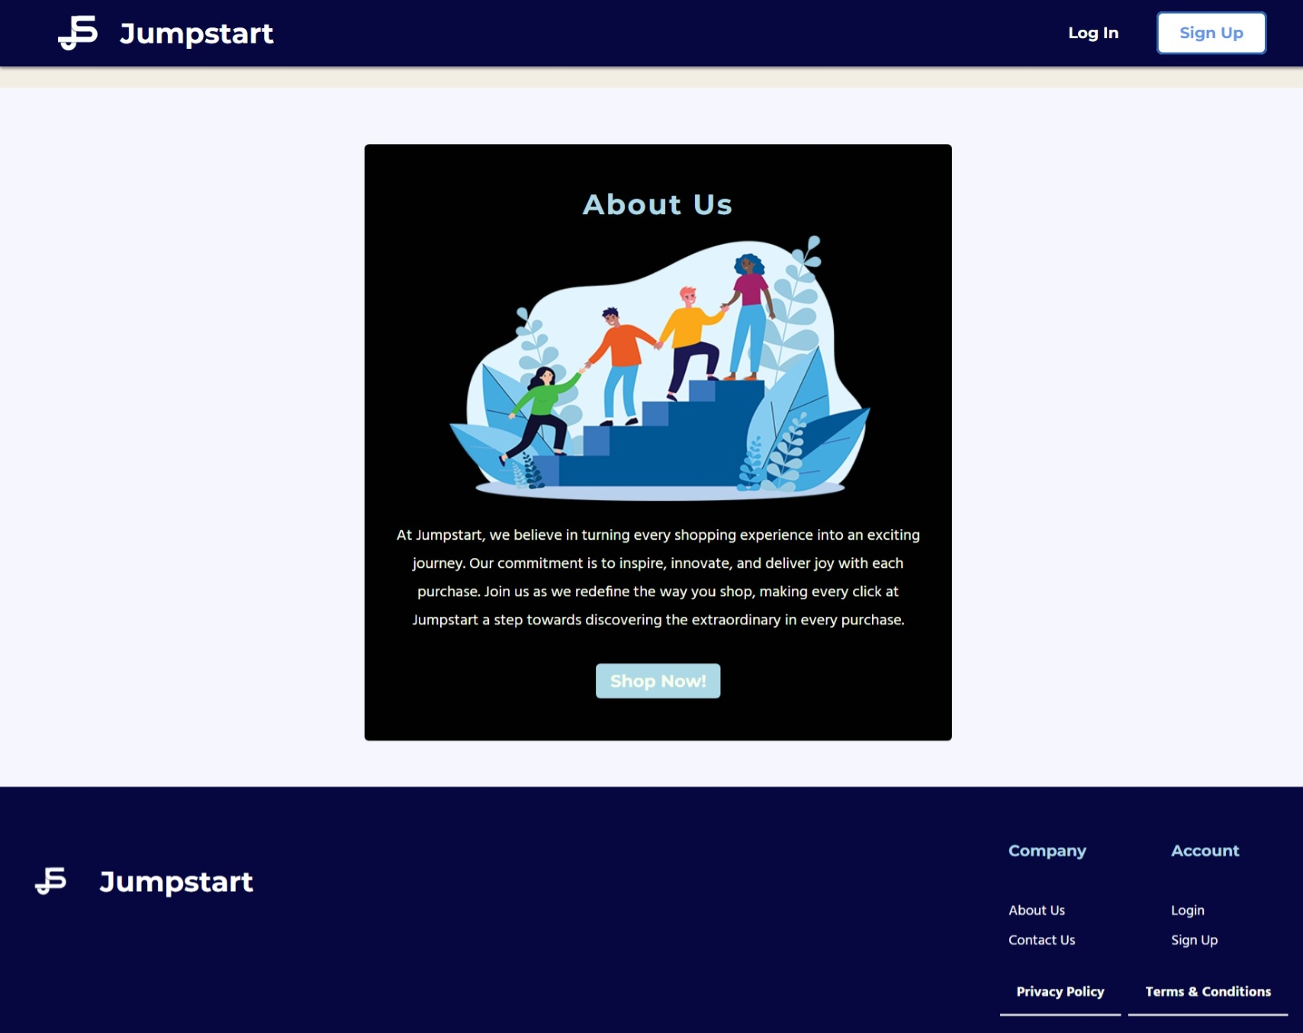

Login

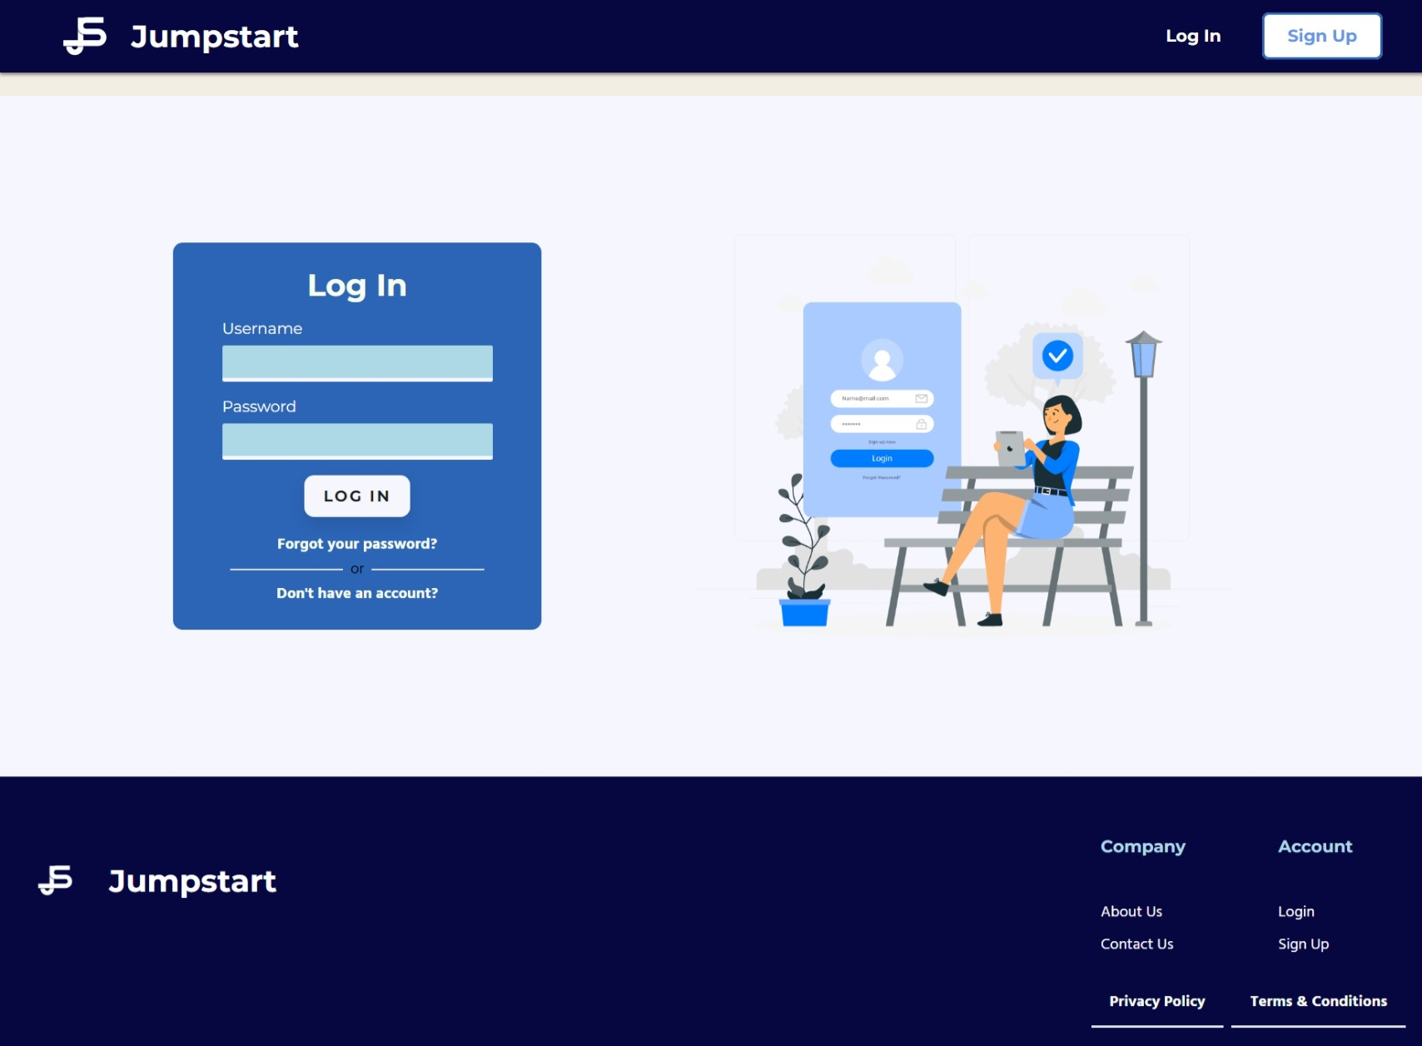

Registration

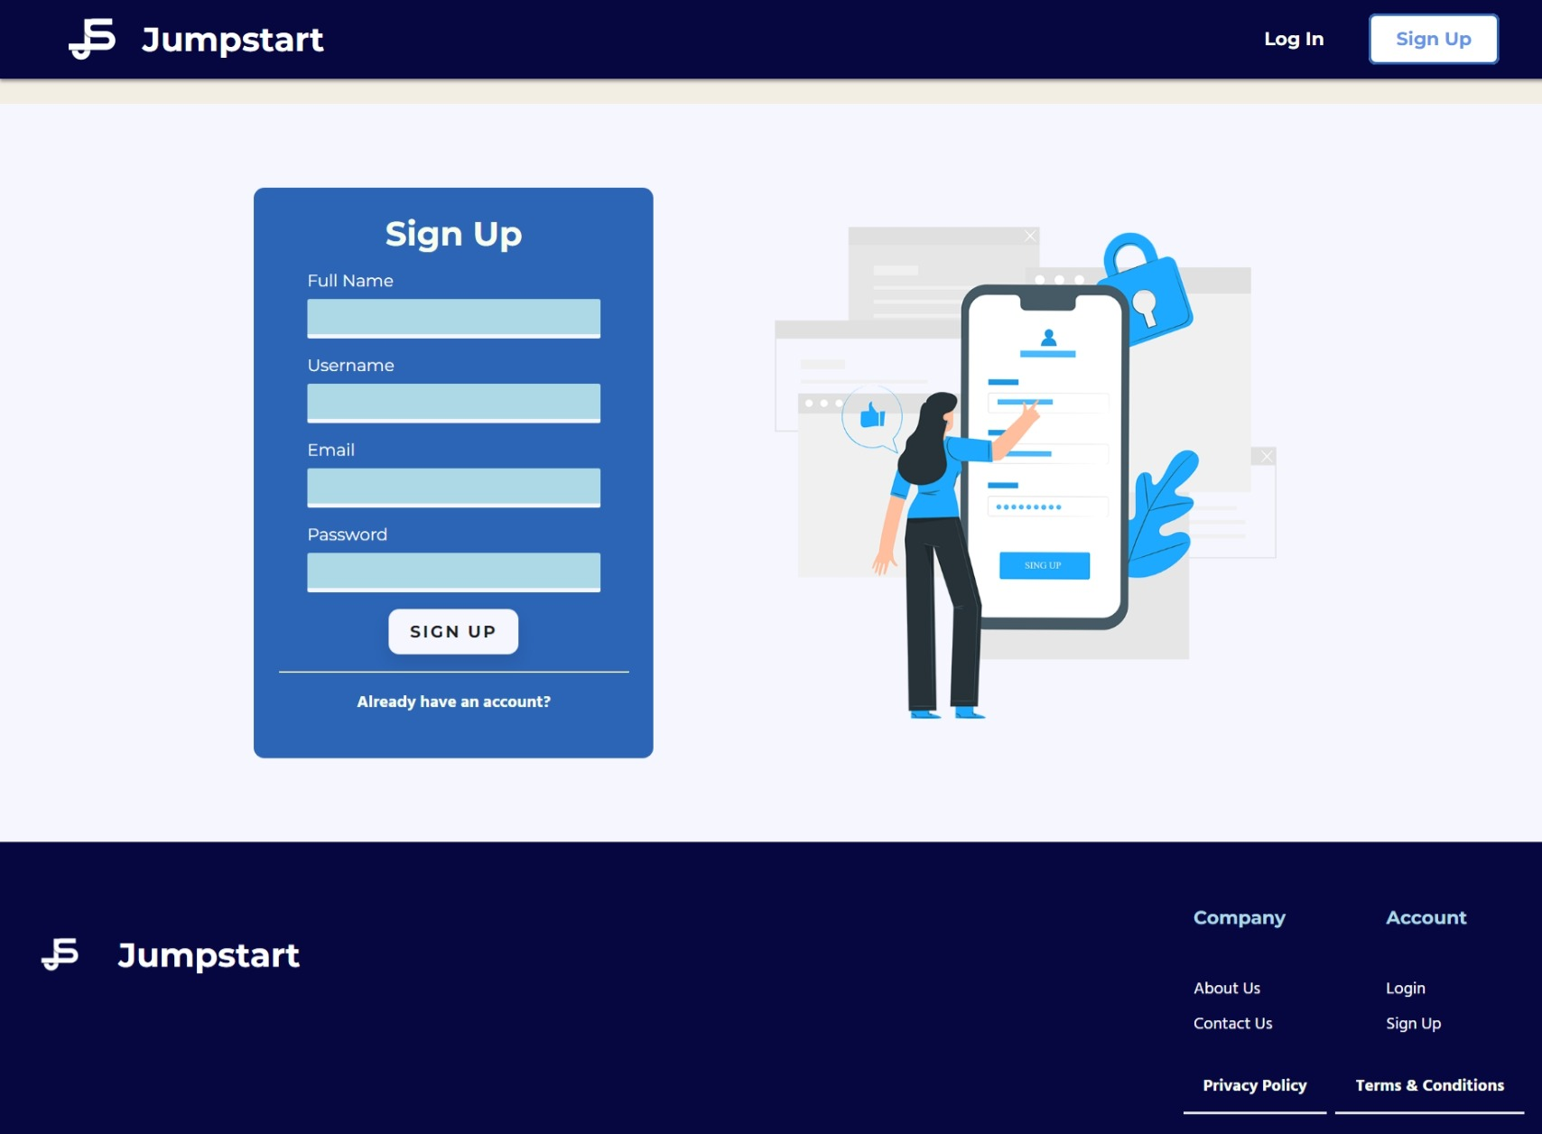

Registration OTP Verification

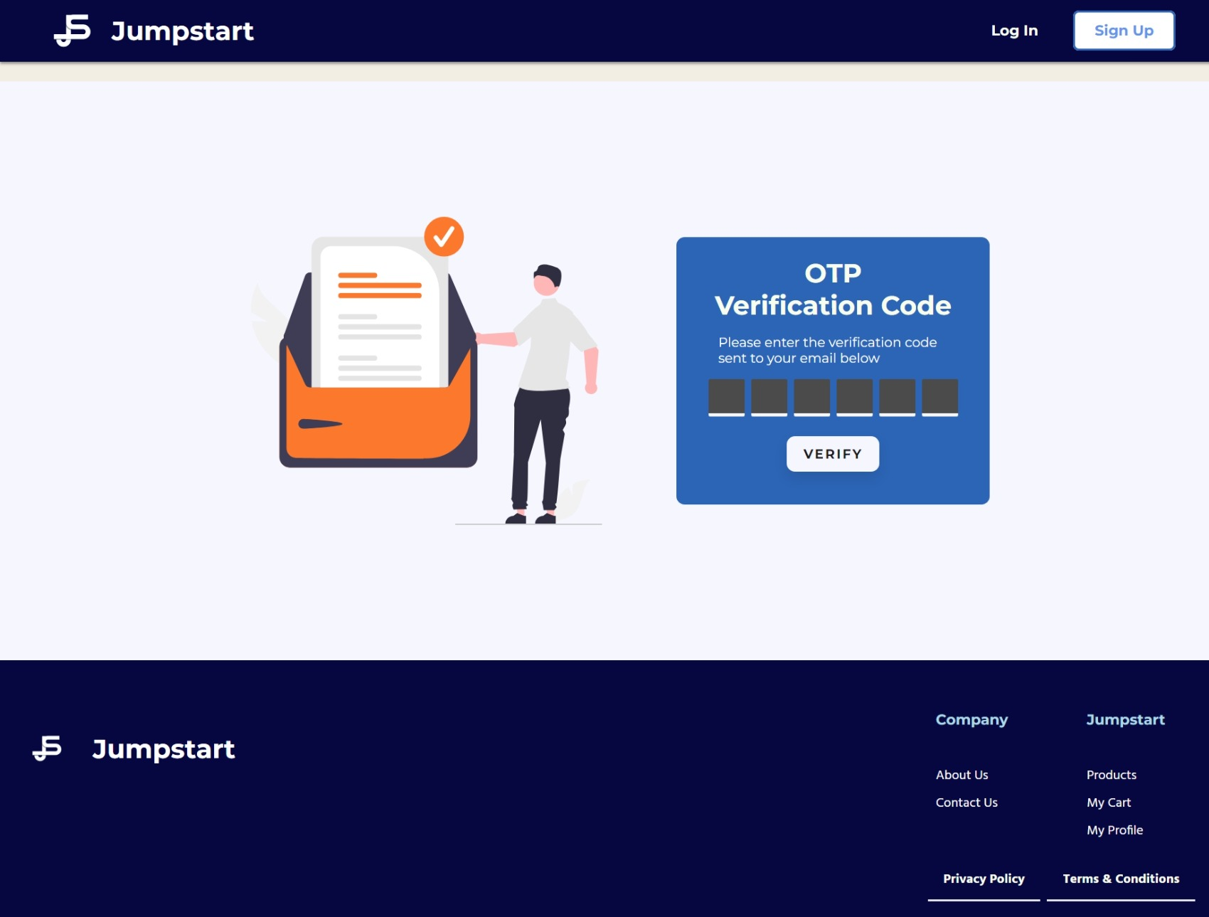

Registration Success

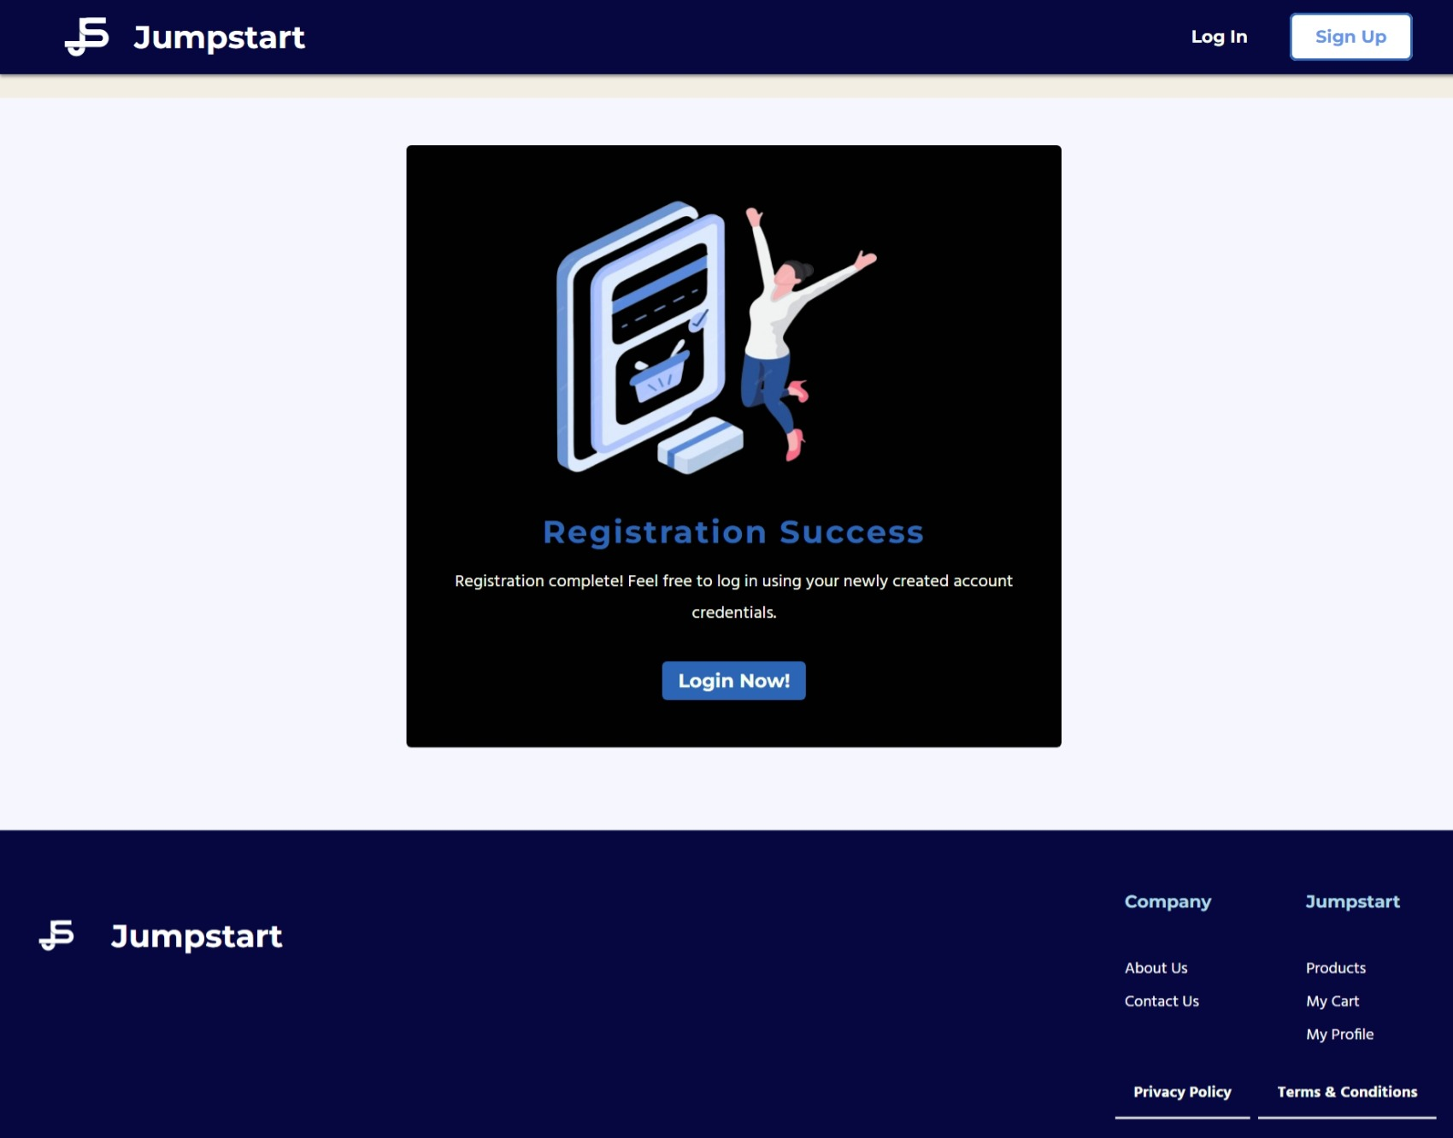

Forgot Password Reset Email

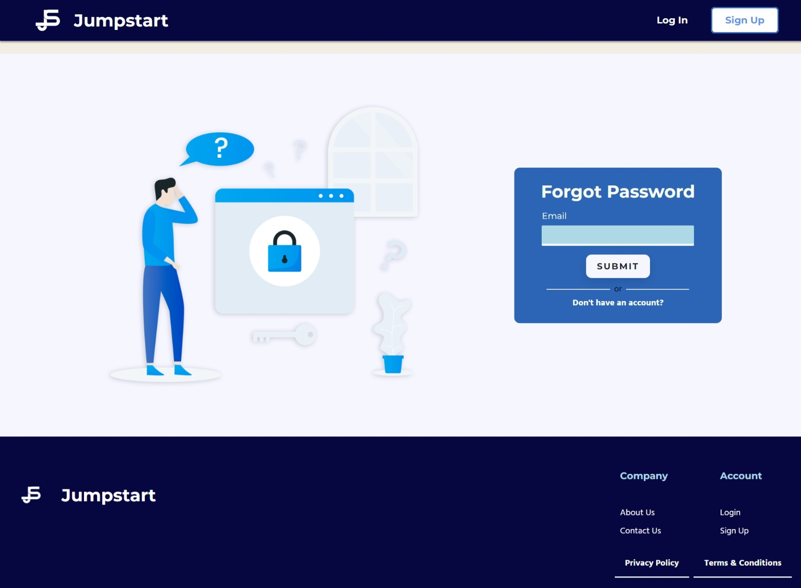

Reset Password

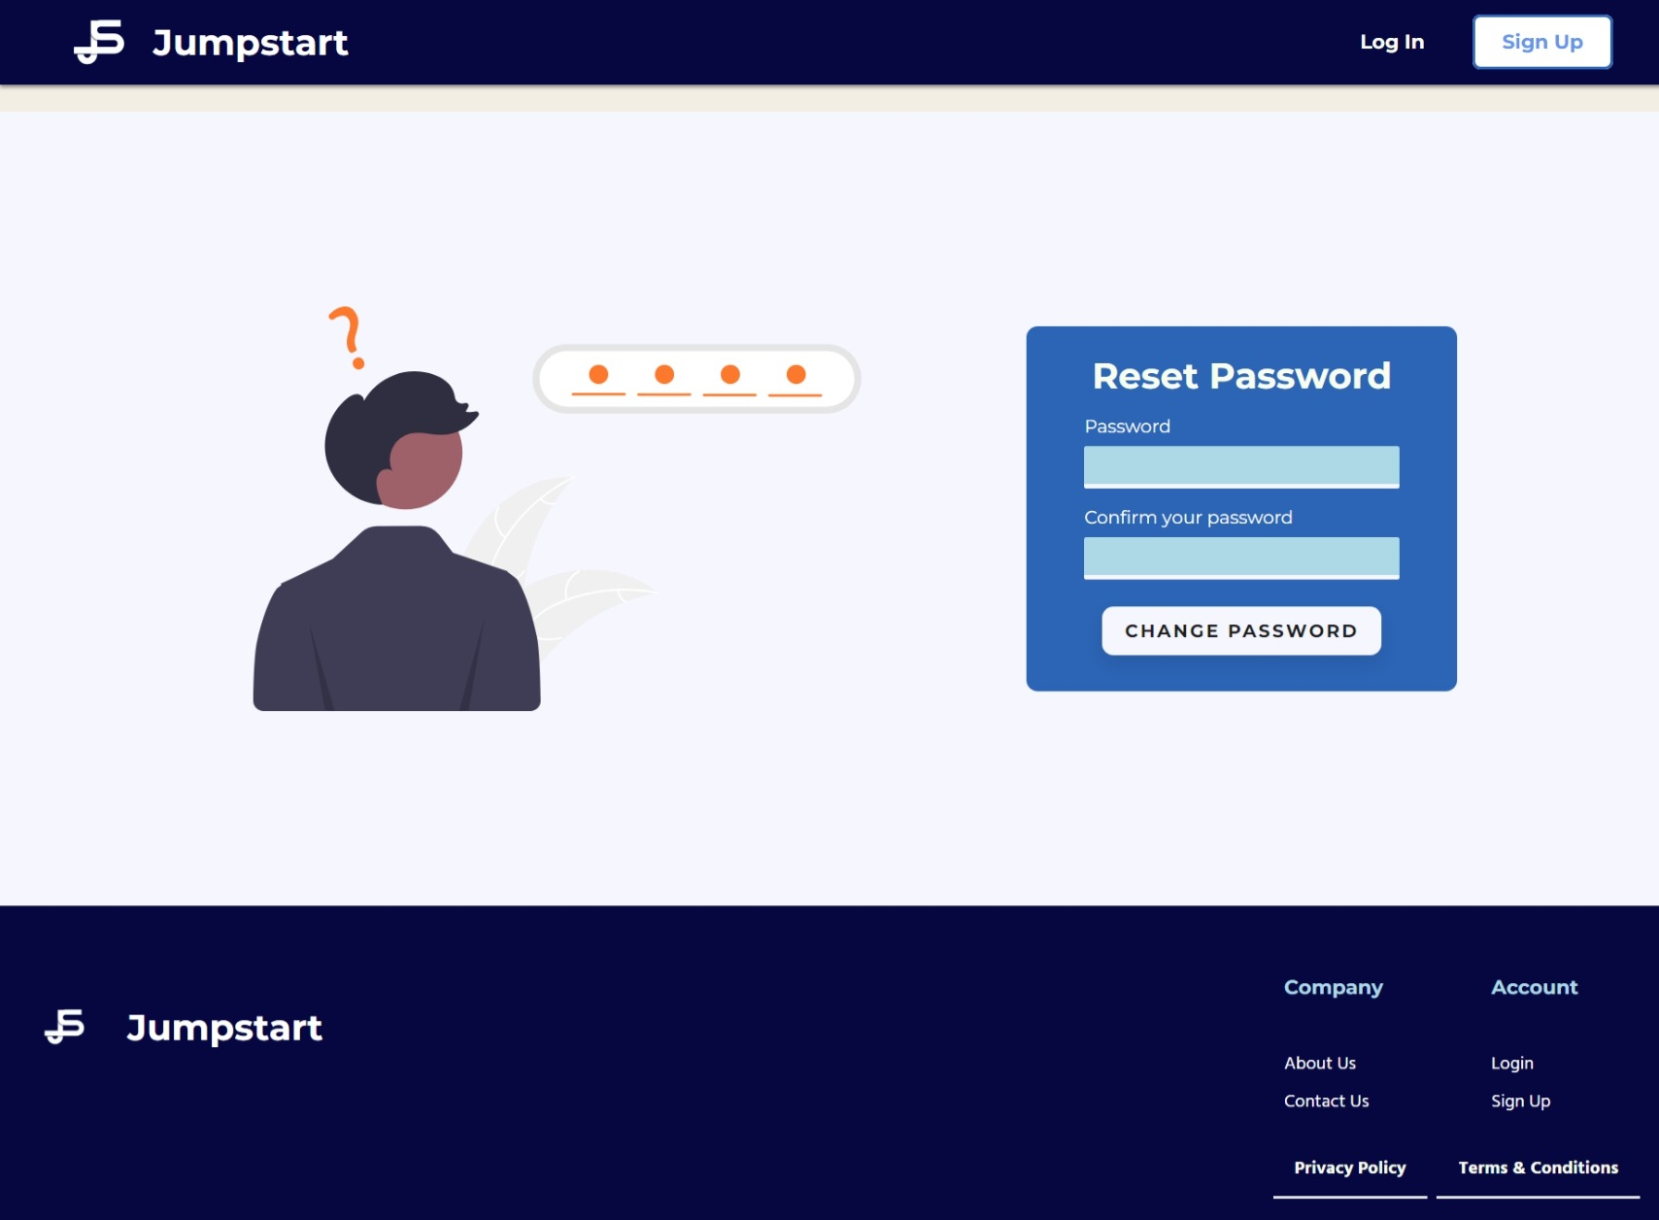

Changed Password Successfully

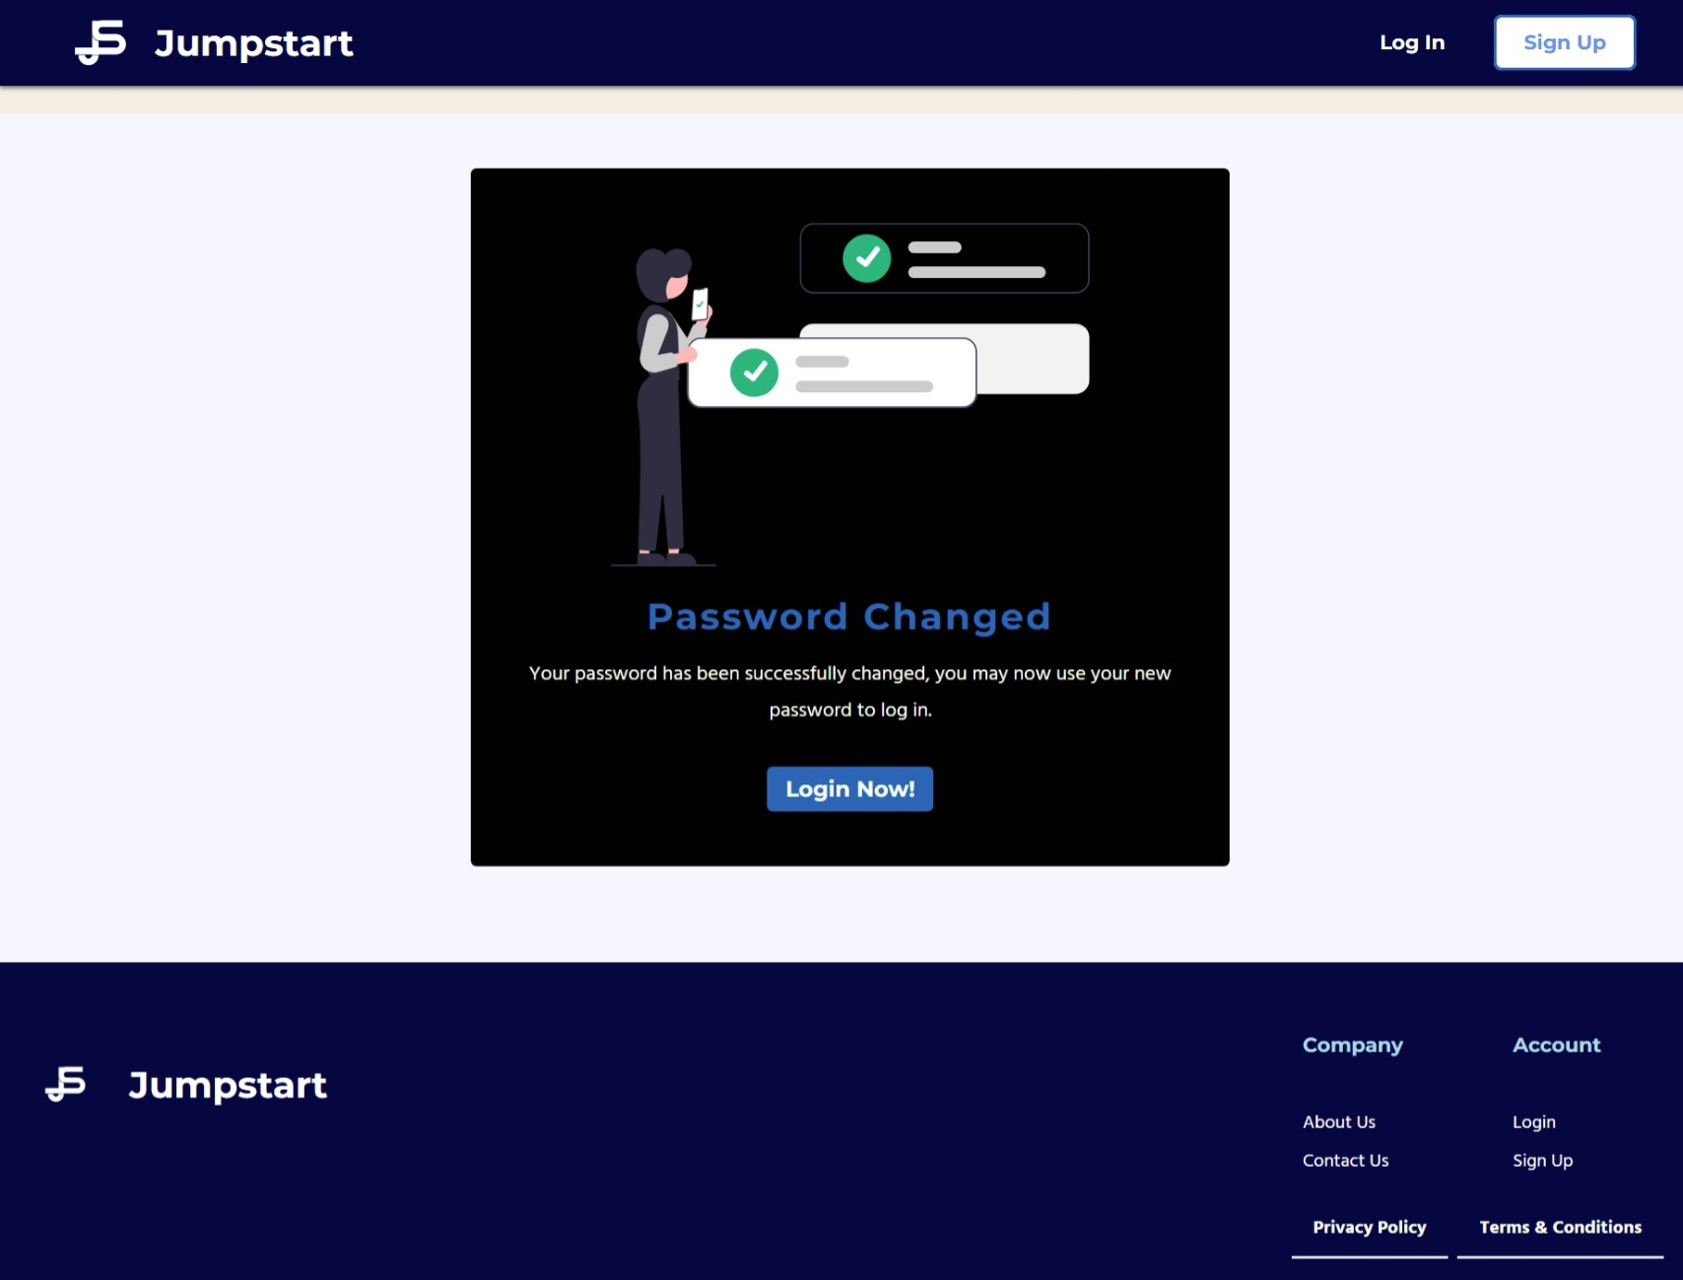

Admin Profile

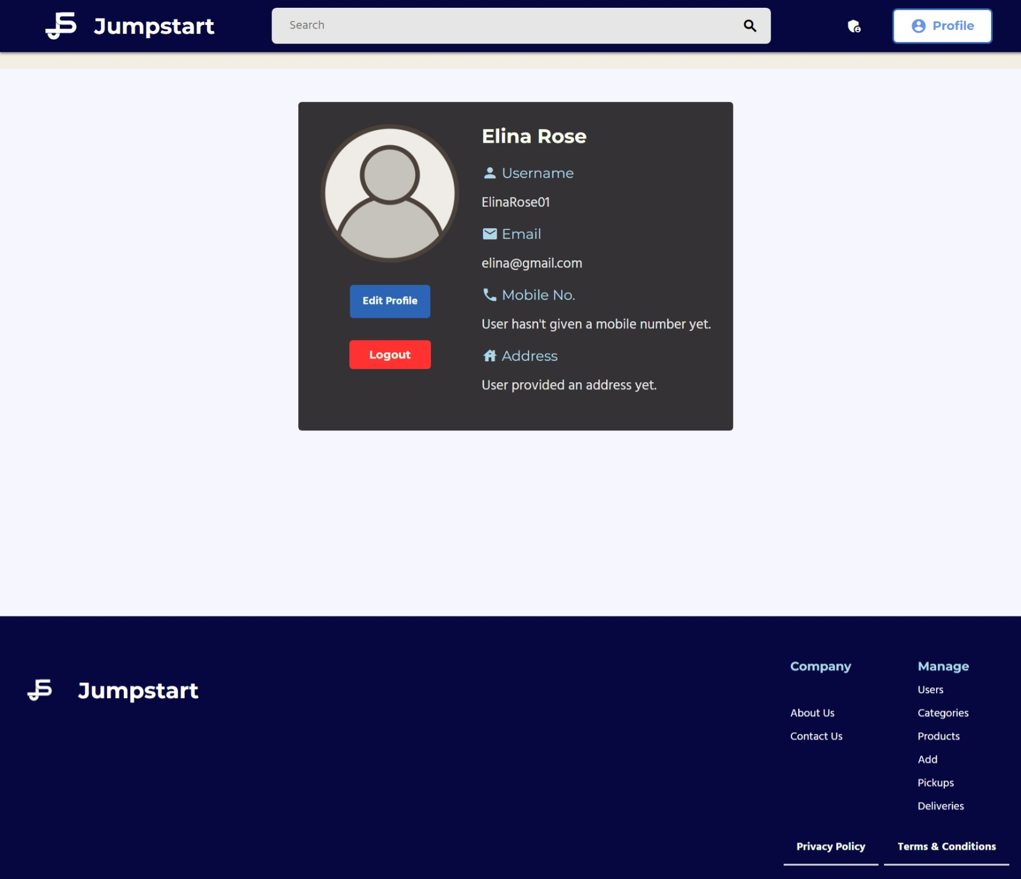

Admin User Management

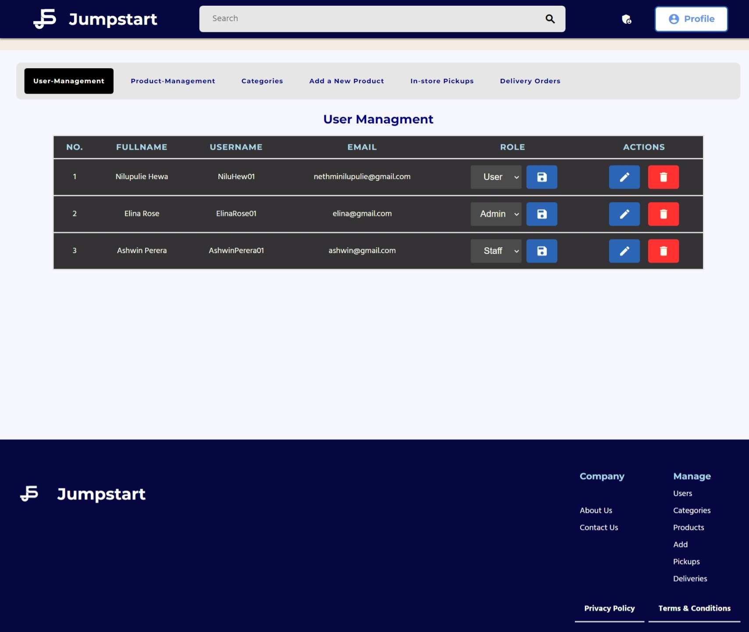

Admin Add Product

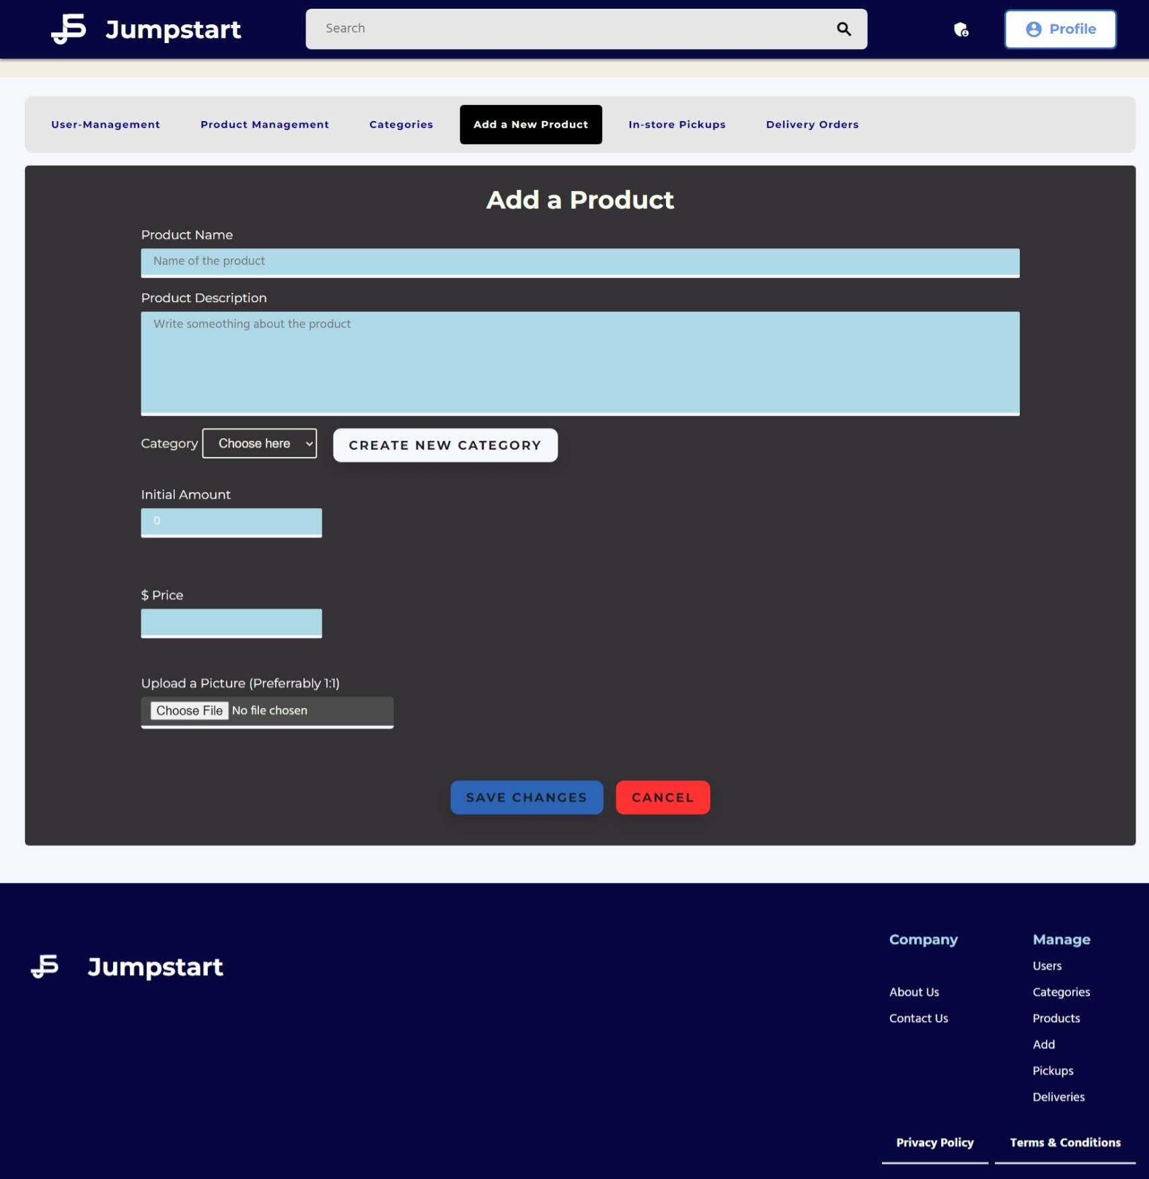

Admin Product Management

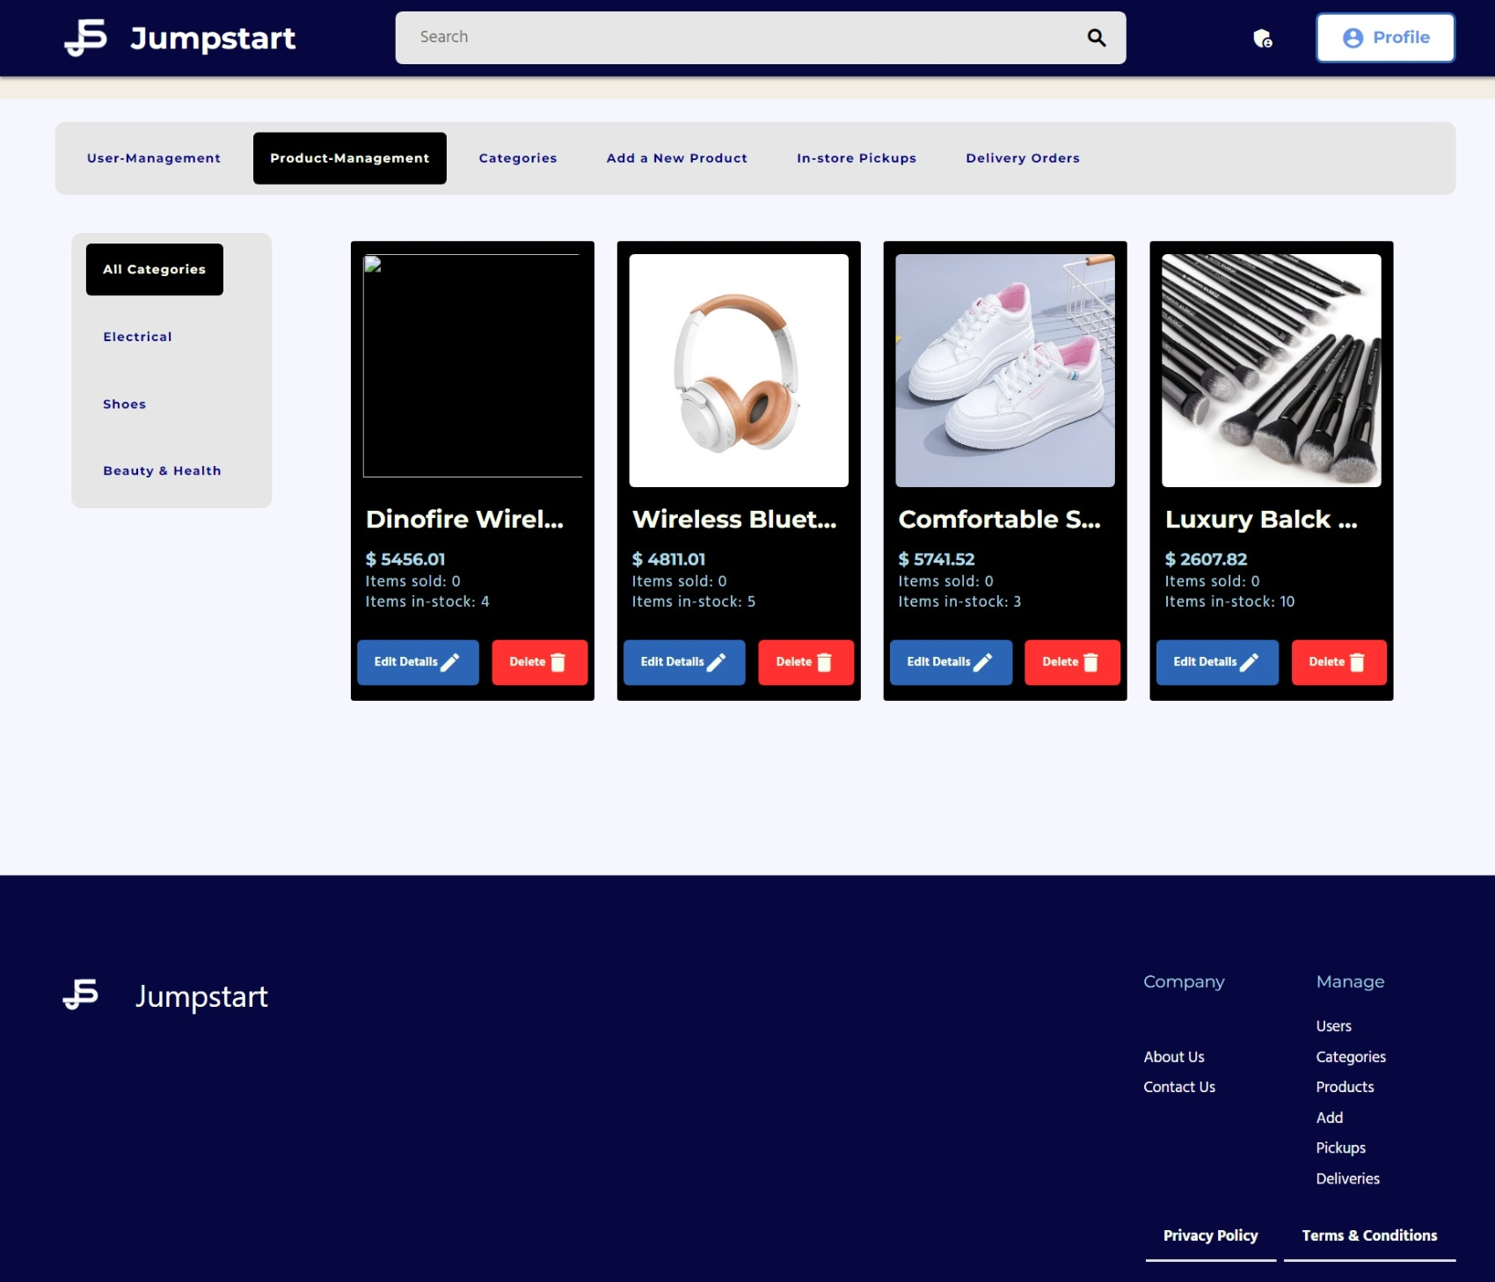

Category Management

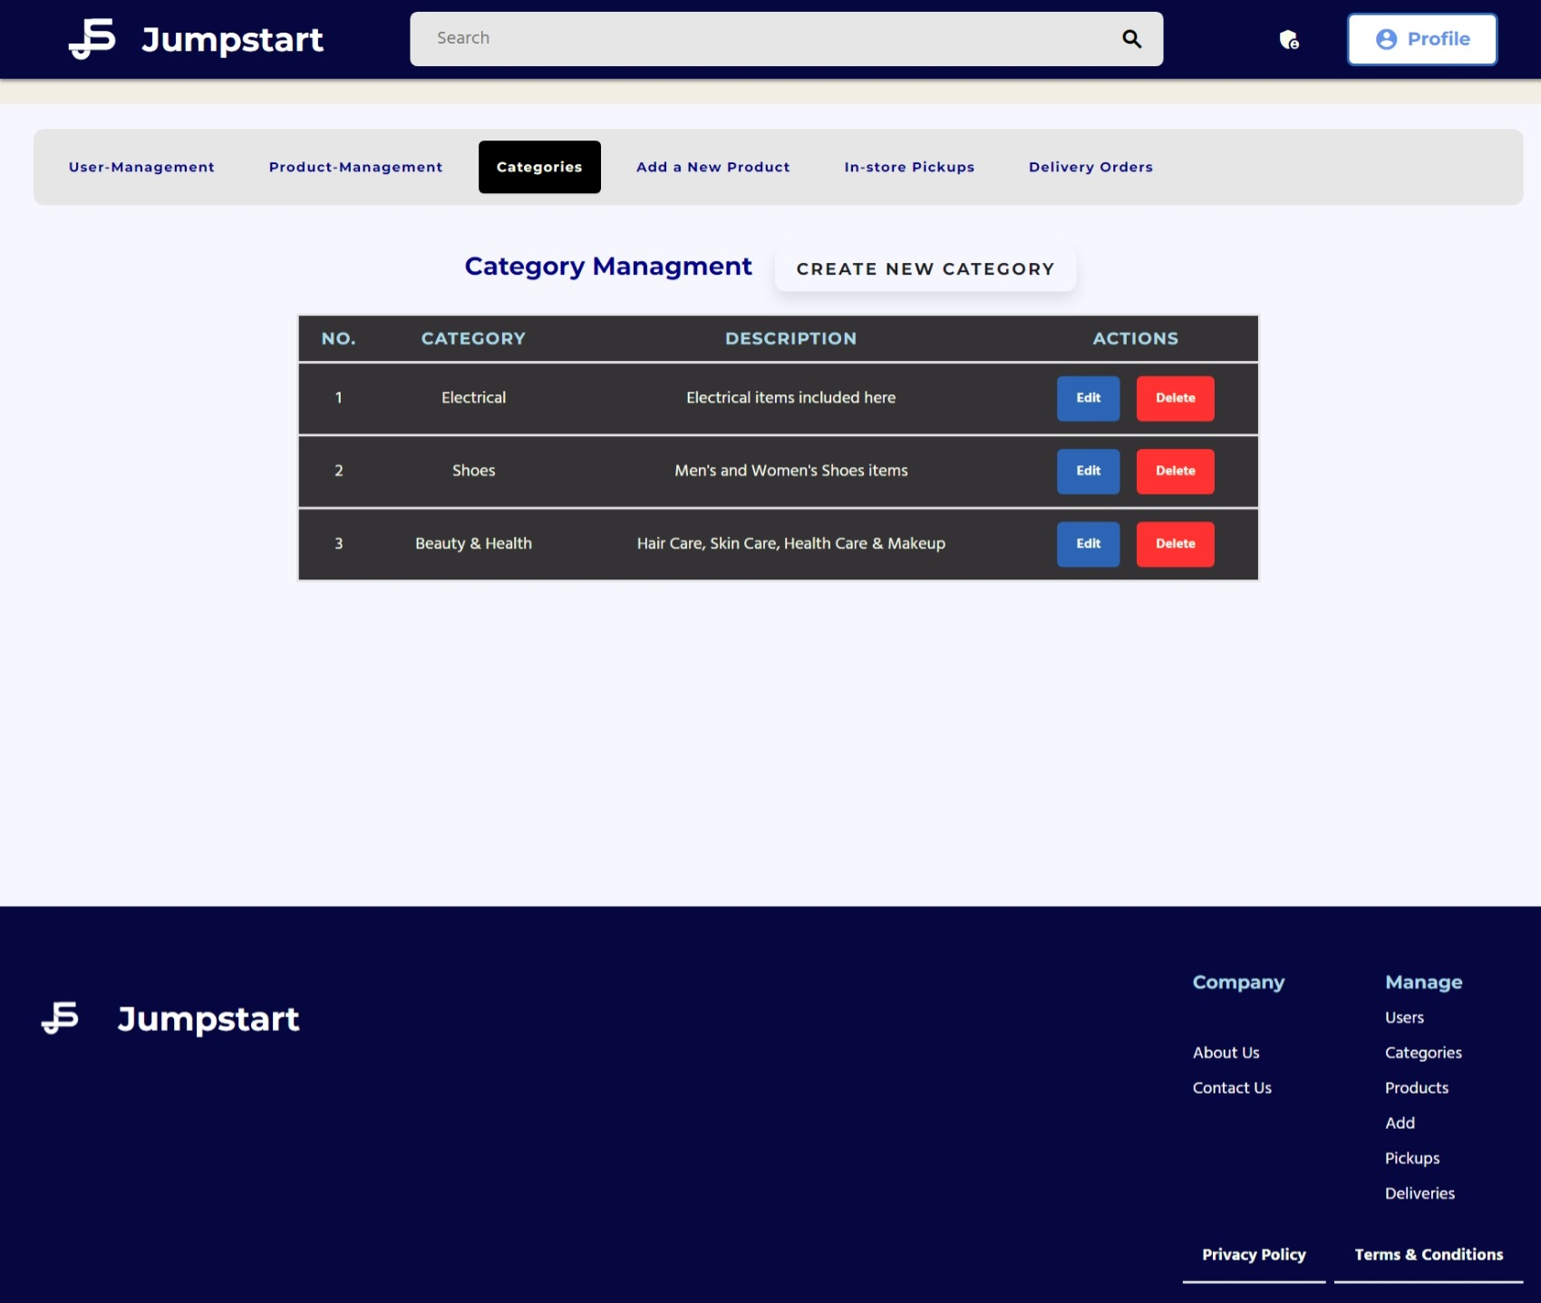

Edit Added Items

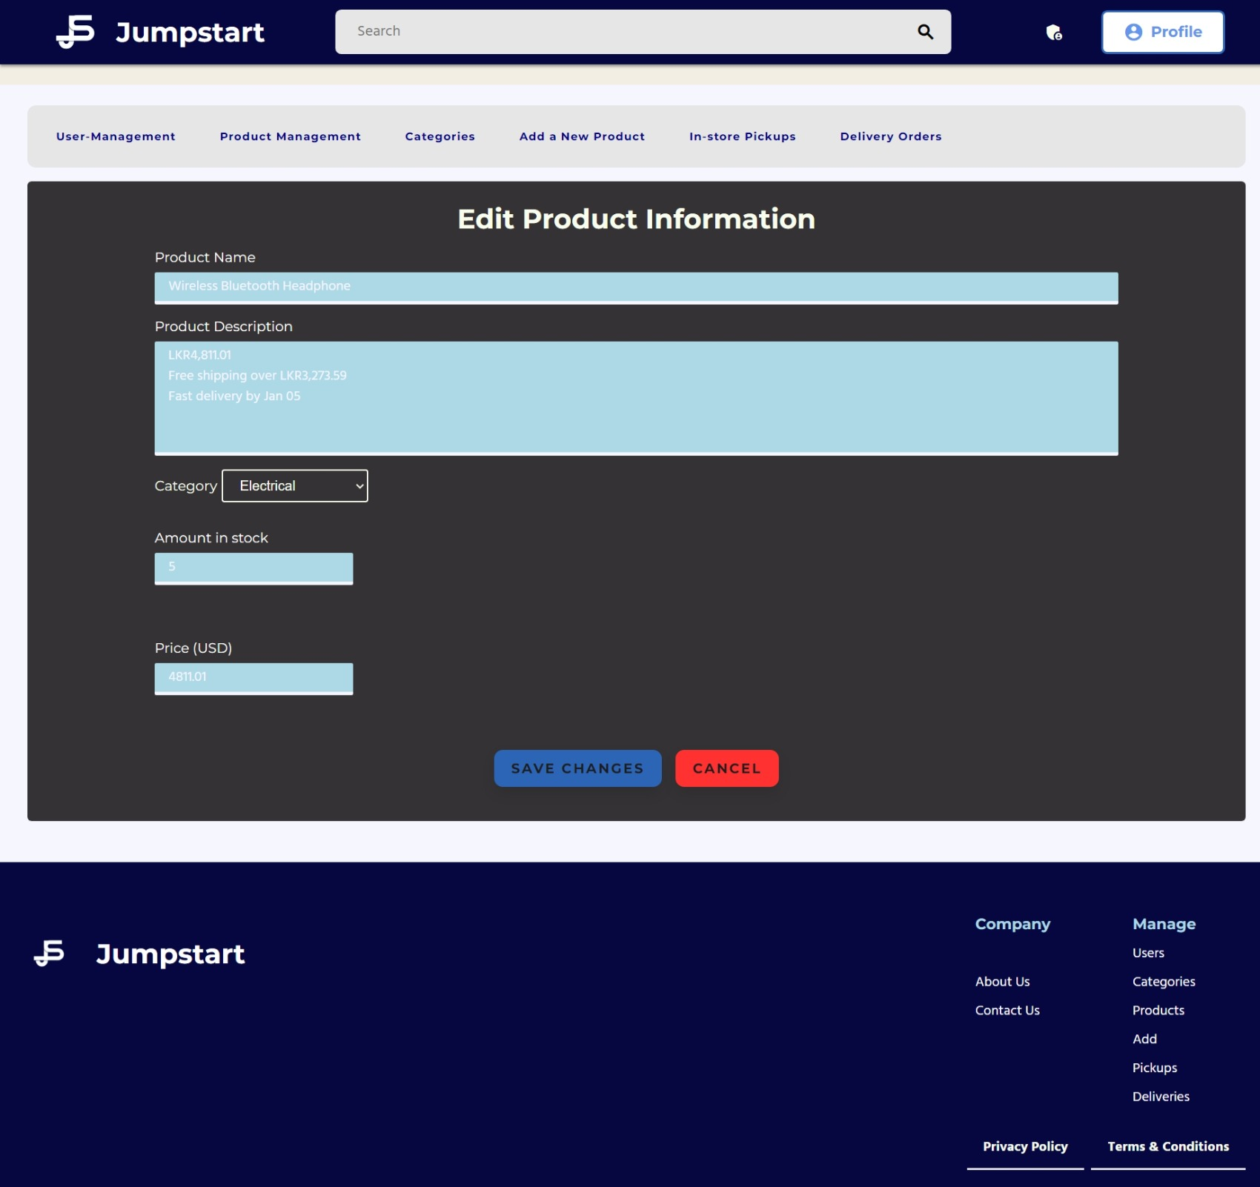

User Profile

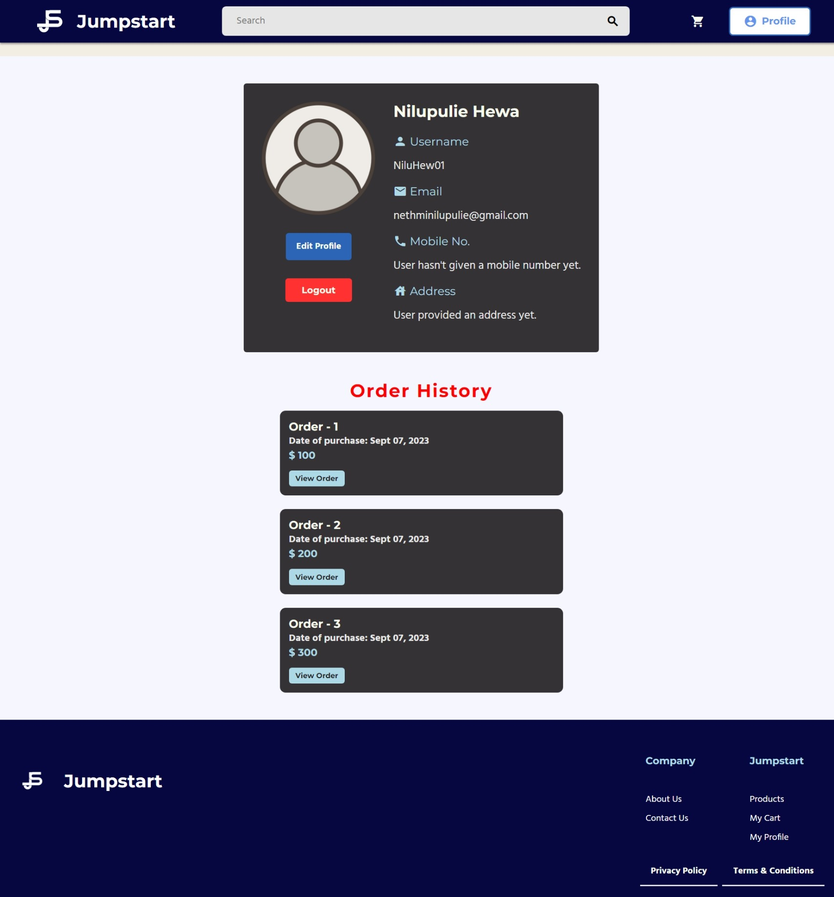

Edit Profile

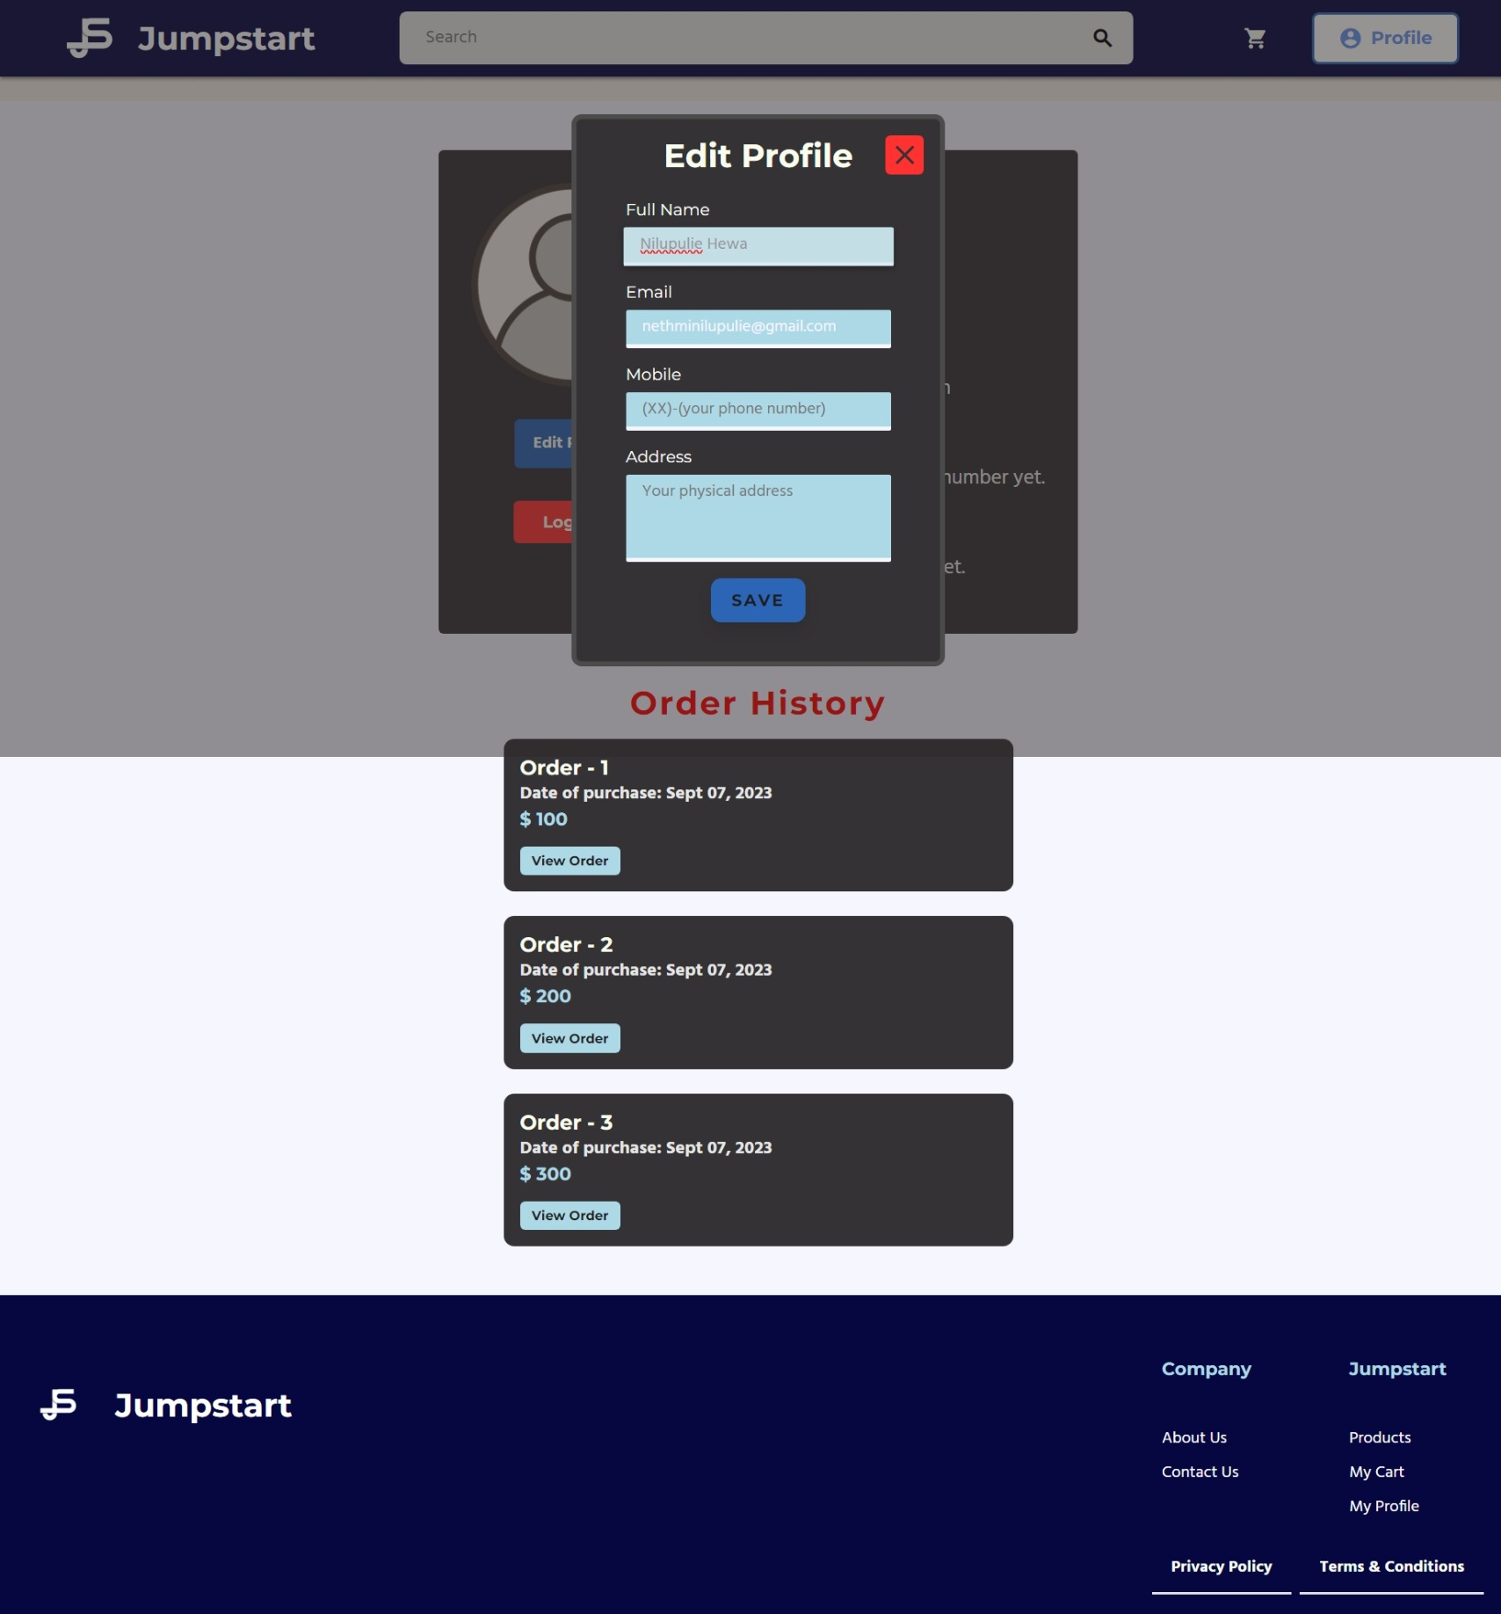

Cart Before

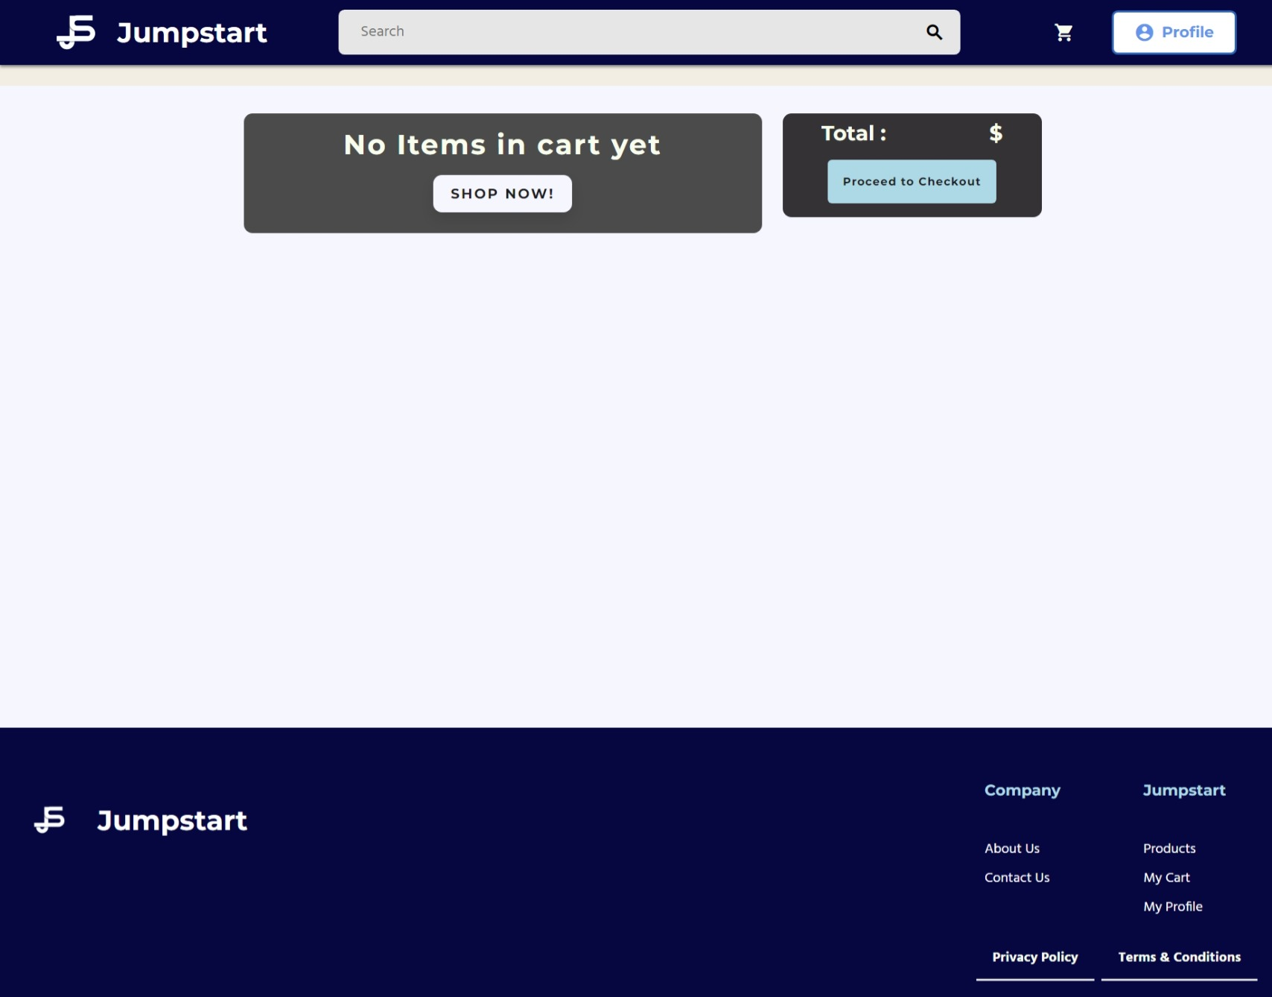

Cart after Added Items

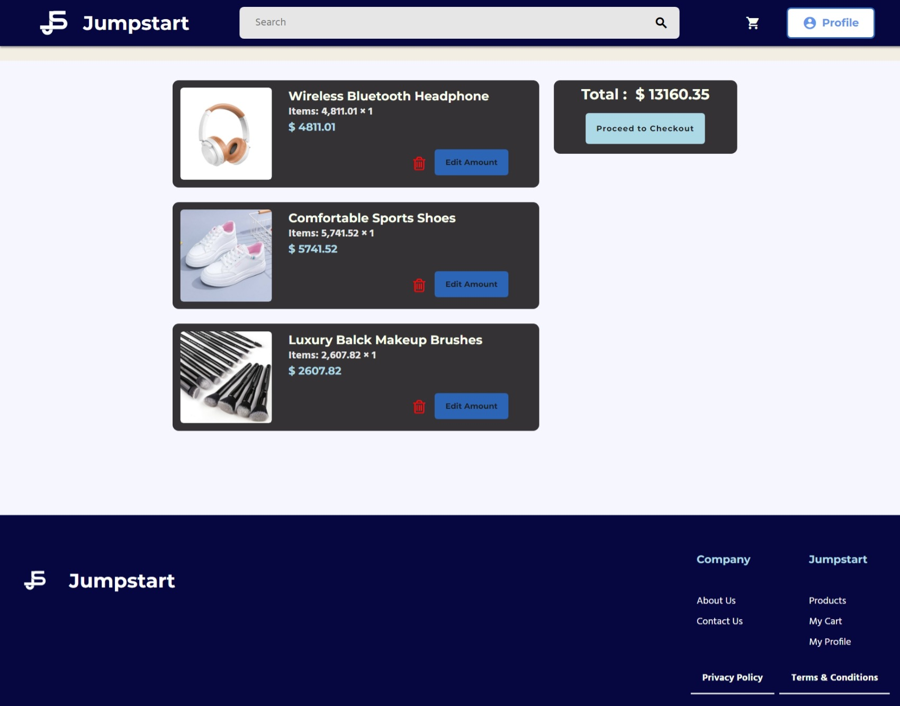

All User Product List

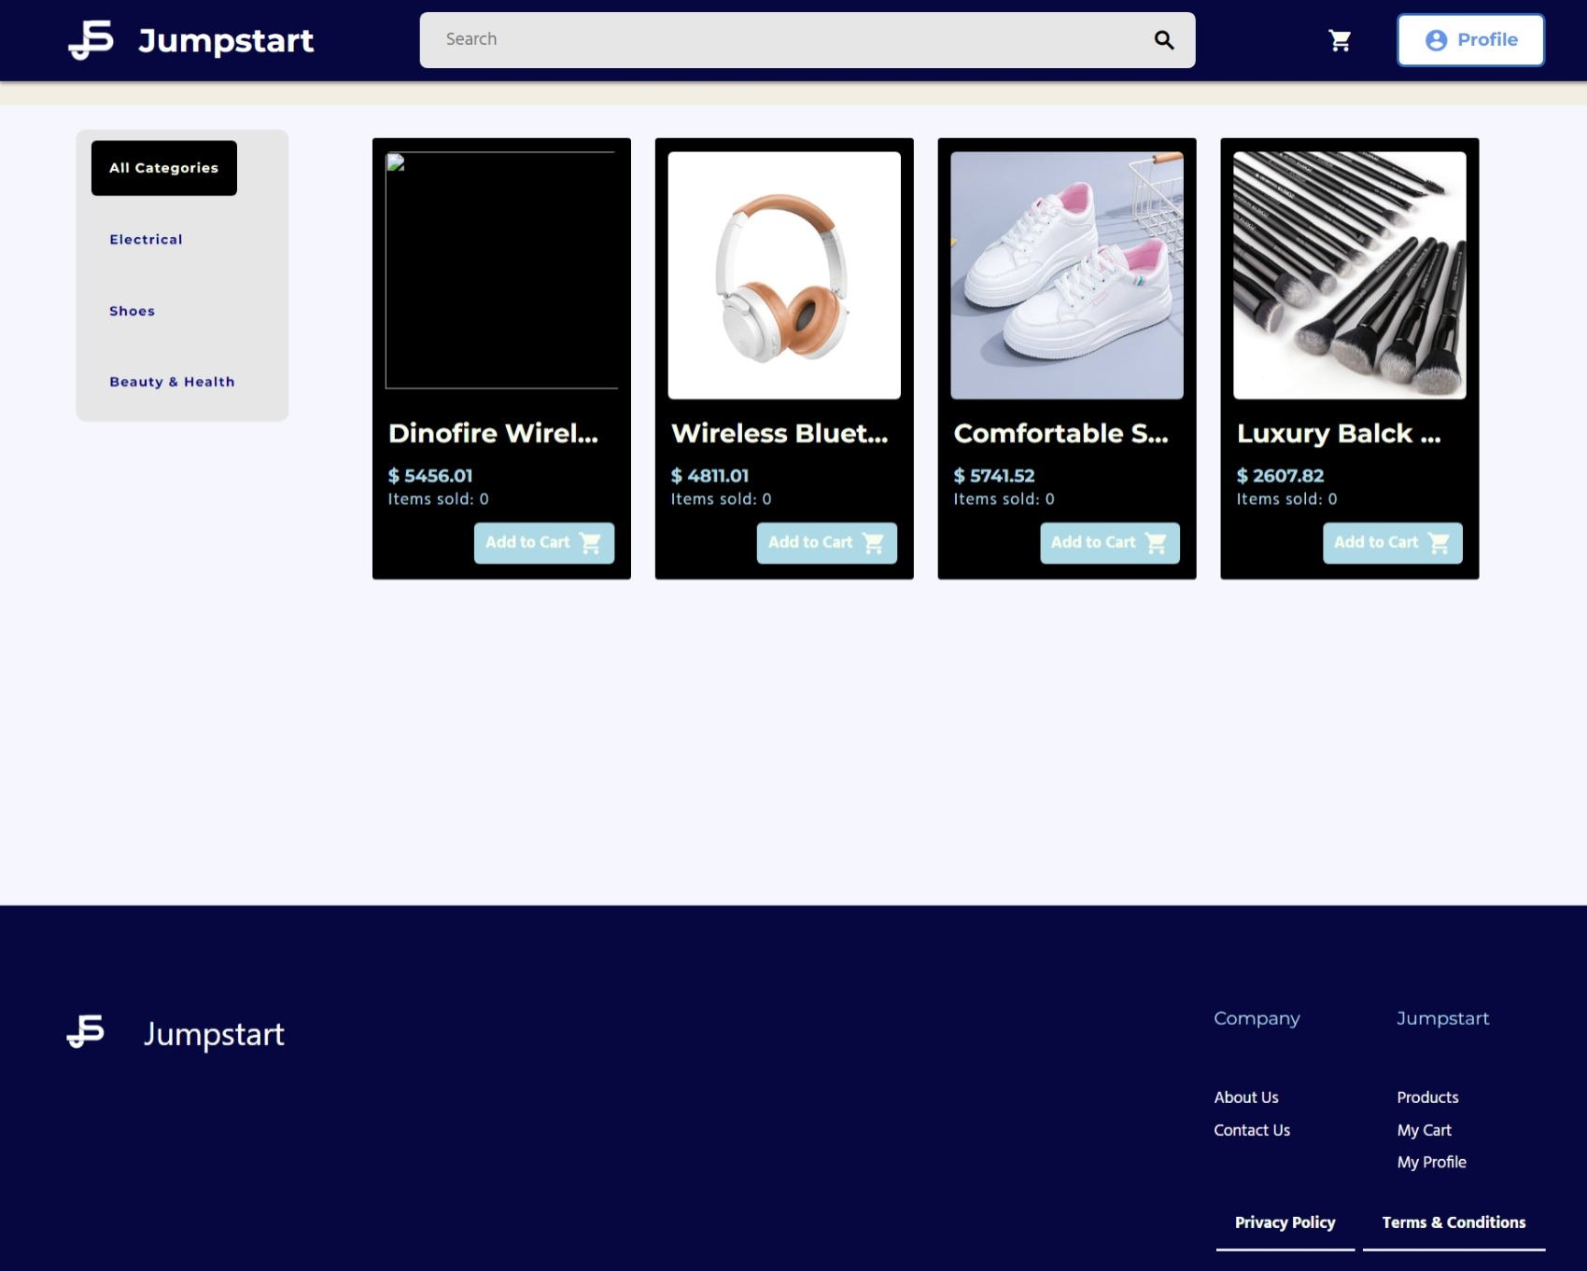

Product View

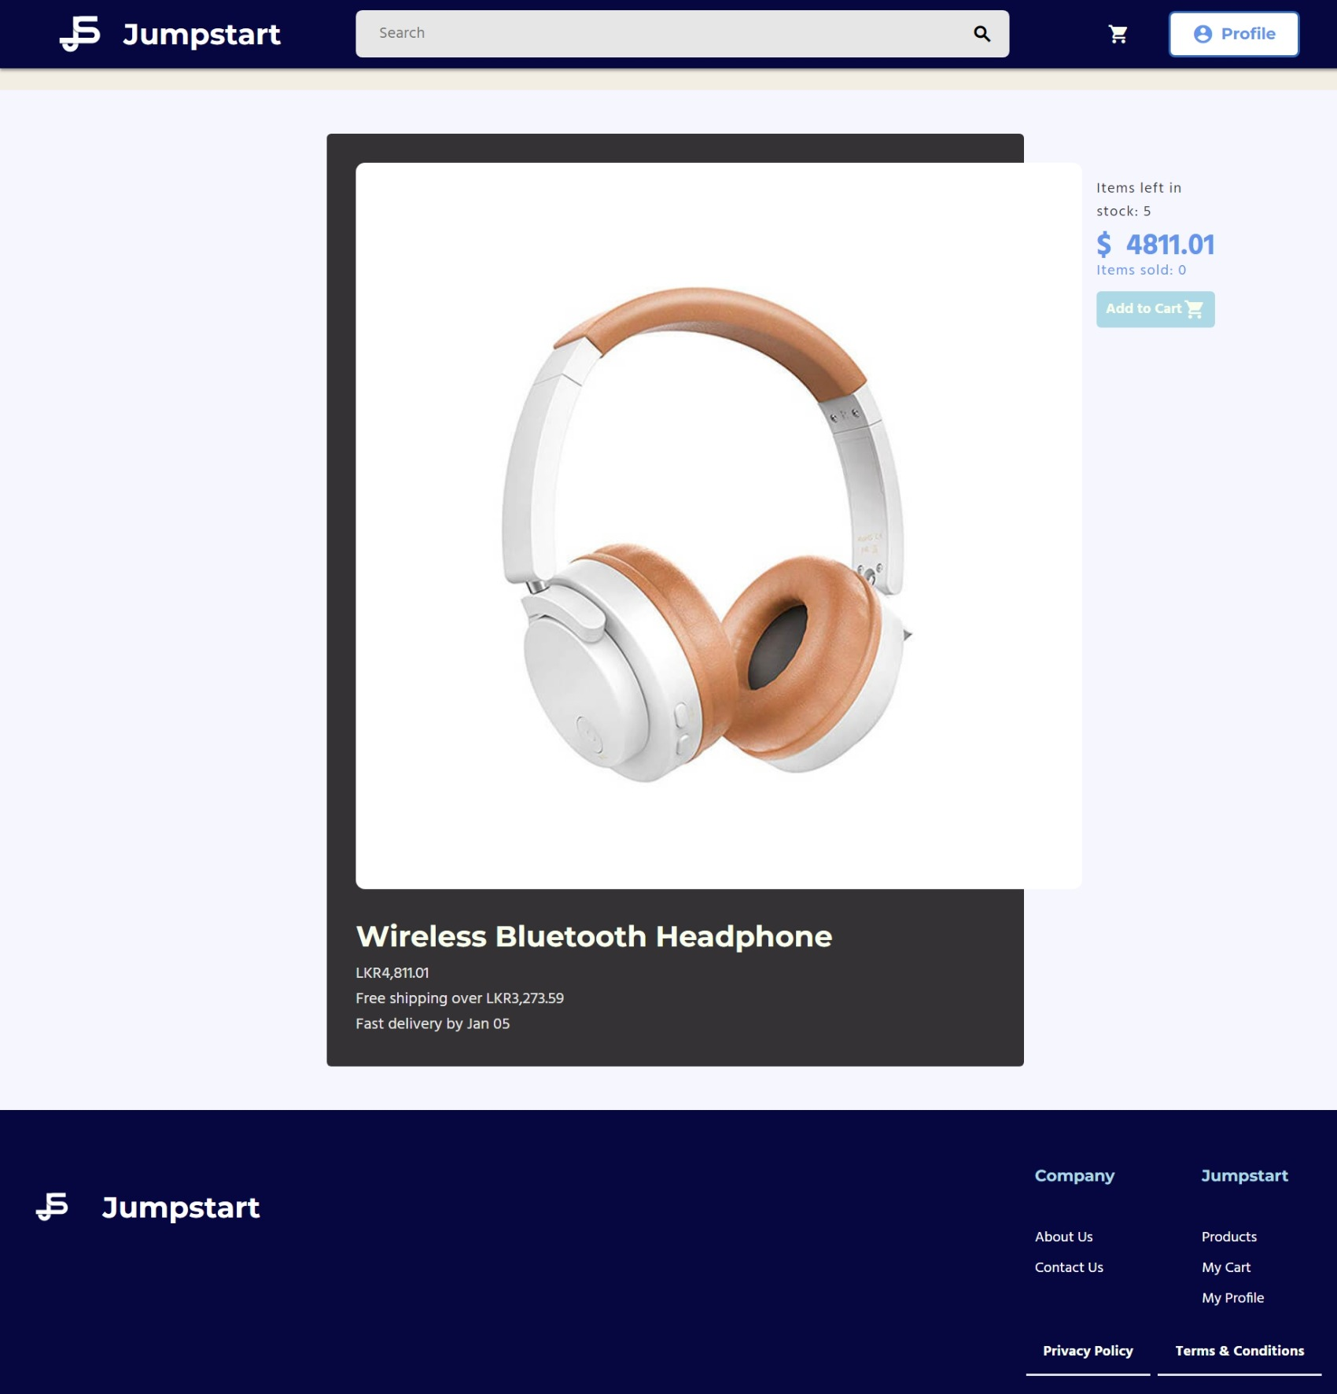

Search Results

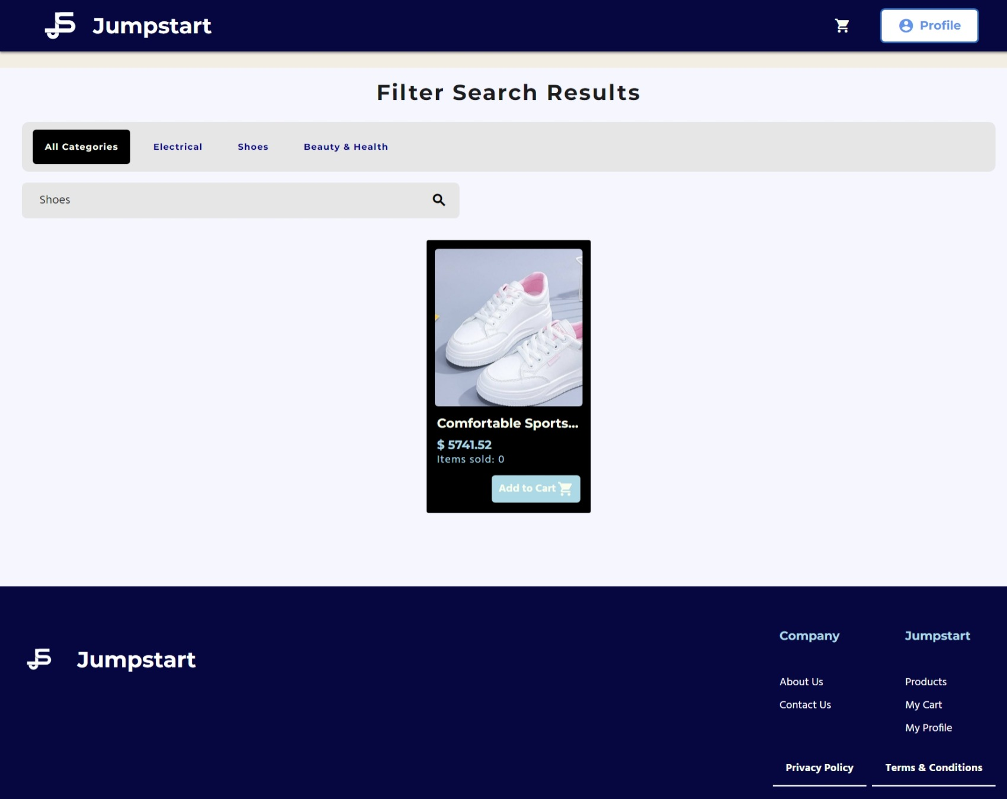

Staff Profile

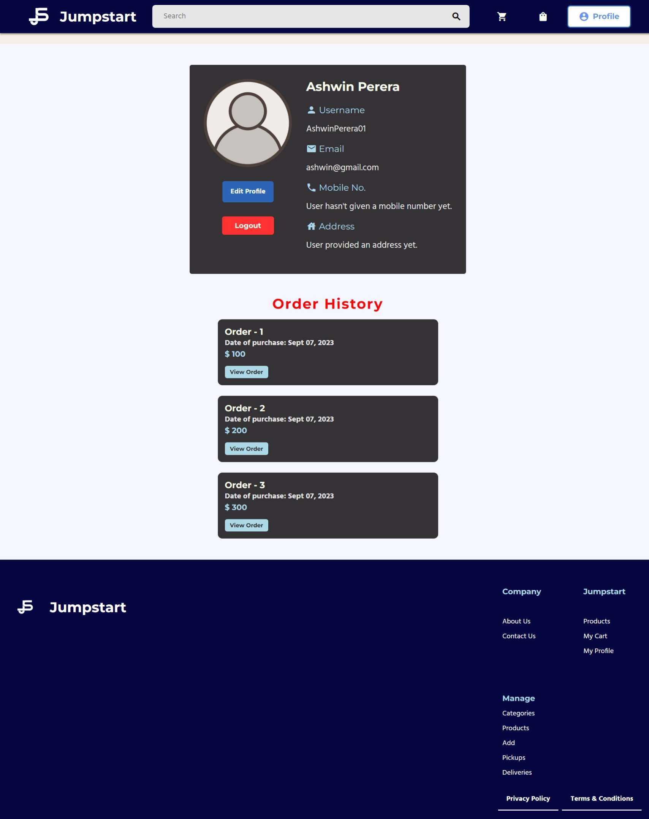

Staff Add Product

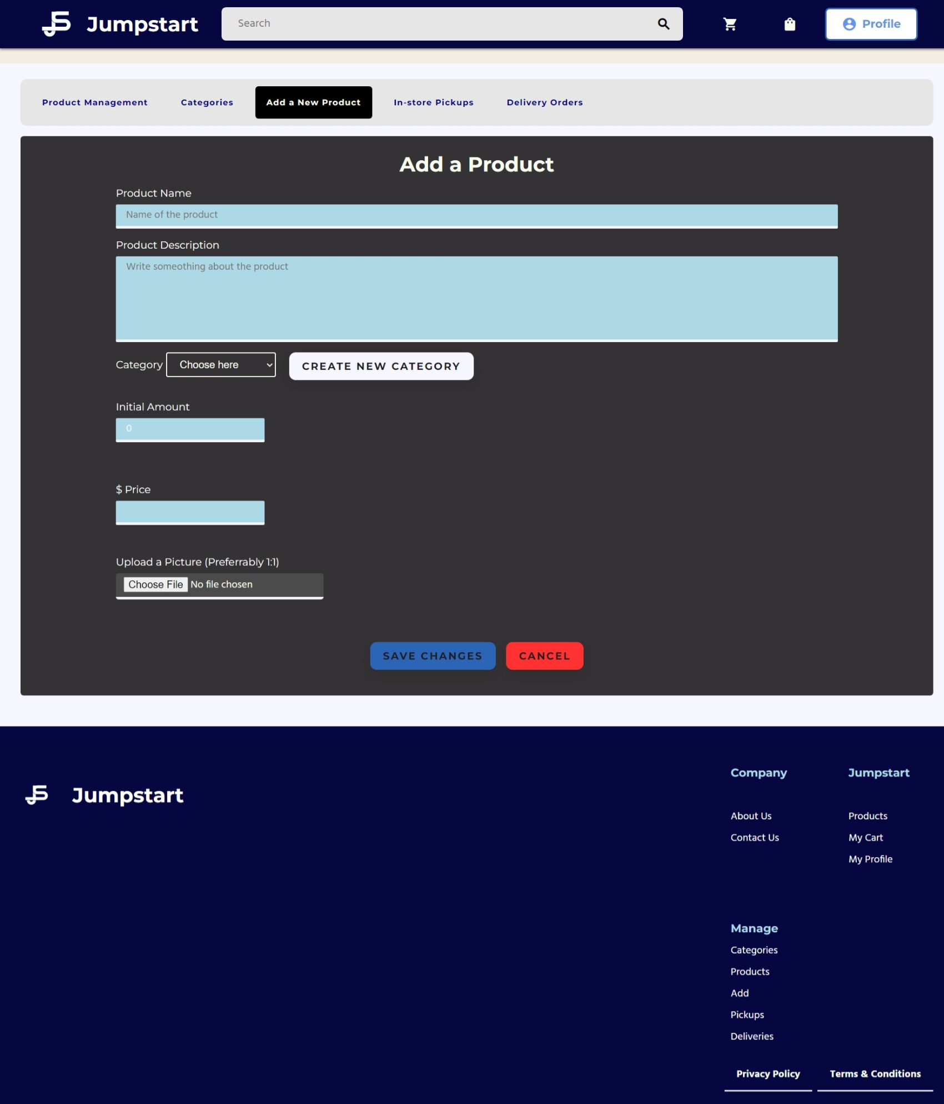

Staff Product Management

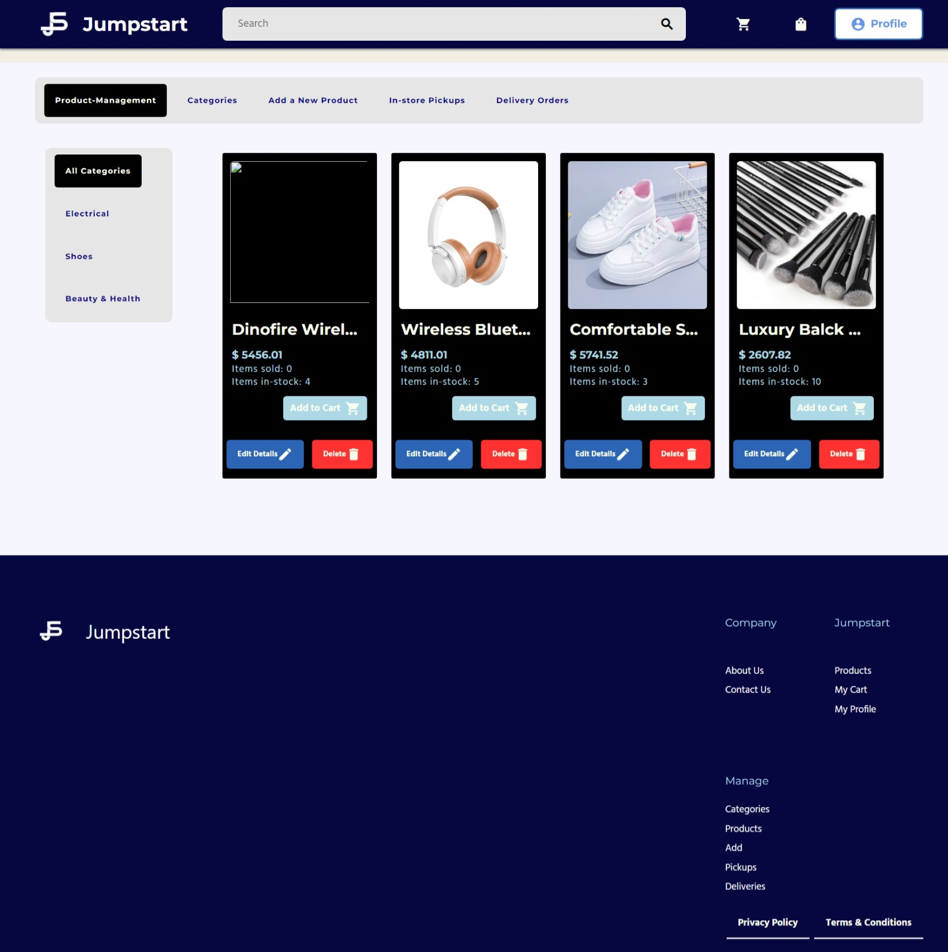

Staff Category Management

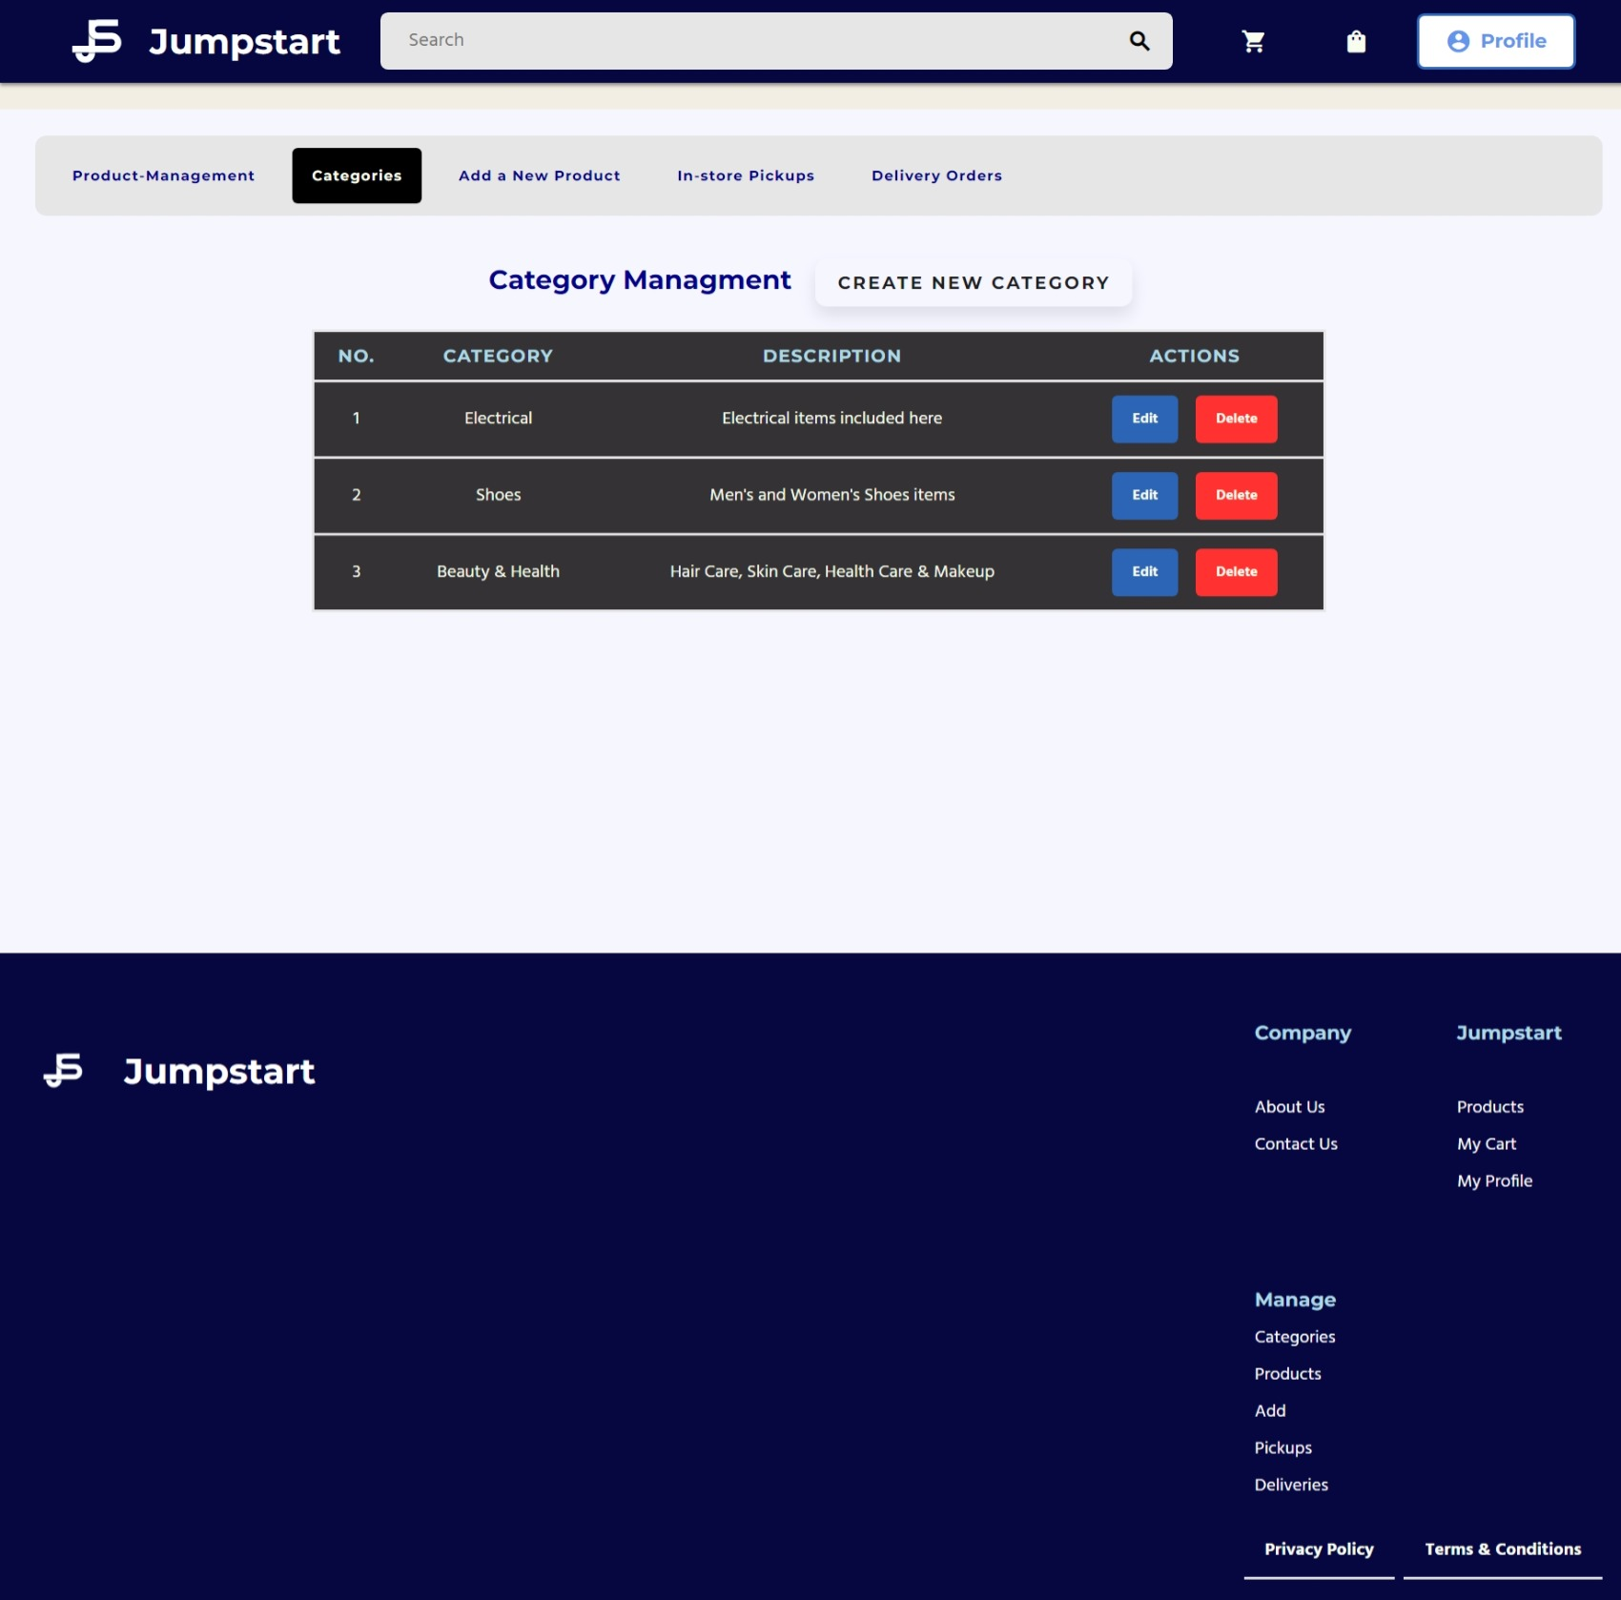

1. Communication with Stakeholders

The regular flow of information between the organization and its stakeholders is known as stakeholder communication. To ensure effective and targeted communication with stakeholders, it is essential to comprehend their identities, goals, motivations, and attitudes. Here are some commonly used mediums for stakeholder communication:

* Ordinary meetings through video or in individual
* Emails
* Phone calls
* Presentations
* Newsletters
* Be aware forums
* Annual or monthly development reviews
* Press releases
* Website portals
* Casual conferences, including dinners
* Focus groups
* Social media

|  |  |  |  |  |
| --- | --- | --- | --- | --- |
| Sender | Receiver | Purpose | Medium | Frequency |
| Acedora Project Manager | Jumpstart Employee or customer | Communicate to provide the solution & recommendation | Microsoft Teams | once in project  Life |
| Acedora Project  Manager | Senior Manager of Acedora | Plan project flow | Email, Microsoft  Teams | Twice per week |

|  |  |  |  |  |
| --- | --- | --- | --- | --- |
| Project Manager | Project team  Project sponsor  Stakeholder | Conduct Kick-off meeting to introduce the undertaking and review goals and dreams. | In person / Face to face | Once |
| Project Manager | Team members,  (Project Team), stakeholders, | Project team meeting to study the reputation of the undertaking | Face to face or  Conference call in  Microsoft Teams | Weekly |
| Acedora Project Manager | Technical team and Creative team | Technical and innovative design conferences to discuss, review and talk technical and design issues and answers. | In Person / Face to face | As needed |
| Acedora Project Manager | Stakeholder | Month-to-month project status conferences to update leadership on venture status. | Face to face or  Conference call  Microsoft teams | Monthly |

|  |  |  |  |  |
| --- | --- | --- | --- | --- |
| Acedora Project Manager | Stakeholder | Project status reporting for detailed report on project status including progress, cost and public. | Email | Monthly |
| CFO, CEO | Key  Stakeholders,  CEO, PMO,COO | Budget Usage | Face to face  Presentation &  Email | Fortnightly |
| PM,PMO | PM,COO | Risk Review and Update | Face to face  Presentation &  Email | Fortnightly |
| PM | Jumpstart  Stakeholder All project team members | Internal & External work requests | Email  Microsoft teams | Once a week |

# Project Implementation

Landing Page



Contact Us



About Us



Login



Registration



Registration OTP Verification



Registration Success



Forgot Password Reset Email



Reset Password



Changed Password Successfully



Admin Profile



Admin User Management



Admin Add Product



Admin Product Management



Category Management



Edit Added Items



User Profile



Edit Profile



Cart Before



Cart after Added Items



All User Product List



Product View



Search Results



Staff Profile



Staff Add Product



Staff Product Management



Staff Category Management



1. Reflection on Research Methods

# Effectiveness and challenges of methods applied

1. Survey

# Effectiveness:

The Cost-Response Paradigm (CRP) evaluates the efficiency of survey methodologies in achieving their intended objectives.

Surveys present a cost-effective approach, with online and mobile surveys being particularly economical, boasting a low cost per respondent. Even with the inclusion of respondent incentives, the expense per response remains notably lower than organizing paper or telephone surveys, often yielding hundreds of qualified responses.

The strength of surveys lies in their ability to depict the characteristics of a large population comprehensively. This unparalleled capability ensures a more accurate and focused sample, facilitating the derivation of conclusions and informed decision-making.

Surveys can be administered through various modes, including online, email, social media, paper, mobile, phone, and face-to-face interviews. Employing a mixed mode of survey studies may be necessary for remote or hard-to-reach respondents, such as combining online and paper surveys to compile responses into a single dataset for analysis.

Anonymity in surveys fosters honesty and validity in responses. For accurate data, respondents must feel free to provide open and truthful replies. Surveys conducted anonymously offer a platform for more genuine and unambiguous responses compared to other research methods, particularly when the assurance of complete privacy is explicitly stated.

# Challenges

* + - Participant related - Response bias, Low response Rates, Sampling error, Data quality, Non response
    - Survey structure related - Lack of personal communication, Limited question types, Technical issues
    - Surveyor-related - Security. Data Privacy. Survey design & Implementation

(b) LR/case study:

* Effectiveness

The data derived from the literature review can be amalgamated to provide a comprehensive and coherent understanding of the selected topic. The literature review addresses inquiries, stays abreast of current perspectives, and presents a spectrum of new material. In this context, the Cost-Response Paradigm (CRP) assesses the effectiveness of the survey methods in accomplishing the defined objective or purpose.

* Challenges

Finding reliable material online for literature reviews is difficult

# Alternative methods to overcome the challenges:

* **Interviews**

# Situational/behavioral interviews

These questions are based on the premise that an individual's past behavior in job-related situations serves as a reliable indicator of their future performance. Create a list of essential job skills and formulate questions to understand how the candidate has applied these skills in previous roles. For instance, if you want to assess how a candidate deals with challenging client situations, inquire about a specific instance where they faced a difficult client and how they successfully managed and improved the relationship. This approach elicits real stories instead of rehearsed generalizations.

# Work simulations

Ask the candidate to showcase task-related skills and assess their performance. Quoting an excerpt from "Work Rules: Insights from Google That Will Transform How You Live and Lead" by Laszlo Bock, he underscores the significance of work simulations: "A work sample test is an excellent predictor of how someone will perform in a job." This involves assigning candidates a sample piece of work similar to what they would encounter in the job and evaluating their performance.

# Cognitive or psychometric testing

Cognitive assessments, akin to college entry exams like the SAT, offer insights into a candidate's intellectual abilities. These tests can also shed light on a candidate's personality and their likely responses in typical work-related situations. When integrated with additional information, the results of these tests can either validate or challenge your perceptions of a candidate's capabilities. However, it's crucial to acknowledge that testing comes with its own set of legal considerations and must undergo thorough scrutiny before implementation.

# Surprise/quirky questions

# A candidate's responses and actions in unforeseen situations can unveil aspects of their personality, motivation, creativity, and composure under stress. As per Inc., unconventional questions have the potential to "spark a conversation and steer the candidate away from rehearsed answers." For instance, you might inquire about the type of cheese that best reflects their personality or the superpower they would most desire. The crucial aspect is not the specific answer but rather how the candidate approaches the task of generating a response. There is no right or wrong answer; instead, it unveils the candidate's ability to think spontaneously and showcase creativity when faced with unexpected challenges.

# Survey

Grounded theory proves advantageous for obtaining reliable online information and understanding the essence of uncertainty. However, grounded theory-based methods necessitate a substantial amount of data, posing challenges in managing the vast information produced. Adherence to strict rules is not mandated, and alternative strategies, such as participant selection, topic choice, method selection, engaging institutions, and data management, can be considered to overcome challenges. When opting for a manual forum over a Google discussion board, various issues may arise, including trade-related challenges. However, using Google forums allows easy posting and problem resolution. Conducting interviews instead of utilizing a server presents difficulties, as individual interviews are time-consuming, involve candidate selection complexities, and entail a complex process. In contrast, utilizing a server streamlines the entire process for easier management.

1. **Conclusion**:

To summarize the successful achievement of CRP objectives and the enabling research methods:

The CRP levels were determined using a calibration curve, employing a logit-log function for signal data subtraction. The analysis was conducted on Behring Nephelometer to quantify CRP, confirmed through successful messages in the Jumpstart operations.

In the Jumpstart online shopping items store, users, including admins, members, and suppliers, can log in separately. Admins can view details of logged-in users, access item listings, and edit information. Users can log in to their profiles, submit and edit items, view garment details, place orders, and perform various actions. The website provides information about the company, contact details, store details, cart, and checkout.

Initially, primary and secondary research related to inventory management was conducted, focusing on store details and sales. Feasibility studies, prototyping, and project planning were executed. The interface was designed, coded using Spring Boot, and both backend and frontend were developed. Separate logins for users and admins were implemented, and the Acadora application manager played a crucial role.

The project manager's responsibilities include managing projects within the organization, utilizing project management processes for planning, budgeting, monitoring, and reporting. Acting as a liaison between upper management and project implementers, project managers ensure smooth progress and timely completion. Regular progress reports are provided to senior management to keep them informed.

# Future research considerations:

* **Order Tracking System**

Monitoring e-commerce orders allows you to assess and manage all your online orders and shipments, providing timely updates on order status to customers. This process encompasses functionalities like shipping tracking, anticipated delivery dates, and regular status updates, significantly influencing the overall customer experience. It ensures customers are well-informed about their orders, setting expectations for their journey and promptly notifying them of any potential delays.

* **Reasons**
* Reduce costs

Effectively handling customer complaints or inquiries can incur substantial long-term costs. Post a successful update, there's a need to hire staff, outsource services, or implement a bot to respond to each query. Failing to do so can result in negative customer reviews. Fortunately, e-commerce order tracking significantly reduces these inquiries. Once implemented, the tracking data is systematically organized. In case of any issues, a quick search through the order history provides the necessary information. Order tracking streamlines the process without adding extra workload, relieving your support team and enhancing the overall customer experience by saving time and resources.

* **Meet customer expectations**

A staggering 97% of customers expect to monitor their orders throughout the entire shipping process. It's evident that customers value a high level of visibility into their orders, especially in the competitive landscape of online shopping. Implementing an e-commerce order tracking system is crucial to avoid losing business to major competitors like Amazon. Failing to meet the expected service level may jeopardize customer loyalty. By offering comprehensive order tracking, meeting customer expectations becomes achievable, leading to positive reviews, repeat purchases, and word-of-mouth referrals. Providing clear answers is far more satisfying for customers than hearing uncertain responses, and maintaining transparency in the shipping process prevents confusion, especially considering the various stages an order goes through before reaching its final destination.

* **Have extra manipulate over success**

The completion of your responsibilities doesn't conclude when the package is packed and handed over to the carriers. Implementing order tracking empowers you to maintain greater control over the order fulfillment process and promptly address any arising issues. Without such a system, critical tracking information may be overlooked, leading to a surge of emails from dissatisfied customers. While acquiring new customers is important, the real revenue lies in cultivating repeat customers who consistently make additional purchases. A robust e-commerce fulfillment strategy, inclusive of order tracking, not only minimizes issues but also enhances the lifetime value of your customers, ultimately driving more sales.

1. **Bibliography:** in Harvard Referencing system

DeFranzo, S.E. (2017). *Advantages and Disadvantages of Surveys*. [online] Snap SURVEYS. Available at: [https://www.snapsurveys.com/blog/advantages-](https://www.snapsurveys.com/blog/advantages-disadvantages-surveys/) [disadvantages-surveys/](https://www.snapsurveys.com/blog/advantages-disadvantages-surveys/).

George, T. (2023). *What is Secondary Research? | Definition, Types, & Examples*. [online] Scribbr. Available at: [https://www.scribbr.com/methodology/secondary-](https://www.scribbr.com/methodology/secondary-research/) [research/](https://www.scribbr.com/methodology/secondary-research/).

SurveySparrow. (2022). *70+ Online Shopping Questionnaire for Ecommerce Businesses*. [online] Available at: https://surveysparrow.com/blog/online-shopping- questionnaire-2/#:~:text=Online%20shopping%20surveys%20are%20great [Accessed 24 Mar. 2023].

DeFranzo, S.E. (2019). *4 Main Benefits of Survey Research*. [online] Snap Surveys Blog. Available at: [https://www.snapsurveys.com/blog/4-main-benefits-survey-](https://www.snapsurveys.com/blog/4-main-benefits-survey-research/) [research/](https://www.snapsurveys.com/blog/4-main-benefits-survey-research/).

Abby Jenkins (2020). *Inventory Management: 20 Challenges, 20 Solutions*. [online] Oracle NetSuite. Available at: <https://www.netsuite.com/portal/resource/articles/inventory>[management/i](https://www.netsuite.com/portal/resource/articles/inventory-management/inventory-management-challenges.shtml) [nventory-management-challenges.shtml.](https://www.netsuite.com/portal/resource/articles/inventory-management/inventory-management-challenges.shtml)

Lumenlearning.com. (2019). *Chapter 9 Survey Research | Research Methods for the Social Sciences*. [online] Available at: [https://courses.lumenlearning.com/suny-hccc-](https://courses.lumenlearning.com/suny-hccc-research-methods/chapter/chapter-9-survey-research/) [research-methods/chapter/chapter-9-survey-research/](https://courses.lumenlearning.com/suny-hccc-research-methods/chapter/chapter-9-survey-research/).